School-based Responses to

Vaping

Environmental Scan

February 2020

The impetus for this scan came out of the April 2019 face-to-face meeting of the School Health Coordinators’ Committee when vaping use among youth was expressed by most jurisdictions in updates. Following this meeting, JCSH developed a Vaping Resource for Schools.
Follow-up question by Sterling Carruthers – January 30 2020:
Do any of your schools have a process post-vaping suspension - that includes an education component? - i.e. I get suspended, then have to watch a video, complete a lesson, read a book etc.... before coming back to school??

Guidelines for Scan Completion
- LEGISLATION, POLICIES, GUIDELINES
- Note any overarching or supporting policies connected to school-based approaches or programs to address vaping use, education, concerns within the school community; these could be at the provincial / territorial as well as the school board / district levels.

- RESOURCES, TOOLS, WORK PLANS, SUPPORTS
- List school-based vaping resources/tools used in your jurisdiction.
- List also any upstream approaches which have met with significant positive – or negative – responses
- Any curriculum or learning outcomes in your jurisdiction that have been connected to the emerging vaping use crisis
- Development of peer-led groups in schools to discuss, provide education around vaping

- EVALUATION OF IMPACTS
- Use this section to describe any evaluation plans, indicators, measures, and measurement tools your jurisdiction is using regarding to support and enhance use of school-based education programs and activities, as well as upstream approaches to minimize vaping use and harms.

- COMMON MESSAGING (Health, Education)

- CHALLENGES, NEEDS, QUESTIONS, AND SUCCESSES
- Use this section to describe any/all challenges, needs, questions, and successes. This section can also house a list of resources that may have not been vetted carefully by referring sources, resources that may be questioned before sharing because the content seems limited or not balanced, or written by companies funded by private sector partners.

British Columbia 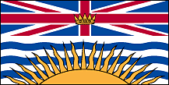 (February 2020)
- LEGISLATION, POLICIES / GUIDELINES
In B.C., vapour products are regulated in the same way as tobacco products are. Tobacco and vapour products cannot be sold to minors or promoted publicly. It cannot be used in public buildings and workplaces, near doorways or air intakes of public buildings, or on school property. For more information on the current vaping legislation in BC, visit the Government of British Columbia - Requirements under the Tobacco and Vapour Products Control Act and Regulation. In B.C., the legal age to buy vaping products is 19 years of age.
For more information about the laws and regulations visit:
- Tobacco and Vapour Free Places, B.C. Government
- Tobacco and Vaping Products Act, Government of Canada
- Tobacco and Vapour Products, B.C. Government
Response to post-vaping suspension question: Here is some information from colleague who oversees the substance use portfolio for BC Ministry of Education :

We do have information that we can share as we've learned a lot from the SD vaping policy scan. There are pretty well known examples from SDs, like Vernon, in which they are using a suspension as an opportunity for education.

"When our students are caught vaping they are in-school suspended (an empathetic approach – education and a little discipline) and required to complete an assignment on the dangers of vaping. Parents are included in this process and are offered help and advice from the district. Assignment: http://www.sd22.bc.ca/Programs/sss/Documents/Vaping%20Assignment.pdf"

Richmond SD is using an education program as an alternative to suspension. Students have to attend the full day program if they've been caught vaping. The program is ran by the Richmond Addiction Services Society and is called Constructive Alternative to Teen Suspension (CATS). In addition to offering a weekly intake for educational sessions for youth caught misusing substances at school, there is a monthly dedicated session for youth who have been vaping at school. https://www.richmondaddictions.ca/images/stories/pdf/ParentPackage20172018.pdf

Both of the above examples link directly to school or program websites, so I would feel confident that you would be able to share. As for our other SDs, there are a variety of other responses that are in play, with most of them being punitive in nature, so not much information to share on the education side at this point.

- RESOURCES, TOOLS, AND SUPPORTS
- Vaping Prevention Toolkit – British Columbia Lung Association
Included Resources within Toolkit:
  - Vaping Infographic – British Columbia Lung Association
  - Vaping Products Information for Teachers – British Columbia Lung Association
- erase – Substance Use Website – BC Ministry of Education
- Supporting and Connecting Youth (SACY) – Vaping 101 Vancouver School Board
- Vaping - HealthLinkBC
- IMPLEMENTATION --EVALUTION OF IMPACTS
- COMMON MESSAGING (Health, Education)
- Statement from the Council of Chief Medical Officers of Health on the increasing rates of youth vaping in Canada
- CHALLENGES, NEEDS, QUESTIONS, AND SUCCESSES

Alberta 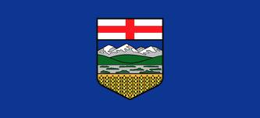
- LEGISLATION, POLICIES / GUIDELINES

Stay tuned – about to engage Albertans and may/may not do legislation, etc.
https://calgary.ctvnews.ca/alberta-to-launch-review-of-vaping-regulations-in-november-1.4620035?fbclid=IwAR3oeSV295zPJumAxB6n5-XYKhI9EC07payHIAbQOoDxNydl9UmLlXOOOfo

- RESOURCES, TOOLS, AND SUPPORTS
In very early stages of development for the province.
Alberta Health Services –
The AHS Tobacco Reduction Program offers resources regarding vaping through Alberta Quits (Albertaquits.ca). Information (recently updated) for Albertans about vaping can be found on My Health Alberta: https://myhealth.alberta.ca/Alberta/Pages/Electronic-cigarettes.aspx.
Targeted resources have and continue to be promoted to AHS field staff and other stakeholders. AHS field staff from Public Health, Addiction and Mental Health and Comprehensive School Health have been providing presentations to parents, teachers, students and as well as other community stakeholders.
- Clinical Support Primer for health professionals: “Tobacco Harm Reduction – E-Cigarettes.”
https://healthcareproviders.albertaquits.ca/files/file/5d5b17935a737/Primer--Tobacco-Harm-Reduction--E-Cigarettes.pdf

- “Electronic Smoking Products” presentation for capacity building in health professionals, teachers and parents. Not intended for use with students. https://www.albertaquits.ca/files/file/5d1bda1f852b2/Electronic_Smoking_Product_PP_November2018.pdf

- Tobacco Information Series: Electronic Smoking Products for health professionals https://healthcareproviders.albertaquits.ca/files/file/5cc893c9ce60c/Electronic_Smoking_Products_Final_Jan19.pdf

- Let’s Talk About E-Cigarettes – a brochure for health professionals to order to use with clients https://secure14.datagroup.ca/ordering/ordering/item_selection.aspx

- Infographic (attached) and presentation for high school students for use by teachers, or those who have a relationship with youth already, as that supports best practice by encouraging follow-up conversations.
  - the presentation is based on our approved vaping messages and uses evidence-based media literacy and social competence approaches, such as awareness of media tactics and consideration of personal goal setting. Please note the speaking notes, as they include much of the teaching approaches.
https://www.albertaquits.ca/files/file/5d1bda05ce9cf/Vaping_presentation_for_students_with_notes_190417.pdf

In addition to the above:
- A new school based youth prevention program for grades 7-9 will be piloted this fall in communities across Alberta. This innovative approach includes a virtual learning environment developed with extensive youth and expert stakeholder input and is aligned with best practice evidence (social competence, critical thinking/decision making, media literacy).

- Presentations have been accepted at Teachers Conventions in February 2020 where AHS staff will share information and resources on tobacco, vaping as well as recommended best practice on youth prevention.

Lung Association - https://www.ab.lung.ca/what-we-do/breathe-smart-education-program
Note that this program has been operating since 2016 and they’ve recently added in the vaping. I’m interested in knowing if other PT jurisdictions have this on offer. Supported by Alberta Blue Cross and the Calgary Flames (hockey team).
- IMPLEMENTATION – EVALUTION OF IMPACTS
Nothing to-date
- COMMON MESSAGING (Health, Education)
Nothing to-date
- CHALLENGES, NEEDS, QUESTIONS, AND SUCCESSES

School divisions are really looking for support in this area. Stay tuned.

Saskatchewan (October 2019)
- LEGISLATION, POLICIES / GUIDELINES
The Government of Saskatchewan passed amendments to The Tobacco Control Act in fall 2019. These amendments will bring vapour products in line with existing tobacco legislation. The Government of Saskatchewan is currently drafting amendments to The Tobacco Control Regulations.
- RESOURCES, TOOLS, AND SUPPORTS
The Ministries of Education and Health collaborated to provide a sample letter to parents/guardians about vaping. The sample letter and the JCSH vaping resource was sent to directors of education and First Nations education authorities in September 2019. The JCSH vaping resource was adapted for Saskatchewan. Vaping is the theme for the November 2019 CSCH eNewsletter and is available here.
- IMPLEMENTATION - EVALUATION OF IMPACTS
- COMMON MESSAGING (Health, Education)
- CHALLENGES, NEEDS, QUESTIONS, AND SUCCESSES
Saskatchewan school divisions have requested reliable vaping materials that come from the health sector.

Manitoba 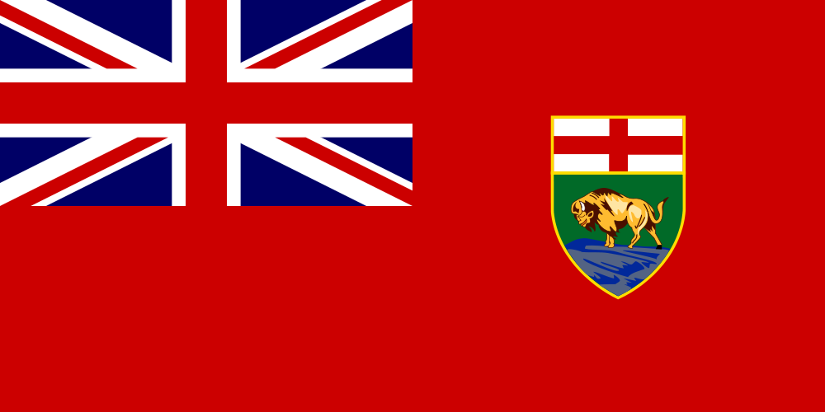
- LEGISLATION, POLICIES / GUIDELINES
- RESOURCES, TOOLS, AND SUPPORTS
- IMPLEMENTATION - EVALUATION OF IMPACTS
- COMMON MESSAGING (Health, Education)
- CHALLENGES, NEEDS, QUESTIONS, AND SUCCESSES

Ontario 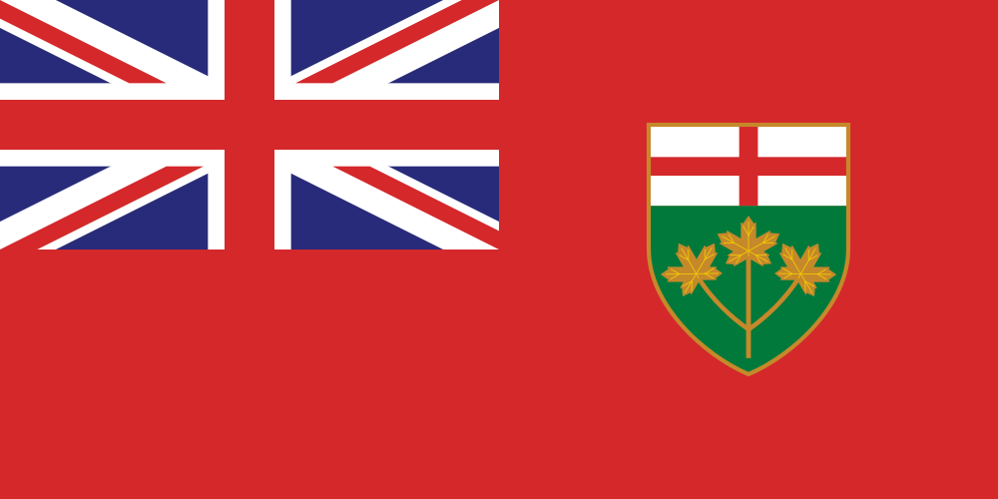
- LEGISLATION, POLICIES / GUIDELINES
Legislation: The Smoke-Free Ontario Act, 2017 (SFOA, 2017) regulates the sale, supply, display and promotion of tobacco and vapour products, as well as the smoking of tobacco, the use of electronic cigarettes to vape any substance (including cannabis), and the smoking of cannabis.
Protocol: The Ontario Public Health Standards: Requirements for Programs, Services, and Accountability (“the Standards”) are published by the Minister under the authority of section 7 of the Health Protection and Promotion Act to specify the mandatory health programs and services provided by boards of health. The Standards identify the minimum expectations for public health programs and services. Protocols are program and topic-specific documents incorporated into the Standards which provide direction on how boards of health shall operationalize specific requirement(s) identified within the Standards. The Tobacco, Vapour and Smoke Protocol, 2018 (or as current) provides direction to each board of health to support compliance with the SFOA, 2017.
Guidelines: Guidelines are program and topic-specific documents which provide direction on how boards of health shall approach specific requirement(s) identified within the Standards. The Tobacco, Vapour and Smoke Guidelines, 2018 (or as current) provide directions to the board of health on required approaches and interventions in developing and implementing a program of public health interventions for comprehensive tobacco control in the health unit population.
Strategy: The Smoke-Free Ontario (SFO) Strategy, released in 2018, is a comprehensive strategy that combines programs, policies, communications and laws to reduce tobacco and vapour product use and lower the health risks to non-smokers and non-vapers in Ontario. A key goal of the SFO Strategy is to reduce the proportion of people who smoke in Ontario to 10 per cent by 2023 (currently roughly one in five Ontarians smoke).
Location | Type of policy | Summary
General | Legislation | - Cannot sell or supply vapour products to persons under 19.  - Currently, convenience stores, grocery stores and gas stations are allowed to promote but not display vapour products — as long as the promotion complies with federal regulations. Starting January 1, 2020, the promotion of vapour products will be banned in convenience stores, grocery stores and gas stations, subject to limited exceptions for informational signs and documents. It will continue to be allowed in specialty vape stores and cannabis retail stores, which are only open to people aged 19 and older.  - The display of vapour products is currently prohibited in non-specialty stores under the SFOA, 2017. Specialty vape stores can display and promote vapour products; however, they must comply with several conditions, including that minors are not allowed entry to these stores.
General | Policy / Strategy | - Ontario’s Smoke-Free Ontario Strategy (2018) includes a focus on preventing the uptake of vaping in youth and non-smokers.
School | Legislation | - Cannot sell vapour products (e.g., e-cigarettes) at private and public schools.  - Cannot use vapour products (e.g., e-cigarettes) at private and public schools and public areas 20 metres from school grounds.
School | Protocol | - Public Health Units conduct mandatory annual inspections at secondary schools related to vaping laws (e.g., use, sale, etc.).  - Public Health Units conduct inspections at schools on a complaint-basis related to vaping laws (e.g., use, sale, etc.).
School | Guideline | - Public Health Units are encouraged to work with schools and school boards on services and programs related to comprehensive tobacco control, including vaping.
Child care centres; Home child care; Early years program | Legislation | - Cannot sell vapour products (e.g., e-cigarettes) at a child care centre or a place where home child care is provided (whether or not children are present).  - Cannot use vapour products (e.g., e-cigarettes) at a child care centre, a place where home child care is provided (whether or not children are present) or a place where an early years program or service is provided.
Child care centres; Home child care; Early years program | Protocol | - Public Health Units conduct inspections related to vaping (e.g., use, sale, etc.) on a complaint-basis at child care centres, places where home child care is provided, and places where an early years program or service is provided.
Child care centres; Home child care; Early years program | Guideline | - Public Health Units are encouraged to work with local partners on services and programs related to comprehensive tobacco control, including vaping.

NOTES:
Public Health Units (board of health) are responsible for enforcing the SFOA, 2017. Public Health Units (PHUs) use a compliance strategy that employs a balance of education, inspection and progressive enforcement. “Progressive enforcement” means the use of warnings and graduated charging options to reflect the frequency and severity of the level of non-compliance.
The SFOA, 2017 is not the only source of vaping restrictions in Ontario. Additional vaping restrictions that go beyond the requirements set out in the SFOA, 2017 may be found in municipal bylaws and the policies of employers and property owners.
Comprehensive tobacco control programs and policies focus on preventing the initiation of tobacco and vapour product use and addiction to nicotine; supporting tobacco cessation efforts; protecting people from social and physical exposure to second-hand smoke and vapour; and identifying and eliminating disparities related to tobacco and vapour product use. A coordinated and integrated comprehensive strategy means that prevention, cessation and protection efforts are mutually reinforcing leading to effective and efficient outcomes.

- RESOURCES, TOOLS, AND SUPPORTS

- Provincial Fact sheets - The Ontario Ministry of Health developed fact sheets related to provincial vaping laws that may be shared with stakeholders, including schools, parents and students. Fact sheets have been provided to local Public Health Units for distribution in their communities and are available upon request.

- Provincial Website - The Government of Ontario website includes information on vaping (www.ontario.ca/vaping) and vaping laws (www.ontario.ca/page/where-you-cant-smoke-or-vape-ontario)

- Locally-developed resources - Local Public Health Units work with community partners (including schools and schoolboards) to develop tools, resources and supports that meet community needs. Resources may be community-specific; however, Public Health Units are encouraged to collaborate and coordinate efforts across regions when appropriate.
- Vaping 101 - PPt Presentation (ON - Wellington-Dufferin-Guelph Public Health)

- Local prevention initiatives - Local Public Health Units work with community partners (including schools and schoolboards) to provide programs and services to help prevent the uptake of vaping in youth. Public Health Units are required to conduct program evaluations for vaping prevention initiatives and are encouraged to share successful initiatives broadly.

- Local peer-led initiatives - Local Public Health Units work with community partners (including schools and schoolboards) to develop tools, resources and supports that meet community needs. Efforts may include peer-led initiatives.

- Vaping resources targeted for youth – Not an Experiment is a game that informs users about the hazards associated with vaping (developed by the Ontario Central East Tobacco Control Area Network); Unfiltered Facts in an interactive website that shares facts about vaping (developed by the Ontario Central West Tobacco Control Area Network).

- Classroom learning - In August 2019, the Ministry of Education issued updated elementary Health and Physical Education curriculum. The updated curriculum includes learning related to substance use, addictions, and related behaviours. These learning expectations focus on understanding of effects of drugs – prescription drugs, non-prescription drugs, tobacco, alcohol, cannabis, and other intoxicating substances – and the consequences of their use. Students also learn about the effects and risks of vaping. This knowledge is integrated with the development of a variety of skills that help students make and maintain healthy choices. Mandatory learning related to vaping occurs in Grade 4 and 6 in the updated (2019) elementary Health and Physical Education curriculum with additional references starting in Grade 1.

- Funding - The Ministry of Education provided school boards with a total of $1.42 million in 2019-20 to support school-level needs on issues related to recreational cannabis and vaping. The overall goal of this funding is to help ensure student safety, promote healthy decision-making for students, and prevent and/or delay cannabis use and vaping among students.

- IMPLEMENTATION - EVALUTION OF IMPACTS

Annual reporting - Public Health Units are required to conduct program evaluations for any vaping prevention initiatives and report outcomes to the Ministry of Health annually.

- COMMON MESSAGING (Health, Education)

The Ontario government is responding to the changing landscape related to tobacco, vapour products, and cannabis by strengthening smoking and vaping laws to protect people from second-hand smoke and vapour, and keeping harmful products out of the hands of children and youth.

Under the Smoke-Free Ontario Act (SFOA), 2017 no person (including a student) is allowed to smoke cannabis or use an electronic cigarette containing any substance (including cannabis) inside schools, on the grounds of school, or in public areas within 20 metres of the perimeter of the school grounds.

The Ministry of Health has provided smoking and vaping resources to public health units, who work with local school boards. The Ministry of Education encourages school boards to work with their local public health unit(s) on compliance with the new smoking and vaping laws.

Common Messaging:
- Vaping is not harmless.
- If you don’t smoke, don’t vape.
- Vaping is not recommended for youth, pregnant women, or adults who do not currently use tobacco products.
- Youth who vape should seek support to quit completely.

Youth-focused messaging
- Our brains continue to grow until adulthood.
- Addiction to nicotine happens faster and at lower levels of nicotine to an adolescent brain versus an adult brain.
- Your brain is particularly susceptible to nicotine’s negative effects which can include as altering brain development, affecting memory and concentration.
- Vaping is not without risk, and the potential long-term effects of vaping remain unknown.

- CHALLENGES, NEEDS, QUESTIONS, AND SUCCESSES

Collaborative Efforts - Monthly meetings with the Ontario Ministry of Health, Ontario Ministry of Education and Local Public Health Units Enforcement Managers to discuss emerging issues, trends, available supports, and strategies/solutions including those focused on vaping. This approach has been successful in supporting local health units with emerging vaping concerns.

School boards and public health units are concerned about vaping and Smoke-Free Ontario Act, 2017 (SFOA, 2017) compliance on school property.
- The SFOA, 2017 requires that schools ensure that smoking and vaping laws on school property are followed.
- Local public health units will carry out inspections and respond to complaints regarding smoking and vaping in schools.
- Public health units/municipal by-law officers are responsible for enforcing public areas within 20 metres of the perimeter of the school grounds.

New Brunswick 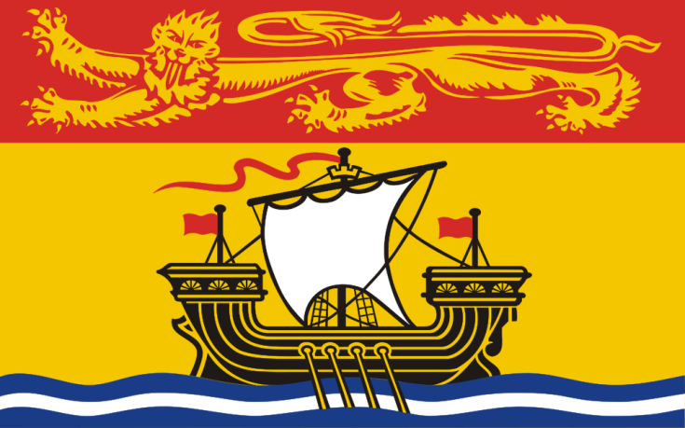 (January 2020)
- LEGISLATION, POLICIES, GUIDELINES

- Legislation:
  - NB Smoke Free Places Act
  - NB Tobacco and E-cigarette Sales Act
  - Motor Vehicle Act

- NB Department of Education and Early Child Development Policies :
  - Policy 120 Materials for Distribution in Schools
    - states tobacco-endorsed activities or ads are inappropriate for school
  - Policy 702 Tobacco Free Schools
    - incorporates other products such as tobacco like products such as cigarettes, cigars, pipes, etc.
  - Policy 315 School & Community Partnerships and Sponsorships
    - no alcohol, cannabis or tobacco sponsorships
  - Policy 407 Community Use of Schools
    - Contracts state that school is smoke/tobacco free campus
- Policy 513 Transportation to/from Off Site School Related Activities
- States not permitted to transport alcohol, and no tobacco, or smoking of any kind in vehicle
  - Policy 712 Search and Seizure
    - Students have a reasonable expectation of privacy

- School District:
  - Campaign against Tobacco, Vape and Cannabis Use
  - Scent Free Workplaces/Schools
  - Clearing the Air on Vaping Toolkit

- Public Health/Horizon Health Network’s Healthy Learners in School Program
  - Ottawa Model for Smoking Cessation

- RESOURCES, TOOLS, WORK PLANS, SUPPORTS

Peer-led Groups in Schools
- TATU (Teens Against Tobacco Use)
- SWAV or SWAT (Students Working Against Vaping/Tobacco)

Curriculum/Learning Outcomes
- To be provided by Department of Education and Early Child Development

Promising Approaches with Positive Results:
- School and Community Messaging with Cessation Nurse: In one community, smoking cessation nurse from local Health Center met with high school students as a resource consultant for smoke-free health promotion and community development. She advised SWAT team about key actions when applying for community grant to increase communication around tobacco use prevention, and to promote cessation. Youth at that school were able to reach out to her via e-communication to book an appointment. Evaluation results pending, but felt to be positive.

- Policy Awareness: Created district level committee to address vaping. Engaged bus drivers, custodians, subject leads, nurses working in the Healthy Learners in School Program, students, and school administrators to examine the issue of vape use among school aged youth. Created communications strategy and toolkit to educate and inform staff, students, parents and community partners. All high schools delivered an education program in September 2019, reinforced that Tobacco Free Schools Policy included vape products, and explained consequences for non-compliance. Communication sent to parents in writing, voice mail, social media, electronic messaging board, and newspapers. Provided information regarding the dangers of the product, and where to get help for addiction. Signage placed on all buses, all entrances to schools, and at entrances to washrooms. Evidence informed dialogues with youth were intentionally held. Policy compliance significantly improved, still working on increasing cessation resources and support.

- 4th R Healthy Relationships Plus Program: One school district obtained a grant to educate 8th grade teachers in the 4th R Healthy Relationships Plus Program. Pilot study demonstrated it met 8th grade health class curricular outcomes. This is an evidenced informed resource to promote positive youth development, through skill building for setting boundaries in peer relationships. Program focuses on refuse, delay negotiate skill development, with applications to substance use, interpersonal relationships, intimate relationships, etc. Plan to apply for funding to offer program training to 8th grade health teachers across the province.

- Be Smoke Free Conference: Students from several middle and high schools met to explore risks of tobacco and vape use. Through fun and interactive events, youth practiced refusal skills, learned about social media push marketing, busted mistruths and myths, and created action plans to implement in their schools.

- Wellness Passport: School wide or community wide application for 6-8 weeks. Participants earn points for each activity they complete in the passport. Activities involve events related to healthy eating (try a new vegetable, visit a Farmer’s Market, drinking water daily, etc.), physical activities (walking a local trail, trying a new sport, doing an activity with an elder, etc.), mental fitness (inviting someone to sit at your lunch table, writing a list of five things you do well, identifying two things you are thankful for at the end of each day, etc.) and substance free living (limiting screen time to 2hrs per day, writing out three ways to refuse substance offers, putting up a smoke free sign on your front door, etc.). Bonus points can be earned for doing activities with other generations, volunteering, or sleeping 8 hours per night.

School Improvement/District Improvement Plan Resources:
  - GoSmokeFree NB Cessation Resource
  - The LINK Program- where youth can access cessation support
  - Joint Consortium’s Vaping Toolkit
  - Joint Consortium’s Positive Mental Health Toolkit
  - Joint Consortium’s Youth Engagement Resource
  - Joint Consortiums Substance Use Toolkit
  - Healthy School Planner (JCSH)

School Resources:
May be used in classroom lessons, or in the environment to influence the social culture, or shared with parents/guardians/youth-serving organizations:
Elementary School Curriculum
  - CAMH “Smoking and Quitting: Clean Air For All” e-book for children
- Heart Healthy Schools K-6 (Heart & Stroke Foundation)
- Clearing the Air on Vaping Toolkit
- Eat Well, Be Active SMART Goals
- At My Best 4-5-6
- Teaming Up for Tobacco Free Kids

Middle School Curriculum
- Currently Under Review
- Trivia Games for Middle and High Schools about Tobacco, Vaping, Risky Behaviors, etc.
- 4th R Healthy Relationships Plus Program (for grade 8 health teachers, and guidance)

High School Curriculum

- Personal Development Career Planning

Youth Engagement Groups:
- TATU or SWAT Groups:
  - Tobacco Free Schools Action Guide
  - www.breakitoff.ca
  - Health Canada Know the Risk
  - Health Canada Consider the Consequences of Vaping
  - Canadian Cancer Society Think Before You Vape Campaign (videos and tools)
  - Stanford Medicine Tobacco Prevention Toolkit
  - SOS Safety Magazine for Youth
  - Get Smart About Tobacco Health And Science Education Program Scholastic
  - E-cigarettes What You Need to Know Teacher’s Guide Scholastic

Parent Engagement Resources:
- Cannabis Talk Kit (Drug Free Kids Canada)
- What Parents Need to Know About Teen Risk Taking (Canadian Association of Mental Health)
  - E-Cigarettes, Vaping Products and Flavoured Tobacco (New Brunswick Anti-Tobacco Coalition) – provided last year by Marlien

- EVALUATION OF IMPACTS
- Use this section to describe any evaluation plans, indicators, measures, and measurement tools your jurisdiction is using regarding to support and enhance use of school-based substance use education programs and activities, as well as upstream approaches.

- Logic Model for Vaping (OTRU) Shared indicators useful for school, family, and community to start dialogue about where changes can be made. OTRU’s Interventions to Prevent Harms from Vaping p. 25
- Healthy Learners in School Program’s Strategic Plan

Evaluation Data Sources:
  - Short term evaluation; School tracking of violations PowerSchool. Measured number of office referrals for vaping on school properties over time, able to target hot-spots and time of day using reporting data. This helped schools to plan for extra supervision for those areas, or ways to make physical/social environment non-conducive to vaping.
  - Medium term evaluation: Tell Them from Me Survey
  - Long term evaluation: New Brunswick Student Wellness Survey, and Canadian Drug, Alcohol, Tobacco Use Survey
  - Presence of tobacco education/prevention, or cessation as strategy on school or district improvement plan (#schools/total #schools in district)
  - Department of Social Development’s Public Health Inspector reports regarding tobacco sales compliance.
  - New Brunswick Health Council, community health indicators and protective factors
  - Canadian Tobacco Use Monitoring Survey (OTRU) Tool to explore datasets and documentation when data mining.
  - Achieving Tobacco Free Living: A Priority for New Brunswick
- Toolkit Evaluation: Horizon/Vitalité Vape Free Toolkit- evaluation component
- Individual school progress on TATU Group Action Plan. (Number of goals, strategies to meet goals, etc.)

- COMMON MESSAGING (Health, Education)
- Working to align messaging among health networks, Government of New Brunswick and Department of Education and Early Child Development
- Consulted with Center for Excellence in Tobacco Cessation, and Population Health Programming to ensure duplication is not occurring, and that evidence-informed best practices are employed in the school environment.
- New Brunswick Anti Tobacco Coalition’s Working Group Against Vaping—by collaborating with other health-serving organizations, we seek to achieve common goals against tobacco and vaping.

- CHALLENGES, NEEDS, QUESTIONS, AND SUCCESSES

- Resurrect Tobacco Education Programs

Unfortunately, globally we have eased off in the anti-tobacco education/uptake prevention efforts. This was part of the perfect storm that allowed vaping to insidiously take hold among our youth. Must resurrect the tobacco education programs and intentionally incorporate vaping; and have a mental fitness approach. This also means a need for additional Professional Development for teachers, health care workers, parents, coaches, community members.
- Cessation Programming:

Need a cessation program that can happen in schools, preferably through youth-serving organization or volunteers who are certified in tobacco cessation program. Watching the American Lung Association’s INDEPTH Program will debut and evaluation 2020.
- Community Engagement and Mobilization:

Need campaign tools to engage communities in helping youth to live healthy, smoke free lives. All citizens have a role in creating healthy environments that nurture youth.
- Financial Support for Front Line Activities:

Need grant funding to implement novel programming, and to engage youth and community partners in interventions
- Resources for Front Line Work:

Need copyright free resources, especially images--- that can be used/ modified/shared in health and education

Nova Scotia 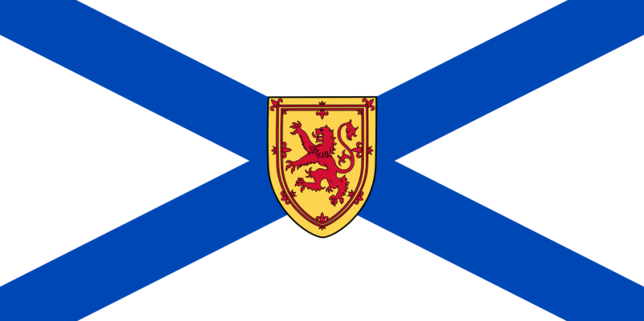
- LEGISLATION, POLICIES / GUIDELINES
- RESOURCES, TOOLS, AND SUPPORTS
- IMPLEMENTATION - EVALUTION OF IMPACTS
- COMMON MESSAGING (Health, Education)
- CHALLENGES, NEEDS, QUESTIONS, AND SUCCESSES

Prince Edward Island 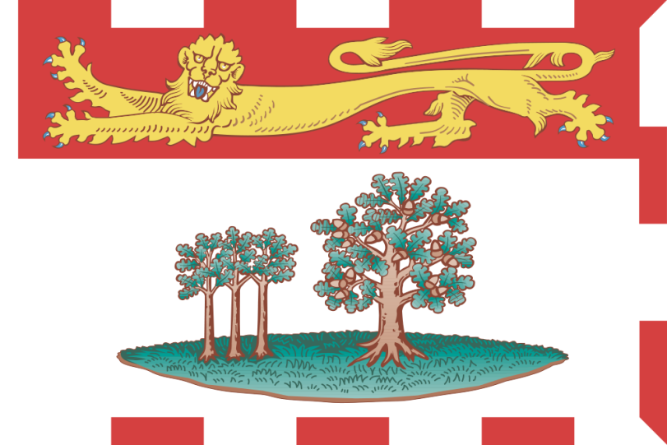 (September 2019)
- LEGISLATION, POLICIES / GUIDELINES
- RESOURCES, TOOLS, AND SUPPORTS
  - PEI Vaping Work Plan – September 16 2019
  - Know the Risks: Vaping and PEI Youth (PEI Tobacco Reduction Alliance - PETRA)
- IMPLEMENTATION - EVALUTION OF IMPACTS
- COMMON MESSAGING (Health, Education)
- CHALLENGES, NEEDS, QUESTIONS, AND SUCCESSES

Newfoundland and Labrador 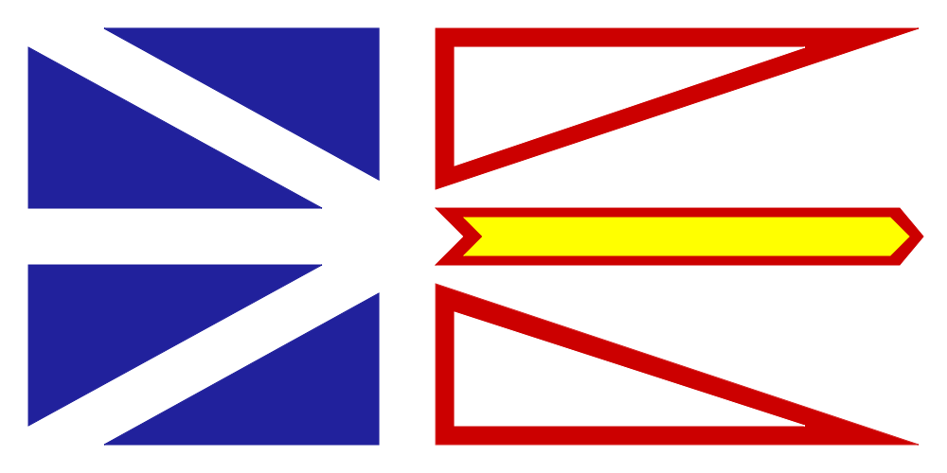
- LEGISLATION, POLICIES / GUIDELINES

NL TOBACCO AND VAPOUR PRODUCTS CONTROL ACT (amended in 2016 to include vapour products)

•aims to reduce the number of young people who begin to smoke by restricting youth access to tobacco, vapour and non-tobacco shisha products,

•makes it illegal for anyone, including retailers, family and friends, to give or sell tobacco, vapour and non-tobacco shisha products, to youth under the age of 19

•restricts how tobacco, vapour and non-tobacco shisha products, products can be displayed, stored and promoted at retail (Tobacco and Vapour Products Control Regulations)

•limits the type and number of establishments that sell tobacco, vapour and non-tobacco shisha

SMOKE-FREE ENVIRONMENT ACT 2005 (amended in 2016 to include vapour products)
  - Aims to protect the public and employees from exposure to second-hand smoke
  - Prohibits the use of e-cigarettes in indoor public places, workplaces and in motor vehicles carrying children under the age of 16
  - Smoking includes tobacco, vapour , water pipe/hookah, and cannabis products
  - Indoor public places include schools, daycares, shopping centers, recreation facilities, restaurants, bars, decks and bingo halls

NEWFOUNDLAND AND LABRADOR ENGLISH SCHOOL DISTRICT CANNABIS AND SMOKE-FREE POLICY

https://www.nlesd.ca/includes/files/policies/doc/1548691595907.pdf

- RESOURCES, TOOLS, AND SUPPORTS
In the fall of 2019 a Youth Vaping Prevention - Public Education and Awareness Campaign will be launched. The primary target audience is youth aged 13 - 18. The secondary audience includes educators, parents and health professionals. The goal is to reduce the uptake of vaping products among youth aged 13-18, with the initial awareness campaign focused on increasing awareness about the harms and risk associated with vaping products for this age group.
With funding and support from the Department of Children, Seniors and Social Development (CSSD), the Alliance for the Control of Tobacco (ACT) is leading the development and implementation of this campaign in partnership with key stakeholders. A working group has been formed to provide guidance, expertise and oversight. Members include NL English School District, Departments of Children Seniors and Social Development, Service NL and Education and Early Childhood Development, NL Federation of School Councils, Western Health and Memorial University.
Parent FAQ and an Administrator poster have been created, see attached.
- IMPLEMENTATION - EVALUTION OF IMPACTS
Using a Comprehensive School Health approach, the targeted school campaign will begin with a Vaping Awareness Day (October 2019) whereby Grade 7-12 classroom teachers across the province will deliver a standardized presentation on vaping to students. This includes the English and French School districts and private schools. Teacher's Toolkit includes a lesson plan, interactive presentation, speaking notes and backgrounder and FAQ on vaping.
To reinforce and sustain the classroom messages, School Administrators will also receive a tailored toolkit (e.g., Health Canada Consider the Consequences of Vaping posters, mirror clings, run ad on school monitors) and be encouraged to post the materials throughout the school, and to post the parent tip sheet to their school website and/or email directly to all parents.
Social media messaging and a Comprehensive School Health - Addressing Student Use of Vaping Products resource will also be provided as part of this toolkit. School Health Promotion Liaison Consultants and Regional Health Educators will provide ongoing support to schools. Messaging and resources targeting elementary schools will be developed. The working group supported phase one of Health Canada's provincial implementation of its Consider the Consequences of Vaping School Tour in March 2019. The tour visited nine schools in the province. Phase two, fall of 2019, will see the tour visit additional schools throughout the province.
A Vaping Awareness Orientation webinar for Community Health/Public Health Nurses, Mental Health and Addictions, and Child Health Consultants will be developed this fall. This is being coordinated in consultation with the NL English School District.
A Vaping Awareness Orientation webinar for health professionals who support schools (e.g, Community Health/Public Health Nurses, Mental Health and Addictions, and Child Health Consultants) is planned for October. They will be provided with a standardized parent presentation which can be used in response to request from schools.
A public multi-media awareness campaign will also be launched later in the fall and will include messages targeting parents.
An evaluation will be conducted on this campaign.
- COMMON MESSAGING (Health, Education)
Our messaging is in line with Health Canada’s Consider the Consequences campaign and is integrating and adapting messages and materials from Massachusetts Public Health’s, The New Look of Nicotine Addiction Campaign:
- The long-term health risks of vaping are unknown
- Vaping nicotine can lead to addiction. Nicotine can affect memory and concentration and is known to alter teen brain development
- Vaping can increase your exposure to chemicals that could harm your health (e.g. cause lung damage)
- Talk to your teens about vaping
- CHALLENGES, NEEDS, QUESTIONS, AND SUCCESSES

Nunavut (September 2019)
- LEGISLATION, POLICIES / GUIDELINES
The Tobacco Control and Smoke-Free Place Act recently amended its definition of “smoke”: "smoke" means to smoke, inhale or exhale vapour from, burn, carry, hold or otherwise have control over a lit or heated cigarette, cigar, pipe, water pipe, electronic cigarette or other device that burns or heats tobacco, cannabis or another substance that is intended to be smoked or inhaled.

All smoke-free buffer zones and smoke-free places now include vaping, which means all school properties across the territory are ‘vape free’.
Buffer zones – 9 Metres
- The legislation on smoking tobacco, vaping and consuming cannabis in public places has changed. The buffer zone around most work places and public places where goods and services are provided has increased from 3 to 9 meters. So you must be at least 9 metres away from any entrance to the building if you are smoking or vaping.

Smoke-free places
- The following places are smoke free, so you cannot smoke, vape, or consume cannabis in any form within 9 metres of their property:
    - a hospital, health centre, or public health office;
    - a day care;
    - a playground;
    - an arena, sports or playing field; and
    - a concert, feast, or other public event.

- RESOURCES, TOOLS, AND SUPPORTS
The Tobacco Has No Place Here Campaign video and teacher’s guide
These resources can help Nunavut teachers work with students. They explore how tobacco affects health, families and culture. The resources are suitable for students in grades 7-12.
https://nuquits.gov.nu.ca/sites/default/files/tobacco_teachers_guide_low_rev.pdf
The teacher’s guide includes basic information on vaping devices as well as a template for facilitating a class discussion about vaping.
Vaping Fact Sheet (Currently under development)
The fact sheet explores vaping key messaging, what is a vape, vaping as a means to quit smoking, health effects and current legislation associated with vaping.
- IMPLEMENTATION - EVALUTION OF IMPACTS
- COMMON MESSAGING (Health, Education)
- Young people and non-smokers should not vape.
- If you smoke, quitting smoking is the best thing you can do to improve your health.
- Smoking and vaping at the same time has greater health risks than using either substance alone.
- Completely replacing smoking with vaping is less harmful than smoking.
- Vaping products contain many chemicals that are harmful to your health.
- More research is needed to understand the long-term health effects of vaping.

- CHALLENGES, NEEDS, QUESTIONS, AND SUCCESSES

While the definition of smoke has been amended, the territory currently does not have any legislation pertaining to retail sales; therefore we default to federal legislation.

Northwest Territories
- LEGISLATION, POLICIES / GUIDELINES
- RESOURCES, TOOLS, SUPPORTS
- IMPLEMENTATION - EVALUATION OF IMPACTS
- COMMON MESSAGING (Health, Education)
- CHALLENGES, NEEDS, QUESTIONS, AND SUCCESSES

Yukon 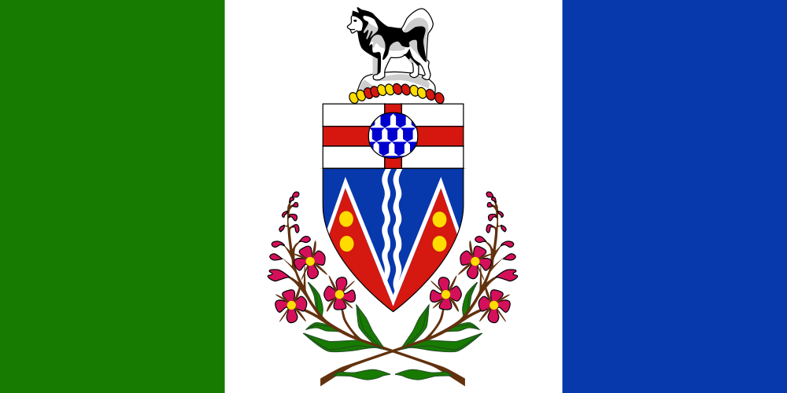

- LEGISLATION, POLICIES, GUIDELINES.
- RESOURCES, TOOLS, WORK PLANS, SUPPORTS
- EVALUATION OF IMPACTS
- COMMON MESSAGING (Health, Education)
- CHALLENGES, NEEDS, QUESTIONS, AND SUCCESSES

Public Health Agency of Canada

(A) SCHOOL-BASED MENTAL HEALTH LEGISLATION, POLICIES / GUIDELINES
(B) RESOURCES, TOOLS, SUPPORTS
(C) EVALUTION OF IMPACTS
(D) COMMON MESSAGING (Health, Education)
(E) CHALLENGES, NEEDS, QUESTIONS, AND SUCCESSES

National Resources

(A) VETTED AND APPROVED
- JCSH Vaping Resource for Schools
- E-Cigarettes in Canada (October 2018) (Heart and Stroke Foundation)
- Think Before You Vape (aimed at teens) (June 21 2016) (Canadian Cancer Society)
- Talking With Your Teen About Vaping (Published 2019-07-08) a Tip Sheet for Parents

(B) OTHER RESOURCES

International Resources

Journal (research, news) Articles

1. McCreary Centre Society: (2019)

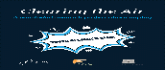
Clearing the Air: A youth-led research project about vaping
The Vaping Research Slam was a fast-paced weekend project during which YRA members and other young people investigated vaping among BC youth. Over two days, youth discussed their views on vaping; generated ideas to support youth who vape and to share the potential risks of vaping with their peers; analyzed data from the BC Adolescent Health Survey, and presented their findings and key messages to stakeholders.
Download / Infographic poster

2. O’Connor, S., Pelletier, H., Bayoumy, D., & Schwartz, R. (2019). Interventions to Prevent Harms from Vaping.
https://www.otru.org/wp-content/uploads/2019/05/special_vape_interventions.pdf

3. Cho, Y. J., Thrasher, J. F., Reid, J. L., Hitchman, S., & Hammond, D. (2019). Youth self-reported exposure to and perceptions of vaping advertisements: Findings from the 2017 International Tobacco Control Youth Tobacco and Vaping Survey. Preventive medicine, 126, 105775.
http://davidhammond.ca/wp-content/uploads/2018/03/2019-ITC-Youth-Vaping-Ad-Exposure-Prev-Med-Cho.pdf

4. Hammond, D., Reid, J. L., Rynard, V. L., Fong, G. T., Cummings, K. M., McNeill, A., ... & O’Connor, R. (2019). Prevalence of vaping and smoking among adolescents in Canada, England, and the United States: repeat national cross sectional surveys. bmj, 365, l2219.
https://www.bmj.com/content/365/bmj.l2219
5. Mehra, V. M., Keethakumar, A., Bohr, Y. M., Abdullah, P., & Tamim, H. (2019). The association between alcohol, marijuana, illegal drug use and current use of E-cigarette among youth and young adults in Canada: results from Canadian Tobacco, Alcohol and Drugs Survey 2017. BMC public health, 19(1), 1-10.
6.2% Canadians aged 15-24 reported using e-cigarettes in the past 30-days, while 23.9% reported having ever tried e-cigarettes. Twenty-three percent of the past 30-day users reported using e-cigarettes every day and 72.5% of the past 30-day users reported having nicotine in their last e-cigarette. Additionally, youth aged 15-17 were 4.95 times more likely to be e-cigarette users as compared to those aged 22-24 (OR: 4.95, 95% CI: 3.1-7.9). Moreover, e-cigarette use was significantly associated with marijuana use (OR:4.17, 95% CI: 2.6-6.7) and alcohol use (OR: 5.08, 95% CI: 2.9-9.0), and approached significance with illicit drug use (OR: 1.68, 95% CI: 1.0-2.9). Furthermore, being a current smoker (OR: 2.93, 95% CI: 1.8-4.7) and male (OR: 2.28, 95% CI: 1.5-3.4) was significantly associated with the outcome.
https://bmcpublichealth.biomedcentral.com/articles/10.1186/s12889-019-7546-y
6. The COMPASS Study
“COMPASS is an ongoing longitudinal study (started in 2012) designed to follow a prospective cohort of grade 9 to 12 students attending a convenience sample of Canadian secondary schools to better understand how changes in school environment characteristics (policies, programs, built environment) and provincial, territorial, and national policies are associated with changes in youth health behaviours. This special edition of the COMPASS brochure highlights current trends of youth e-cigarette use in Canada using the COMPASS data.”
https://uwaterloo.ca/compass-system/compass-system-projects/compass-study

