Addressing Substance Use and Abuse Prevention
in Health Education Curricula,
provincial/territorial programs,
community supports,
youth voice

A Jurisdictional Scan
January 2020

The request for an update of this scan began with an email request from Pat Martz in October 2019 for information from PTs on resources they have available on substance prevention / use / abuse / education.

Guidelines for Scan Completion
- LEGISLATION, POLICIES, GUIDELINES
- Note any overarching or supporting policies connected to school-based approaches or programs to address substance use/abuse/prevention; these could be at the provincial / territorial as well as the school board / district levels.

- RESOURCES, TOOLS, WORK PLANS, SUPPORTS
- List school-based substance use resources/tools used in your jurisdiction.
- List also any upstream approaches which have met with significant positive – or negative – responses
- Any curriculum or learning outcomes in your jurisdiction that have been connected to the education on substance use
- Development of peer-led groups in schools to discuss, provide education around substance use; other information on youth voice on the issue of substance use / abuse in a Province/Territory.

- EVALUATION OF IMPACTS
- Use this section to describe any evaluation plans, indicators, measures, and measurement tools your jurisdiction is using regarding to support and enhance use of school-based substance use education programs and activities, as well as upstream approaches.

- COMMON MESSAGING (Health, Education)

- CHALLENGES, NEEDS, QUESTIONS, AND SUCCESSES
- Use this section to describe any/all challenges, needs, questions, and successes. This section can also house a list of resources that may have not been vetted carefully by referring sources, resources that may be questioned before sharing because the content seems limited or not balanced, or written by companies funded by private sector partners.

British Columbia (2013)

(A) LEGISLATION, POLICIES / GUIDELINES
(B) RESOURCES, TOOLS, AND SUPPORTS
1. Provincially Recommended Learning Resources
- HealthSmart (grades K-3, 4-7)
- Making Decisions (grade 4)
- Health for Life 2 (grade 8)
- Exploring the Issues: Teens – Alcohol and Other Drugs (grades 8, 9, 10)
- Targeted! How Tobacco and Alcohol Companies Try to Get You Hooked (grade 8)
- Health Issues 9 (grade 9)
- Road Safety Package (grades 9, 10)
2. Provincial Programs:
Programs Provided in School Districts
- Cigarette Smoking Project (Vernon) - The Substance Abuse Prevention Program in SD#22 has developed this program for students who have been suspended for the use of tobacco products while under school jurisdiction. Includes fact-based information on the dangers of cigarette smoking, a smoking habit screening quiz to help to determine if the student has need for further consultation or help, a choice of one student assignment to complete, and a directory of places to get more information or help with quitting smoking. http://www.sd22.bc.ca/smoking/
- Alternative Intervention for Marijuana Suspension (AIMS) (Kelowna) - UBC Okanagan research project aligning the RCMP, Kelowna School District and Addiction Services to provide an alternative program for students. Consists of students completing a self-assessment and attending a one-hour counseling session: http://www.kelowna.ca/CM/page1161.aspx
- Project Resiliency (Langley) http://www.sd35.bc.ca/programs/counselling/default.aspx?ID=33
3. Community Supports
- iMinds – Developed by the Centre for Addiction Research BC to support a whole school approach to prevent substance use related harms and promote mental health. Includes development of classroom lesson plans (grades 6-10), a resource guide for teachers, teacher training and ongoing web support. http://www.carbc.ca/Publications/EducationResources/tabid/329/LiveAccId/10520/Default.aspx
- Provincial Outreach Program for Fetal Alcohol Spectrum Disorder (POPFASD) - Developed by the Ministry of Education to support teachers of students with FASD. Shares current FASD research, resources and successful practices and provides a network for teachers and others. The POPFASD website provides information, e-learning modules and resources for teachers. www.fasdoutreach.ca/
- RoadSense - Insurance Corporation of BC (ICBC) provides curriculum-based materials to BC schools, Grades K-10. The materials support road safety learning outcomes and emphasize the importance of 2 good decision-making skills. In the Grade 8, 9, and 10 materials there are lesson plans dealing with impaired driving (due to alcohol and drugs). Between March and May each year, ICBC speakers tour BC high schools. hhttp://www.icbc.com/road-safety/roadsafety-activities/educators
- Making Decisions - Developed by Alcohol and Drug Education Service (ADES), this learning resource (grades 4-9) is offered to BC schools. ADES plans to conduct a revision process for this resource along with a web friendly component. http://ades.bc.ca/resources/making_decisions.html
- ‘Through a Blue Lens’ - This video for youth on drug abuse is extensively used in BC schools, and was developed by a department of the Vancouver Police called the Odd Squad. http://www.oddsquad.com/
4. Youth Voice
- Drugfacts.ca http://www.drugfacts.ca/

(C) IMPLEMENTATION - EVALUTION OF IMPACTS
(D) COMMON MESSAGING (Health, Education)
(E) CHALLENGES, NEEDS, QUESTIONS, AND SUCCESSES

Alberta (2019)
- LEGISLATION, POLICIES / GUIDELINES
Kindergarten to Grade 9 (K–9) Health and Life Skills
In the K–9 Health and Life Skills program of studies, students learn about positive health habits, substance and abuse awareness, the importance of decision-making and refusal skills when offered inappropriate substances and examine and evaluate the impact of substance use on wellness. In the General outcome: Wellness Choices: Students will make responsible and informed choices to maintain health and to promote safety for self and others.
- W–K.6 recognize that some household substances may be harmful; e.g., medication, household products
- W–1.6 determine safe and responsible use of various household/ garage substances
- W–2.6 determine safe and responsible use of medications
- W–3.6 describe the importance of decision-making and refusal skills when offered inappropriate substances; e.g., drugs, tobacco, allergens
- W–4.6 examine and evaluate the health risks associated with smoking and various forms of tobacco
- W–5.6 examine and evaluate the impact of caffeine, alcohol and drugs on personal health/wellness; e.g., physical, emotional, social W–7.6 analyze social factors that may influence avoidance and/or use of particular substances
- W–7.6 analyze social factors that may influence avoidance and/or use of particular substances
- W–8.6 analyze possible negative consequences of substance use and abuse; e.g., fetal alcohol syndrome, drinking and driving
- W–9.6 analyze addictions; e.g., stages, kinds, and resources available to treat addictions

High School Career and Life Management (CALM)
At the high school level, the CALM program of studies enables students to evaluate choices that can create barriers to achieving and maintaining health, including the use and abuse of alcohol and drugs. Students also examine and explain the media’s role and influence over personal, emotional/spiritual expression, peer pressure and the use of alcohol and drugs.

- P2. evaluate choices and combinations of choices that can create barriers to achieving and maintaining health, and identify actions to improve health
  - appreciate the value of positive attitudes about self when making choices
  - analyze poor choices or lack of ability to pursue healthy choices and decisions
  - assess the effects of substance use and abuse—tobacco, alcohol, drugs—on health
- RESOURCES, TOOLS, AND SUPPORTS
1. Provincially Recommended Learning Resources
In Alberta, local school jurisdictions have the responsibility for the selection and approval of the resources teachers use in their classrooms. Jurisdictions may choose among the resources on the Education authorized resource lists (https://education.alberta.ca/applications/authorized-resources/), or they may choose other resources that support the Alberta programs of study. Generally, teachers are responsible for selecting resources to use in in their classrooms, in alignment with approval policies set by their school and jurisdiction
2. Provincial Programs:
- Leaps and Bounds (AB, Canada) – An Alberta Health Services School Health resource for Grades 4-6 (https://www.albertahealthservices.ca/amh/Page2682.aspx). Alberta Health Servcies provides other curriculum-aligned lesson plans and educational resources to provide students with knowledge and life skills that will empower them to make healthy choices about substance use and gambling, such as Alcohol: A Conversation, and Be Your Own Hero. https://www.albertahealthservices.ca/amh/Page2683.aspx
- Developing substance use and gambling use policies for Alberta schools. This guide was developed in direct response to requests from school principals and teachers who were looking for input and support in developing a school substance use and gambling policy. Schools can use the steps outlined in the guide to work through the policy development process. https://www.albertahealthservices.ca/assets/healthinfo/AddictionsSubstanceAbuse/if-tch-school-policy-manual.pdf
- Prevent Alcohol and Risk-Related Trauma in Youth (PARTY) Grade 9 students experience a full day session: listening to health-care workers describe the journey of a trauma patient listening to facts about brain and spinal cord injuries https://www.albertahealthservices.ca/findhealth/Service.aspx?serviceAtFacilityId=1005894
- The Academy for Tobacco Prevention – Alberta Quits. A targeted school based resource designed to engage and educate students about the harms of tobacco use and the benefits of never using tobacco products. https://www.albertaquits.ca/topics/teachers-and-school/the-academy-for-tobacco-prevention

- What about E-Cigarettes and Vaping – Alberta Quits. Designed to use with high school students by teachers or those who have relationships with youth already. This presentation uses evidence-based media literacy and social competence approached. https://www.albertaquits.ca/topics/teachers-and-school

- IMPLEMENTATION – EVALUTION OF IMPACTS
- COMMON MESSAGING (Health, Education)
- CHALLENGES, NEEDS, QUESTIONS, AND SUCCESSES

Saskatchewan (2013)
- LEGISLATION, POLICIES / GUIDELINES
- RESOURCES, TOOLS, AND SUPPORTS
1. Provincially Recommended Learning Resources
Drug education is a topic addressed in Health Education, which is one of the seven Required Areas of Study within Saskatchewan’s Core Curriculum. The renewed provincial health education curricula is designed on an inquiry for a healthy decision-making process that features students developing the understandings, skills, and confidences to negotiate information about drugs, make healthy decisions to improve the health of self, family, and/or community, and then designing and carry out a personal action plan to meet their goals related to avoiding, preventing, and/or reducing the risks and impact of drug use.

Students benefit from drug education that is addressed within a comprehensive provincial health education curriculum. Topics are presented at developmentally appropriate ages. For example, students in grade 3 learn how the misuse of helpful and the use of harmful substances affect the health of self and others, grade 5 students learn to prevent, avoid, and/or respond to negative peer pressure related to drugs, and in grade 9, students learn about the impact of addictions on the well-being of the individual, the family, and the community.

The provincial health education curriculum is designed to be implemented within a comprehensive school health framework that features health professionals, community organizations, and parents/caregivers supporting the school health education program and promoting the healthy development of children and youth through the school setting. This co-ordination reduces the ad hoc, sporadic, sometimes competing initiatives aimed at schools. Co-ordinated, sustained programs have significant, positive health and educational outcomes.

The provincial health education curricula incorporate a specific perspective through which health understandings, skills, and confidences are acquired. Each year, students gain understandings, skills, and confidences from a different perspective and these include:
Grade 6: Affirming Personal Standards
Grade 7: Committing Self
Grade 8: Supporting Others
Grade 9: Promoting Health

2. Provincial Programs:

3. Community Programs
- Fact Sheet: What to do if alcohol or drugs are causing problems in your teen’s life http://www.health.gov.sk.ca/adx/aspx/adxGetMedia.aspx?DocID=59c030e4-8bed-42d9-98b3-c5628af4a552&MediaID=5426&Filename=youth-recovery-fact-sheet-2011.pdf&l=English
- Adolescence Alcohol and Drugs: What Parents Need to Know http://www.health.gov.sk.ca/adx/aspx/adxGetMedia.aspx?DocID=1801,94,88,Documents&MediaID=5755&Filename=adolescence-alcohol-drugs.pdf&l=English

4. Youth Services

- IMPLEMENTATION – EVALUTION OF IMPACTS
- COMMON MESSAGING (Health, Education)
- CHALLENGES, NEEDS, QUESTIONS, AND SUCCESSES

Manitoba (2013)
- LEGISLATION, POLICIES / GUIDELINES
- RESOURCES, TOOLS, AND SUPPORTS
The question of prescription drug abuse is addressed in Manitoba through the Substance Use and Abuse Prevention strand of the Physical Education/Health Education curriculum which can be found here: http://www.edu.gov.mb.ca/k12/cur/physhlth/curriculum.html.
Learning outcomes for K-Grade 10 were introduced in 2000 while the Grade 11 outcomes were implemented in 2008.
Learning Outcomes include:
- Kindergarten and Grade 1 - students identify substances, such as medications and prescribed medicinal products that may be helpful or harmful.
- Grade 3 - students learn to identify and describe potential dangers as well as effects and consequences associated with substance abuse (including medicines). Factors that influence decisions regarding substance use are also examined.
- Grade 5 - students distinguish between medicinal and non-medicinal substances and appropriate use (including prescription drugs) as well as their effects and consequences. Peer, cultural, media, and social influences related to substance use and abuse are also identified.
- Grade 7 – students differentiate between the use and abuse of medicinal and non-medicinal substances with further focus on different consequences and the positive and negative social factors that may influence avoidance and/or use of substances.
- Grade 9 - students examine more of the potential consequences of substance use and abuse as well as identify community support agencies and resources.
- Grade10 - students analyze issues, including legal aspects and consequences, concerning the use and abuse of legal and illegal substances (including prescription drugs).
- Grade 11 - the goal is to reinforce the importance of avoiding the use and abuse of substances that may be harmful to self or to others, as taught in previous grades.
- IMPLEMENTATION – EVALUTION OF IMPACTS
- COMMON MESSAGING (Health, Education)
- CHALLENGES, NEEDS, QUESTIONS, AND SUCCESSES

Ontario 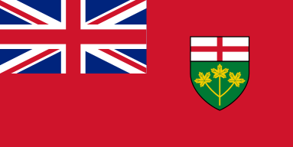 (2013)
- LEGISLATION, POLICIES / GUIDELINES
- RESOURCES, TOOLS, AND SUPPORTS\
- Educating Students about Drug Use and Mental Health: Curriculum Support for the Ontario Curriculum http://www.camh.net/education/resources_teachers_schools/drug_Curriculum/index.html
CAMH offers an integrated set of web based resources for teachers, schools and allied partners to utilize in their prevention/health promotion work with youth: Educating Students About Substance Use & Mental Health - Ready-to-Use Lesson Plans for Your Classroom. Ontario's Health and Physical Education Curriculum now has expectations related to substance use (grade 1-10) and mental health (grade 11-12). http://www.camh.net/curriculum.
- Talking about Mental Illness (TAMI) - An anti-stigma/education program for secondary school students, developed in collaboration with CMHA Ontario Division and Mood Disorders Association. Currently being implemented in 44 school boards across Ontario. http://www.camh.net/education/Resources_teachers_schools/TAMI/index.html
- Take Action Project – Developed by CAMH and Ontario Physical and Health Education Association (OPHEA), Take Action is a comprehensive, classroom-based program designed to support educators and engage school communities in teaching safety awareness regarding medicines and harmful substances and provides information about tobacco, alcohol and substance use through the integration of health and physical education expectations. www.ophea.net.
- Youth Scoop - A free series of tip sheets for child and youth serving professionals that summarize the latest research related to addiction and mental health issues. http://www.camh.net/education/Resources_teachers_schools/Youth%20Scoop/index.html

- IMPLEMENTATION – EVALUTION OF IMPACTS
- COMMON MESSAGING (Health, Education)
- CHALLENGES, NEEDS, QUESTIONS, AND SUCCESSES

Quebec (2013)
- LEGISLATION, POLICIES / GUIDELINES
- RESOURCES, TOOLS, AND SUPPORTS
Presently, the physical education and health section of the Educational program do not include any information about drugs for primary school. However, in secondary school, the physical education and health section of the Educational program include information related to drugs or other substances that is progressive with the age of the students (e.g. type of habits, type of substances discussed): Included in the information is:
- Detrimental lifestyle habits: Comparison of beneficial and detrimental effects of various substances: tobacco, drugs, alcohol, steroids, supplements, foods
- Effects of different substances on performance and training.
The Ethics and Religious cultures section of the Educational program includes content like the following examples:
- The distinction between what is acceptable and unacceptable in society and appropriate and inappropriate behaviour.
In grade 5-6 teachers are invited to talk about peer pressure in general and examples could include:
- A learning and evaluation situation involving thrill-seeking behaviour could be developed in order to help students become aware of the consequences of their personal choices on their health and well-being.
- A learning and evaluation situation that touches on the quest for happiness could help students reflect on each individual's need for affirmation, acceptance and personal development.
Overall, the health sector has not created any programs that focus specifically on prescription drugs to help teachers to discuss these issues. There are different programs on drugs as well as alcohol consumption though. For more information about the syntheses of recommendations for the school context, specifically the section on healthy lifestyle habits: alcohol, drugs, games of chance and gambling visit:
https://www.inspq.qc.ca/pdf/publications/1384_EducationalSuccessHealthWellBeingEffectiveActionInSchools.pdf.
Note: In Quebec grades are divided by cycles as follows:
Primary school cycle 1: Grade 1 and 2
Primary school cycle 2: Grade 3 and 4
Primary school cycle 3: Grade 5 and 6
Secondary school cycle 1: Grade 7 and 8
Secondary school cycle 2: Grade 9, 10 and 11

- IMPLEMENTATION – EVALUTION OF IMPACTS
- COMMON MESSAGING (Health, Education)
- CHALLENGES, NEEDS, QUESTIONS, AND SUCCESSES

New Brunswick 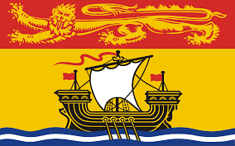 (January 2020)
- LEGISLATION, POLICIES, GUIDELINES

- Legislation:
  - NB Smoke Free Places Act
  - NB Cannabis Control Act
  - NB Tobacco and E-cigarette Sales Act
  - Motor Vehicle Act
  - Cannabis Control Act

- NB Department of Education and Early Child Development Policies :
  - Policy 120 Materials for Distribution in Schools
    - states tobacco-endorsed activities or ads are inappropriate for school
  - Policy 702 Tobacco Free Schools
    - incorporates other products such as tobacco like products such as cigarettes, cigars, pipes, etc.
  - Policy 315 School & Community Partnerships and Sponsorships
    - no alcohol, cannabis or tobacco sponsorships
  - Policy 407 Community Use of Schools
    - Contracts state that school is smoke/tobacco free campus
- Policy 513 Transportation to/from Off Site School Related Activities
- States not permitted to transport alcohol, and no tobacco, or smoking of any kind in vehicle
  - Policy 712 Search and Seizure
    - Students have a reasonable expectation of privacy

- School District:
  - Campaign against Tobacco, Vape and Cannabis Use
  - Scent Free Workplaces/Schools
  - Clearing the Air on Vaping Toolkit

- Public Health/Horizon Health Network’s Healthy Learners in School Program
  - Ottawa Model for Smoking Cessation

- RESOURCES, TOOLS, WORK PLANS, SUPPORTS

Peer-led Groups in Schools
- TATU (Teens Against Tobacco Use)
- SWAV or SWAT (Students Working Against Vaping/Tobacco)
- TADD Groups (Teens Against Drunk Driving)

Curriculum/Learning Outcomes
- To be provided by Department of Education and Early Child Development

Promising Approaches with Positive Results:
- School and Community Messaging with Cessation Nurse: In one community, smoking cessation nurse from local Health Center met with high school students as a resource consultant for smoke-free health promotion and community development. She advised SWAT team about key actions when applying for community grant to increase communication around tobacco use prevention, and to promote cessation. Youth at that school were able to reach out to her via e-communication to book an appointment. Evaluation results pending, but felt to be positive.

- Policy Awareness: Created district level committee to address vaping. Engaged bus drivers, custodians, subject leads, nurses working in the Healthy Learners in School Program, students, and school administrators to examine the issue of vape use among school aged youth. Created communications strategy and toolkit to educate and inform staff, students, parents and community partners. All high schools delivered an education program in September 2019, reinforced that Tobacco Free Schools Policy included vape products, and explained consequences for non-compliance. Communication sent to parents in writing, voice mail, social media, electronic messaging board, and newspapers. Provided information regarding the dangers of the product, and where to get help for addiction. Signage placed on all buses, all entrances to schools, and at entrances to washrooms. Evidence informed dialogues with youth were intentionally held. Policy compliance significantly improved, still working on increasing cessation resources and support.

- 4th R Healthy Relationships Plus Program: One school district obtained a grant to educate 8th grade teachers in the 4th R Healthy Relationships Plus Program. Pilot study demonstrated it met 8th grade health class curricular outcomes. This is an evidenced informed resource to promote positive youth development, through skill building for setting boundaries in peer relationships. Program focuses on refuse, delay negotiate skill development, with applications to substance use, interpersonal relationships, intimate relationships, etc. Plan to apply for funding to offer program training to 8th grade health teachers across the province.

- Be Smoke Free Conference: Students from several middle and high schools met to explore risks of tobacco and vape use. Through fun and interactive events, youth practiced refusal skills, learned about social media push marketing, busted mistruths and myths, and created action plans to implement in their schools.

- Wellness Passport: School wide or community wide application for 6-8 weeks. Participants earn points for each activity they complete in the passport. Activities involve events related to healthy eating (try a new vegetable, visit a Farmer’s Market, drinking water daily, etc.), physical activities (walking a local trail, trying a new sport, doing an activity with an elder, etc.), mental fitness (inviting someone to sit at your lunch table, writing a list of five things you do well, identifying two things you are thankful for at the end of each day, etc.) and substance free living (limiting screen time to 2hrs per day, writing out three ways to refuse substance offers, putting up a smoke free sign on your front door, etc.). Bonus points can be earned for doing activities with other generations, volunteering, or sleeping 8 hours per night.

School Improvement/District Improvement Plan Resources:
  - GoSmokeFreeNB Cessation Resource
  - The LINK Program- where youth can access cessation support
  - Joint Consortium’s Vaping Toolkit
  - Joint Consortium’s Positive Mental Health Toolkit
  - Joint Consortium’s Youth Engagement Resource
  - Joint Consortiums Substance Use Toolkit
  - Healthy School Planner (JCSH)

School Resources:
May be used in classroom lessons, or in the environment to influence the social culture, or shared with parents/guardians/youth-serving organizations:
Elementary School Curriculum
  - CAMH “Smoking and Quitting: Clean Air For All” e-book for children
- Heart Healthy Schools K-6 (Heart & Stroke Foundation)
- Clearing the Air on Vaping Toolkit
- Eat Well, Be Active SMART Goals
- At My Best 4-5-6
- Teaming Up for Tobacco Free Kids

Middle School Curriculum
- Currently Under Review
- Trivia Games for Middle and High Schools about Tobacco, Vaping, Risky Behaviors, etc.
- 4th R Healthy Relationships Plus Program (for grade 8 health teachers, and guidance)

High School Curriculum

- P.A.R.T.Y. (Prevent Alcohol Related Trauma in Youth) Program
- Personal Development Career Planning

Youth Engagement Groups:
- TATU or SWAT Groups:
  - Tobacco Free Schools Action Guide
  - www.breakitoff.ca
  - Health Canada Don’t Drive High
  - Health Canada Know the Risk
  - Health Canada Know More Campaign (Opioid Dependence)
  - Health Canada Consider the Consequences of Vaping
  - Canadian Cancer Society Think Before You Vape Campaign (videos and tools)
  - Stanford Medicine Tobacco Prevention Toolkit
  - SOS Safety Magazine for Youth
  - Get Smart About Tobacco Health And Science Education Program Scholastic
  - E-cigarettes What You Need to Know Teacher’s Guide Scholastic

Parent Engagement Resources:
- Cannabis Talk Kit (Drug Free Kids Canada)
- Together Let’s Start the Conversation About Cannabis (video, brochures) for coaches, athletes, parents
- What Parents Need to Know About Teen Risk Taking (Canadian Association of Mental Health)
- WWW.weedmyths.ca (Mental Health Foundation of Nova Scotia with the Nova Scotia Early Psychosis Program)
- Healthy Canadian Channel: Questions About Cannabis
- What the RCMP want Youth to Know Infographic (Poster for class)

- EVALUATION OF IMPACTS

- Logic Model for Vaping (OTRU) Shared indicators useful for school, family, and community to start dialogue about where changes can be made. OTRU’s Interventions to Prevent Harms from Vaping p. 25
- Building on Our Strengths- Canadian Standards for School-based Youth Substance Use Prevention. A Guide for Educators and Health Personnel
- Healthy Learners in School Program’s Strategic Plan

Evaluation Data Sources:
  - Short term evaluation; School tracking of violations PowerSchool. Measured number of office referrals for vaping on school properties over time, able to target hot-spots and time of day using reporting data. This helped schools to plan for extra supervision for those areas, or ways to make physical/social environment non-conducive to vaping.
  - Medium term evaluation: Tell Them from Me Survey
  - Long term evaluation: New Brunswick Student Wellness Survey, and Canadian Drug, Alcohol, Tobacco Use Survey
  - Presence of tobacco education/prevention, or cessation as strategy on school or district improvement plan (#schools/total #schools in district)
  - Department of Social Development’s Public Health Inspector reports regarding tobacco sales compliance.
  - New Brunswick Health Council, community health indicators and protective factors
  - Canadian Tobacco Use Monitoring Survey (OTRU) Tool to explore datasets and documentation when data mining.
  - Achieving Tobacco Free Living: A Priority for New Brunswick
- Toolkit Evaluation: Horizon/Vitalité Vape Free Toolkit- evaluation component
- Individual school progress on TATU Group Action Plan. (Number of goals, strategies to meet goals, etc.)

- COMMON MESSAGING (Health, Education)
- Working to align messaging among health networks, Government of New Brunswick and Department of Education and Early Child Development
- Consulted with Center for Excellence in Tobacco Cessation, and Population Health Programming to ensure duplication is not occurring, and that evidence-informed best practices are employed in the school environment.
- New Brunswick Anti Tobacco Coalition’s Working Group Against Vaping—by collaborating with other health-serving organizations, we seek to achieve common goals against tobacco and vaping.

- CHALLENGES, NEEDS, QUESTIONS, AND SUCCESSES

- Resurrect Tobacco Education Programs

Unfortunately, globally we have eased off in the anti-tobacco education/uptake prevention efforts. This was part of the perfect storm that allowed vaping to insidiously take hold among our youth. Must resurrect the tobacco education programs and intentionally incorporate vaping; and have a mental fitness approach. This also means a need for additional Professional Development for teachers, health care workers, parents, coaches, community members.
- Cessation Programming:

Need a cessation program that can happen in schools, preferably through youth-serving organization or volunteers who are certified in tobacco cessation program. Watching the American Lung Association’s INDEPTH Program will debut and evaluation 2020.
- Community Engagement and Mobilization:

Need campaign tools to engage communities in helping youth to live healthy, smoke free lives. All citizens have a role in creating healthy environments that nurture youth.
- Cannabis Education:

Since cannabis has been legalized, need to incorporate into curriculum; and to get more community messaging out. Need for both prevention and harm reduction type messaging.
- Financial Support for Front Line Activities:

Need grant funding to implement novel programming, and to engage youth and community partners in interventions
- Resources for Front Line Work:

Need copyright free resources, especially images--- that can be used/ modified/shared in health and education

Nova Scotia 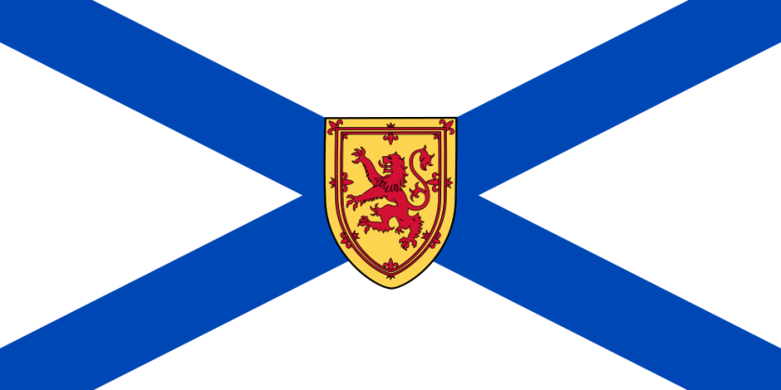 (2013)

- LEGISLATION, POLICIES / GUIDELINES
In Nova Scotia, Department of Education and Early Childhood Development is working with partners to determine how best to address the prescription drug issue. A point of contention is at what grade level prescription drug abuse should be addressed. Currently, it is included in our grade 9 curriculum. There is significant pressure from parents and community spokespersons to include this as early as grade 6 in our health education curriculum.
It is important to ensure that substance abuse topics are addressed in the right way at the right time and addressing some substance abuse topics too early can result in increasing students' interest in experimentation, not preventing abuse. Decisions need to be based on when to address particular aspects of substance abuse on the best available epidemiological data from the Nova Scotia Department of Health and Wellness. Presently being used are studies such as the Cross-Canada Report on Student Alcohol and Drug Use and surveillance data from the Nova Scotia Student Drug Use Survey (students in grades 7,9, 10, and 12) to prioritize and focus substance use prevention awareness and education. Informed by best practice, drug education in NS begins in grade primary.
Attention is paid to risk behavior just prior to their onset, based students' behavioral development and use patterns. These include:
- Inoculation (prevention efforts aimed at deterring or delaying the onset on use): prior to the average age of first use of a substance but when interest in the substance is occurring (e.g., for alcohol, about ages 11-12 years/grades 5-6)
- Early relevance: when most students are experiencing initial exposure and some are experimenting with the substance (e.g., for alcohol about 13-14 years of age/grades 7-8)
- Later relevance: when students are exposed to higher risk forms of use, different situations, and/or different substances (grade 9)
- RESOURCES, TOOLS, AND SUPPORTS
- IMPLEMENTATION – EVALUTION OF IMPACTS
- COMMON MESSAGING (Health, Education)
- CHALLENGES, NEEDS, QUESTIONS, AND SUCCESSES

Prince Edward Island 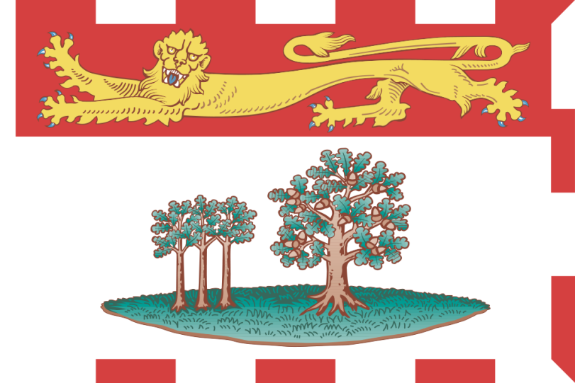 (2013)
- LEGISLATION, POLICIES / GUIDELINES
- RESOURCES, TOOLS, AND SUPPORTS

Wellness Choices: General Curriculum Outcome: Students will make responsible and informed choices to maintain health and to promote safety for self and others.
Specific Curriculum Outcomes for Personal Health: Students are expected to:
Grade2: Demonstrate an understanding of responsible use of medicine Grade 3: Describe the importance of decision-making and refusal skills when offered inappropriate substances
Grade 5: Examine and evaluate the impact of caffeine, alcohol, and drugs on personal health/wellness
Grade 6: Analyze how laws, regulations, and rules contribute to health and safety practices
Grade 7: Analyze social factors that may influence avoidance and/or use of particular substances
Grade 8: Identify possible negative consequences of substance use and abuse
Demonstrate an understanding of the effect of harmful involvement with alcohol, cannabis, and other drugs on a family
Develop strategies to effectively access health information and health services in the community
Grade 9: Identify several risks associated with use of alcohol, cannabis, and other drugs
Identify several signs and stages of dependence on a substance
Identify several strategies for helping a friend who is having problems with alcohol or other drugs
Identify ways that laws and community-based services support the treatment of addictions
Draft outcomes for physical education 10 - Students are expected to:
Assess the impact of mental health on overall well-being of self, family, and community
Optional outcome - Design a plan to address community well-being
Youth Substance Use Programs:
Strength Program: http://www.justtalkpei.ca/images/PEI%20Health_Strength_Program.pdf
Youth Voice:
http://www.justtalkpei.ca/uploads/posters/YouthAddiction_11x17_Girl.pdf
http://www.justtalkpei.ca/uploads/posters/cathy.pdf
http://www.justtalkpei.ca/uploads/posters/bob.pdf
http://www.justtalkpei.ca/uploads/posters/sally.pdf
http://www.justtalkpei.ca/uploads/posters/YouthAddiction_11x17_Boy.pdf

- IMPLEMENTATION – EVALUTION OF IMPACTS
- COMMON MESSAGING (Health, Education)
- CHALLENGES, NEEDS, QUESTIONS, AND SUCCESSES

Newfoundland and Labrador 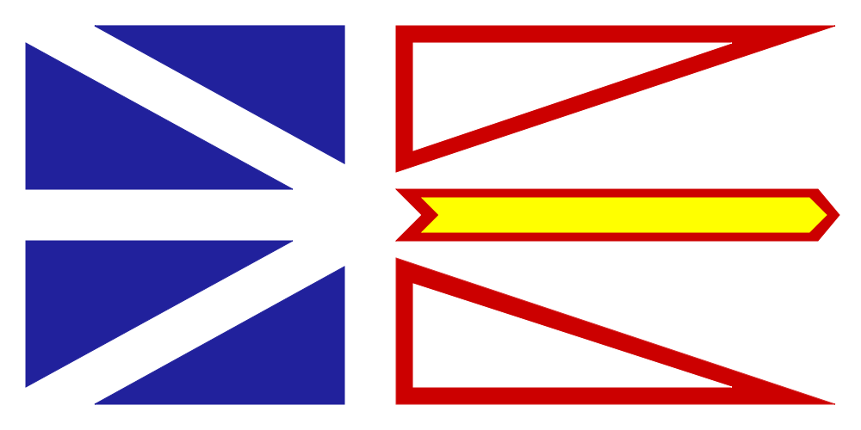 (2013)

- LEGISLATION, POLICIES / GUIDELINES
- RESOURCES, TOOLS, AND SUPPORTS
Health/Family Studies K-12 Curricula: Prescription Drug Abuse Related Outcomes
General outcome:
- Partnership with RCMP to carry out the Drug Abuse Resistance Education (D.A.R.E.) program with grade 6 students.
Primary Health: At the primary level, the drug education focus is primarily within the home with an emphasis on medications. As the student nears the end of primary schooling, the focus broadens to raise awareness about situations that could arise outside the home.
Kindergarten and Grade 1: “Unit 4. All Around Me: My Environment” puts a focus on the home with regards to prescription drugs; identifying them as a hazard and the action required to promote personal safety. The outcomes in this unit, by grade, are:
Kindergarten:
- understand that some products commonly found in homes may be harmful if ingested, touched or smelled (medications)
Grade 1:
- identify safety practices employed in the home related to hazards (medicine)
Grade 2: “Unit 4. All Around Me: My Environment”, strives to expand student awareness of drugs beyond the home environment. The outcomes in this unit are:
- understand that medicines contain drugs
- identify dangerous substances around the home
- know how to respond when offered candy or unknown substances by other children or adults
- know when it is safe to accept food or candy from others
- identify certain situations when children need to take medication while in school
Grade 3: The Drug Education component at this grade level promotes the development of knowledge and skills that will enable young people to make responsible decisions regarding drugs. Special attention is given to developing and practicing communication, refusal, decision-making and problem-solving skills. The outcomes in this component are:
- identify common over-the-counter drugs
- understand that some over-the-counter drugs have many questionable value but sometimes are necessary to relieve symptoms of minor ailments
- know how the pharmacist can help when choosing over-the-counter medication
- realize that people sometimes use drugs for non-medicinal purposes
- identify ways that drugs are administered: oral, injections.
- recognize that some drugs may have unpleasant or dangerous side effects
- understand the need for safe handling of medicines
- know that certain combinations of drugs may be life threatening
Elementary: Drug Education focuses on how the body and different drugs interact and how
personal choices about drugs affect the well-being of self and others. The Drug Education component is relevant to the specific needs of children in this province in terms of the impact of drug use, misuse, abuse and chemical dependency. There is an emphasis on identification, prevention, treatment and the legal implications of substance abuse. The outcomes for the Drug Education component, by grade level, are listed below:
Grade 4 Health:
- relate the major functions of medicines and the importance of safe use and handling
- know that the most reliable sources of prescription drugs are doctors, nurses, and pharmacists
- identify some reasons why people use drugs for non-medicinal purposes,
- recognize that nicotine and caffeine are drugs
- identify the reasons why people do or do not smoke
- discuss some of the physiological effects of smoking
- describe the short term and long term effects of smoking
- identify a number of activities to do instead of smoking
- outline the effects of environmental tobacco smoke (ETS)
- suggest ways to protect oneself from environmental tobacco smoke (ETS)
- practice ways to say “no” to drugs
Grade 5 Health:
- outline where and how to obtain accurate information regarding medicines
- understand that food/drink can affect the potency of certain drugs, thus the
- need to follow prescriptions accurately
- realize that alcohol is a drug (depressant)
- identify reasons for drinking and not drinking alcohol
- outline the effects of occasional drinking, regular usage and prolonged usage
- identify commonly used inhalants
- develop awareness of the danger of inhalants
- identify reasons for using and not using mood-altering inhalants
- identify alternate ways to deal with personal problems
- demonstrate a variety of refusal skills
- identify some constructive activities to do instead of using substances, and
- discuss the reasons for laws on drugs and drug abuse
Grade 6 Health:
- evaluate advertising techniques used to convince people to smoke cigarettes and consume alcohol
- discuss the personal and societal cost of smoking, drinking and other drug use
- identify alternative uses for money not spent on tobacco and alcohol
- identify street drugs and their effects on health and well-being
- identify alternatives to drug usage
- recognize the potential for addiction to tobacco and alcoholic beverages
- practice problem-solving and decision-making skills for preventing substance use and abuse
- practice refusal skills
- identify community resources that offer prevention and treatment services for substance abuse,
- recognize that criminal activity is sometimes related to drug abuse
Intermediate Health: In grades 7-8, the drug education component is broken down into Smoking and Alcohol in grade 7 and Alcohol and Other Drugs in grade 8. In grade 9, students apply drug education concepts and skills to relationships. The outcomes for grades 7-9 are as follows:
Grade 7:
- To understand that tobacco contains and addictive drug and other chemicals that effect health
- To identify reasons why people choose to smoke or not to smoke.
- To be aware of the immediate and long-term effects of cigarette smoking, both physical, social and psychological.
- To understand the effects of second-hand and side-stream smoke.
- To understand the influence of advertising on smoking behavior.
- To recognize the rights of smokers and non-smokers.
- To use the decision-making model with regard to tobacco use.
- To identify and practice refusal skills with regard to smoking.
- To promote and encourage appropriate health-related practices.
- To be aware of the laws pertaining to tobacco use.
- To be aware of the immediate and long-term benefits of cessation.
- To identify programs and methods used by smokers in an effort to quit smoking.
Grade 8:
- To distinguish between facts and myths with regards to drugs and alcohol.
- To be aware of the dangers of combining alcohol and other drugs.
- To have an appreciation of the role of drugs in our society.
- To distinguish between drug use, drug misuse, and drug abuse and drug dependence.
- To be aware of the physical and psychological potential for dependence on drugs.
- To be aware of how advertising and the media influence decisions regarding drug use.
- To be aware of Canadian laws relating to the possession, use and sale of drugs.
- To be aware of alternatives to drug abuse/use.
- To consider personal, societal and familial values with respect to the use of drugs.
- To be aware of sources of help for drug-dependent persons
- To be aware of the part that decision making plays in drug use and abuse and to practice assertiveness and refusal in this area.
Grade 9:
- To analyze influences on dating behaviors.
- To develop effective communication skills to assist in maintaining personal values and coping with other issues that may arise in dating relationships.
- To assess the effect of high-risk dating practices on overall wellness.
- To identify healthy ways of coping with stress.
- To apply the decision-making process to common scenarios.

- IMPLEMENTATION – EVALUTION OF IMPACTS
- COMMON MESSAGING (Health, Education)
- CHALLENGES, NEEDS, QUESTIONS, AND SUCCESSES

Nunavut 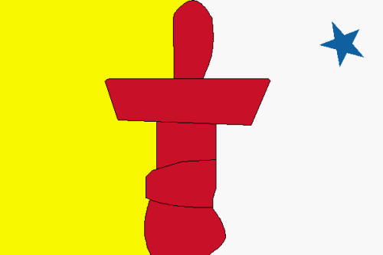
- LEGISLATION, POLICIES / GUIDELINES
- RESOURCES, TOOLS, AND SUPPORTS
- IMPLEMENTATION – EVALUTION OF IMPACTS
- COMMON MESSAGING (Health, Education)
- CHALLENGES, NEEDS, QUESTIONS, AND SUCCESSES

Northwest Territories
- LEGISLATION, POLICIES / GUIDELINES
- RESOURCES, TOOLS, AND SUPPORTS
- IMPLEMENTATION – EVALUTION OF IMPACTS
- COMMON MESSAGING (Health, Education)
- CHALLENGES, NEEDS, QUESTIONS, AND SUCCESSES

Yukon 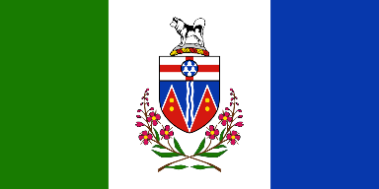
- LEGISLATION, POLICIES / GUIDELINES
- RESOURCES, TOOLS, AND SUPPORTS
- IMPLEMENTATION – EVALUTION OF IMPACTS
- COMMON MESSAGING (Health, Education)
- CHALLENGES, NEEDS, QUESTIONS, AND SUCCESSES

Public Health Agency of Canada

(A) LEGISLATION, POLICIES / GUIDELINES
(B) RESOURCES, TOOLS, SUPPORTS
(C) EVALUTION OF IMPACTS
(D) COMMON MESSAGING (Health, Education)
(E) CHALLENGES, NEEDS, QUESTIONS, AND SUCCESSES

National Resources

- JCSH Resources: Addressing Substance Use in Schools
  - Effective Substance Use Policy. A knowledge kit for School Administrators (2009)
  - School-Family-Community Partnerships. A knowledge kit for School and Community Leaders (2009)
  - Responding to the Needs of Higher Risk Youth. A knowledge kit for Counsellors and Health Workers (2009)
  - Effective Substance Use Education. A knowledge kit for Teachers (2009)

- National Anti-Drug Strategy: Use Your Voice http://www.nationalantidrugstrategy.gc.ca/prevention/youth-jeunes/speak-exprime/index.html

- 3 Virtual Party - An interactive web-based resource, developed by youth, for youth. An educational tool aimed at offering information in an interactive story, promoting healthy choices and reducing risky behaviour related to alcohol use. Targeted to youth 13-19 years of age. www.virtual-party.org

International Resources
- School Health and Alcohol Harm Reduction Project (Australia) - Teacher’s Manual, Student Workbooks I and II. http://www.ndri.curtin.edu.au/shahrp/download.html

- MindMatters: Mental Health Promotion Resource for Secondary Schools (Australia) http://www.mindmatters.edu.au/resources_and_downloads/resources_landing.html

- The Gatehouse Project (Australia) - A well-evaluated initiative focused on Grade 8 students in 26 schools in Melbourne, Australia that aimed to improve the emotional well-being of secondary students through individual- and environment-focused approaches.

- NIDA Goes Back to School (USA) - Specialized curricula and other teaching aids http://backtoschool.drugabuse.gov/

- The Seattle Social Development Project (USA) - A universal intervention for students in Grades 1-6 that combines parent training with modified teaching practices. http://depts.washington.edu/ssdp/

- The Child Development Project (USA) - This program is intended to transform schools into “caring communities of learners”. http://www.cdp.auburn.edu/

