Sexual Violence, Misconduct

Environmental Scan

January 2020

The request for this scan came from Scott Beddall (BC) : have we done any JCSH scans on the topic of addressing sexual violence/misconduct in schools? We are doing some work in this area and were interested in finding out if any of the other PTs had developed any initiatives or resources....
Guidelines for Scan Completion
- LEGISLATION, POLICIES / GUIDELINES
- Note any overarching or supporting policies; these could be at the provincial / territorial as well as the school board / district levels.

- RESOURCES, TOOLS, AND SUPPORTS
- List resources/tools used in your jurisdiction to address sexual violence/misconduct in school communities.
- Are there any curriculum or learning outcomes in your jurisdiction that have elements to address sexual violence/misconduct?
- Does your jurisdiction’s school boards/divisions, schools have school-based peer support groups to address sexual violence/violence?

- EVALUATION OF IMPACTS
- Use this section to describe any evaluation plans, indicators, measures, and measurement tools your jurisdiction is using to support and enhance education/initiatives to address sexual violence/misconduct. Does your jurisdiction have targets? Does your jurisdiction have any results to share?

- COMMON MESSAGING (Health, Education)

- CHALLENGES, NEEDS, QUESTIONS, AND SUCCESSES
- Use this section to describe any/all challenges, needs, questions, and successes.

British Columbia

(A) LEGISLATION, POLICIES / GUIDELINES
(B) RESOURCES, TOOLS, AND SUPPORTS
- Partner Resources
- School District Developed Resources
(C) IMPLEMENTATION --EVALUTION OF IMPACTS
(D) COMMON MESSAGING (Health, Education)
- CHALLENGES, NEEDS, QUESTIONS, AND SUCCESSES

Alberta (Jan 2020)

(A) LEGISLATION/POLICIES / GUIDELINES / STANDARDS:

The ministry of Education doesn’t collect information on student-led sexual violence/misconduct or have policies/guidelines in place; however, individual schools and/or school authorities may; the development of these is determined by each school/school authority.

Individual school authority websites may display their school policies.

(B) RESOURCES, TOOLS, AND SUPPORTS
- Partner Resources
- School District Developed Resources

(C) IMPLEMENTATION – EVALUTION OF IMPACTS
(D) COMMON MESSAGING (Health, Education)

(E) CHALLENGES, NEEDS, QUESTIONS, AND SUCCESSES

Saskatchewan

(A) LEGISLATION / POLICIES / GUIDELINES / STANDARDS:
(B) RESOURCES, TOOLS, AND SUPPORTS
- Partner Resources
- School District Developed Resources
(C) IMPLEMENTATION -- EVALUTION OF IMPACTS
(D) COMMON MESSAGING (Health, Education)
(E) CHALLENGES, NEEDS, QUESTIONS, AND SUCCESSES

Manitoba

(A) LEGISLATION / POLICIES / GUIDELINES / STANDARDS:
(B) RESOURCES, TOOLS, AND SUPPORTS
- Partner Resources
- School District Developed Resources
(C) IMPLEMENTATION - EVALUATION OF IMPACTS
(D) COMMON MESSAGING (Health, Education)

(E) CHALLENGES, NEEDS, QUESTIONS, AND SUCCESSES

Ontario (January 2020)

(A) LEGISLATION / POLICIES / GUIDELINES / STANDARDS:
Policy/Program Memorandum 128: The Provincial Code of Conduct and School Board Codes of Conduct (PDF)
A school should be a place that promotes responsibility, respect, civility, and academic excellence in a safe learning and teaching environment. A positive school climate exists when all members of the school community feel safe, included, and accepted, and actively promote positive behaviours and interactions.
The Provincial Code of Conduct
Purposes of the Code
Subsection 301(1) of Part XIII of the Education Act states that “the Minister may establish a code of conduct governing the behaviour of all persons in schools”. Subsection 301(2) sets out the purposes of this provincial code of conduct, as follows:
- To ensure that all members of the school community, especially people in positions of authority, are treated with respect and dignity.
- To promote responsible citizenship by encouraging appropriate participation in the civic life of the school community.
- To maintain an environment where conflict and difference can be addressed in a manner characterized by respect and civility.
- To encourage the use of non-violent means to resolve conflict.
- To promote the safety of people in the schools.
- To discourage the use of alcohol, illegal drugs and, except by a medical cannabis user,9 cannabis.
- To prevent bullying in schools.
The provincial Code of Conduct sets clear provincial standards of behaviour. These standards of behaviour apply to students whether they are on school property, in a virtual learning environment, on school buses, at school-related events or activities, in before-and after-school programs, or in other circumstances that could have an impact on the school climate. They also apply to all individuals involved in the publicly funded school system – principals, teachers, early childhood educators, other school staff, parents, school bus drivers, volunteers, and members of various community groups.
All members of the school community must not:
- engage in bullying behaviours, including cyberbullying;
- commit sexual assault;
- traffic in weapons or illegal drugs;
- give alcohol or cannabis to a minor;
- commit robbery;
- be in possession of any weapon, including firearms;
- use any object to threaten or intimidate another person;
- cause injury to any person with an object;
- be in possession of, or be under the influence of alcohol, cannabis (unless the individual has been authorized to use cannabis for medical purposes), and illegal drugs;
- provide others with alcohol, illegal drugs, or cannabis (unless the recipient is an individual who has been authorized to use cannabis for medical purposes);
- inflict or encourage others to inflict bodily harm on another person;
- engage in hate propaganda and other forms of behaviour motivated by hate or bias;
- commit an act of vandalism that causes extensive damage to school property or to property located on the premises of the school.
Policy/Program Memorandum 145: “Progressive Discipline and Promoting Positive Student Behaviour” defines serious student incidents as activities for which suspension or expulsion must be considered, as set out in subsections 306(1) and 310(1) of the Education Act.
A principal shall suspend a pupil if he or she believes that the pupil has engaged in any of the following activities while at school, at a school-related activity or in other circumstances where engaging in the activity will have an impact on the school climate:

1. Possessing a weapon, including possessing a firearm.

2. Using a weapon to cause or to threaten bodily harm to another person.

3. Committing physical assault on another person that causes bodily harm requiring treatment by a medical practitioner.

4. Committing sexual assault.

5. Trafficking in weapons or in illegal drugs.

6. Committing robbery.

7. Giving alcohol or cannabis to a minor.

7.1 Bullying, if,
i. the pupil has previously been suspended for engaging in bullying, and
ii. the pupil’s continuing presence in the school creates an unacceptable risk to the safety of another person.

7.2 Any activity listed in subsection 306 (1) that is motivated by bias, prejudice or hate based on race, national or ethnic origin, language, colour, religion, sex, age, mental or physical disability, sexual orientation, gender identity, gender expression, or any other similar factor.

8. Any other activity that, under a policy of a board, is an activity for which a principal must suspend a pupil and, therefore in accordance with this Part, conduct an investigation to determine whether to recommend to the board that the pupil be expelled.

The Provincial Model for a Local Police/ School Board Protocol (2015)

A safe, inclusive, and equitable school environment fosters and supports learning and the ongoing development of respect, responsibility, civility, and other positive behaviours and characteristics. An effective school-police partnership plays an important part in safeguarding these qualities and promoting a positive school climate.

At the root of effective school-police partnerships is a common understanding of each partner’s roles and responsibilities, as well as agreed-upon procedures and clearly delineated decision-making authority. Providing the best possible education for students in a safe school community is a shared responsibility that requires a commitment to collaboration, cooperation, and effective communication.

The following incidents require mandatory reporting to police. (Note: For considerations regarding students under the age of 12, refer to section 16 below.) Note that mandatory police reporting does not mean that police will lay charges in every situation; however, for the incidents listed, police must be notified.

The incidents listed include those that happen at school, during school-related activities in or outside school, or in other circumstances if the incident has a negative impact on school climate.

Mandatory Notification of Police

At a minimum, the police must be notified of the following types of incidents:
- all deaths;
- physical assault causing bodily harm requiring treatment by a medical practitioner;
- sexual assault*;
- robbery*;
- criminal harassment*;
- relationship-based violence*;
- possessing a weapon, including possessing a firearm;
- using a weapon to cause or to threaten bodily harm to another person;
- trafficking* in weapons or in illegal drugs;
- possessing an illegal drug;
- hate and/or bias-motivated occurrences*;
- gang-related occurrences*;
- extortion*;
- non-consensual sharing of intimate images*; and
- bomb threats.

(B) RESOURCES, TOOLS, AND SUPPORTS
- Partner Resources
  - OPHEA Public education campaign run locally by participating schools that focuses on changing attitudes, beliefs and behaviours that perpetuate sexual violence and harassment against women and girls and provides effective strategies to move educators and students from bystanders to advocates in all four sectors.

  - White Ribbon
    - The Draw-the-Line/Traçons-les-limites (DTL/TLL) campaign is a bilingual campaign that challenges common myths about sexual violence and equips those closest to women and girls with the skills to intervene safely and effectively.
    - It Starts with You. It Stays with Him/ Ça commence avec toi. Ça reste avec lui (ISWY/CCAT) is a bilingual campaign that engages men to be role models to boys and young men by promoting gender equality and teaching them about consent for sexual activity and healthy relationships
    - Preventing Sexual Exploitation Resource
Currently developing a digital curriculum resource to support educators and school staff to prevent sexual exploitation, promote digital citizenship and the responsible use of technology and foster healthy relationships.
  - In 2019-2020, the Ontario Principal Associations Projects (in partnership with Victim Services Toronto) are implementing the following:
    - Cyberbullying prevention and intervention skills development for Principals and Vice-Principals across Ontario through virtual professional learning sessions on the implementation and effective use of the Healthy Relationships Placemat Tool (which includes both proactive and reactive strategies).
    - Supporting Victim Services Toronto on their student leadership program to:
      - Expand youth-focused social media initiatives (T.E.A.R.™ Twitter Chats and Instagram). Weekly T.E.A.R.™ Twitter Chats are developed by youth and led by youth with staff support (T.E.A.R. stands for Teens Ending Abusive Relationships) on topics such as sexual/dating violence.
      - Work with youth to create a ‘best practices of youth engagement guide’ in French and English. This resource will be a guide on initiating, operating and sustaining a vibrant student leadership and student driven social media engagement program focused on encouraging healthy relationships and leadership.

School District Developed Resources
  - N/A
- Are there any curriculum or learning outcomes in your jurisdiction that have elements to address sexual violence/misconduct?

- The Health and Physical Education curriculum includes personal safety topics that focus on developing skills to identity, prevent, and resolve issues in areas such as bullying (including cyberbullying), peer assault, child abuse, harassment, and violence in relationships. These skills can be applied in both face-to-face situations and online environments.
- Updates to the elementary Health and Physical Education curriculum include new and enhanced learning on a variety of concepts and topics.
  - New and enhanced learning about bullying, including cyberbullying, was incorporated with additional new learning added in Grades 3 and 8.
  - New and enhanced learning about online safety is now mandatory in all grades (was formally only in Grades 4, 5 and 7). In addition, language and terminology has been updated and learning about cyberbullying, cyber security, and privacy has increased. The Kindergarten Program has also been updated to include learning related to online safety.
  - In Grades 7-8, students will continue to build on their learning related to the concepts such as sexting, introduced in the primary and junior grades.
(C) IMPLEMENTATION - EVALUTION OF IMPACTS
- Partner Resources
2016-2018:
  - OPHEA ‘s public education campaign reached:
    - 166 schools
    - 92,637 students
    - 5,487 teachers

  - White Ribbon’s campaign:
    - Strengthened capacity of the education system in Ontario to prevent sexual violence across the elementary and secondary sectors through the delivery of 30 workshops, webinars and awareness-raising events including:
      - 642 educators through 15 different workshops;
      - 313 pre-service teachers through 4 workshops in Faculties of Education; and
      - 241 student leaders, including at least 89 male identified students, through 7 workshops on the implementation of the DTL campaign in their schools and classrooms.
    - Developed and distributed 498,312 Educator Guides in both French and English for Elementary and Secondary Schools
    - Created 4 e-learning modules for all 4 sectors (public English, publish French, English catholic and French catholic)
    - Implemented a Social Marketing Campaign (SMC) in partnership with Good Digital Culture. The SMC had:
      - 191,266 impressions for students; 286,260 for parents, and 419,766 for educators. As a component of the marketing campaign, educators were encouraged to request ‘back-to-school’ kits. The request from educators exceeded expectations by 200%.

(D) COMMON MESSAGING (Health, Education)
Key Messages:
- A safe and positive school environment is essential for student achievement and well-being.

- The Education Act requires boards to provide a safe, inclusive, and accepting learning environment for all students. The Act provides a common definition of bullying, which includes bullying based on sex/gender, gender identity, gender expression and sexual orientation and requires all boards to have a policy and plan on bullying prevention and intervention.

- To ensure that students feel safe at school, legislation, policies and protocols have been put into place to prevent and respond to sexual violence and bullying and/or harassment, including sexual harassment.

- School boards must follow the direction provided in the ministries Provincial Model for a Local Police/School Board Protocol, 2015 which states that schools must report certain incidents to police, which includes incidents of sexual assault and/or relationship-based violence.

Sexual Harassment
- Boards are required to take measures to prevent and address bullying and to provide safe, inclusive, and accepting learning environments for all students.

- Board employees who work directly with students are required to respond to any student behaviour that is likely to have a negative impact on school climate. This includes racist, sexual, sexist, or homophobic behaviours, comments, slurs, and jokes or graffiti, as well as activities for which suspension and expulsion must be considered.

- In addition, board employees must report to the principal any serious student incident that must be considered for suspension or expulsion.

- As part of the monitoring and evaluation of their policies, boards conduct anonymous school climate surveys of their students, staff and parents at least once every two years and share survey results with their safe and accepting schools teams. Surveys must include questions on bullying/harassment related to sexual orientation, gender identity and gender expression as well as questions on sexual harassment.

- In accordance with Subsection 303.1 (1) of the Education Act every board shall support students who want to establish and lead activities and organizations that promote a safe and inclusive learning environment, acceptance of and respect for others, and the creation of a positive school climate (e.g., promoting gender equity).

(E) CHALLENGES, NEEDS, QUESTIONS, AND SUCCESSES

Challenges:

Sexual violence is an underreported crime which leads to a lack of reliable data. There is no reliable consistent data on sexual violence in the province or across Canada.

Questions:

How to we build on the successes of province-wide initiative when the projects are complete? How do we ensure that the momentum built by these initiatives is sustained?

Successes:

Initiatives like Draw the Line Campaign, It Starts With You It Stays With Him, Campaign Messengers: Take a Stand reached hundreds of schools and thousands of students and teachers. These projects had a measurable positive impact on increasing awareness, ending stereotypes and providing resources to students and teachers.

New Brunswick 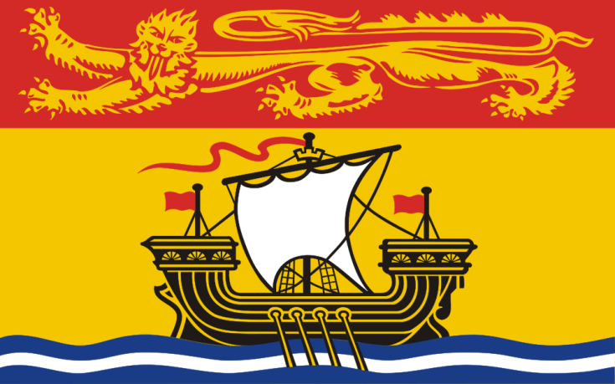 (January 2020)
- LEGISLATION / POLICIES / GUIDELINES / STANDARDS:
- Policy 701 – Protection of Pupils
- Policy 703 – Positive Learning and Working Environments

(B) RESOURCES, TOOLS, AND SUPPORTS
- Partner Resources – Public Health works directly with schools to support awareness of sexual violence, sexual harassment and partner violence.
- School District Developed Resources – Many school districts in NB have their own sexual violence policy. These policies have been developed to support the two provincial policy 701 and 703. A few examples of District Policy that exist can be found:
- Anglophone School District – West – Policies 700 series
- Anglophone School District – East
- Anglophone School Districts – South

(C) IMPLEMENTATION - EVALUTION OF IMPACTS
- The evaluation of the programs and services that school provide for sexual violence is done through the NB Wellness Survey.

(D) COMMON MESSAGING (Health, Education)

(E) CHALLENGES, NEEDS, QUESTIONS, AND SUCCESSES

Nova Scotia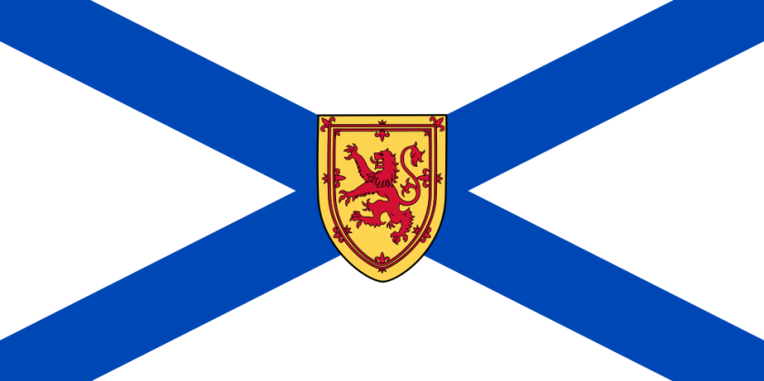

(A) LEGISLATION / POLICIES / GUIDELINES / STANDARDS:
(B) RESOURCES, TOOLS, AND SUPPORTS
- Partner Resources
- School District Developed Resources
(C) IMPLEMENTATION - EVALUTION OF IMPACTS
(D) COMMON MESSAGING (Health, Education)
(E) CHALLENGES, NEEDS, QUESTIONS, AND SUCCESSES

Prince Edward Island 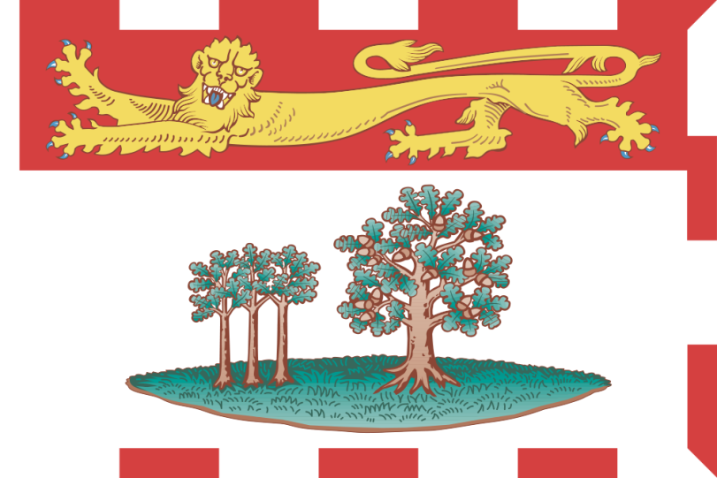

(A) LEGISLATION / POLICIES / GUIDELINES / STANDARDS
(B) RESOURCES, TOOLS, AND SUPPORTS
- Partner Resources
- School District Developed Resources
(C) IMPLEMENTATION - EVALUTION OF IMPACTS
(D) COMMON MESSAGING (Health, Education)
(E) CHALLENGES, NEEDS, QUESTIONS, AND SUCCESSES

Newfoundland and Labrador (January 2020)
- (LEGISLATION / POLICIES / GUIDELINES / STANDARDS
- Government of Newfoundland and Labrador Safe and caring schools Policy promotes a safe, caring and inclusive learning environment for all students. Inappropriate sexual behaviour is documented at the school level as per the safe and caring schools policy:
(https://www.gov.nl.ca/eecd/files/k12_safeandcaring_sacs_policy_procedures.pdf)
- REFUSAL OF SCHOOL ADMISSION POLICY
The Newfoundland and Labrador English School Board is committed to providing a safe and caring learning environment for all students. This includes the implementation of a consistent process for the refusal of school admission where the District CEO/Director of Education is of the opinion that the presence of a student in the school is detrimental to the physical or mental well-being of a student(s) or staff. This must be balanced with a fair and just process to address the rights of all students to an education. A student refused school admission will be provided alternate delivery of the educational program.
https://www.nlesd.ca/includes/files/policies/doc/1541440508607.pdf
- The Schools Act legislation is currently under review and being revised to reflect a safe learning environment. (https://www.cbc.ca/news/canada/newfoundland-labrador/school-act-changes-announced-1.4672698)

(B) RESOURCES, TOOLS, AND SUPPORTS
- Partner Resources
- School District Developed Resources
(C) IMPLEMENTATION - EVALUTION OF IMPACTS
(D) COMMON MESSAGING (Health, Education)
(E) CHALLENGES, NEEDS, QUESTIONS, AND SUCCESSES

Nunavut (Jan 14 2020)

- LEGISLATION, POLICIES / GUIDELINES

- Nunavut Teacher’s Association Collective Agreement – Section 22 “Harassment”
- Nunavut Employees Union Collective Agreement (paraprofessional positions) – Section 46 “Harassment”
- Harassment in the Workplace Policy (Purpose pasted below) & accompanying Harassment Complaint Form (copy attached separately)

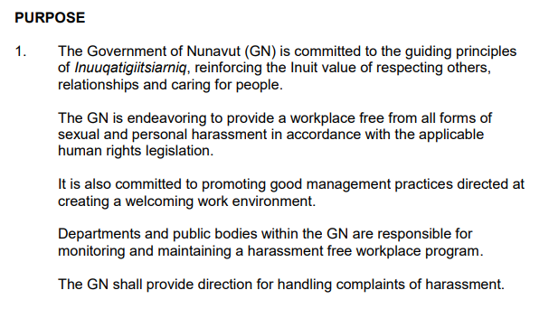

- Violence in the Workplace Policy (Purpose pasted below)

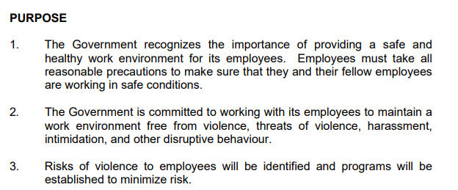;
- Public Service Act
- Education Act

- Schools must have Inuuqatigiitsiarniq Policy and Discipline regulations.
The purpose is to “create and maintain a welcoming, positive, and safe school environment that is supportive of the students and their education”. It must include pieces like:
  - strategies for managing student behavior
  - expected behaviour of district education authority, school staff, parents, visitors
  - consequences for failure to fulfill responsibilities or meet requirements
  - progressive discipline
  - factors to be considered before suspension/expelling a student, etc.

- RESOURCES, TOOLS, AND SUPPORTS

Schools use a Crisis Response Manual. It is an operational manual. Pertinent sections include:

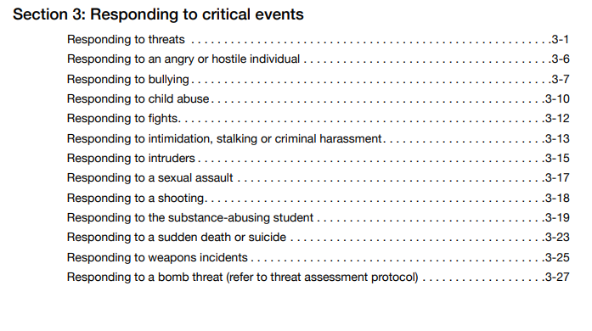

This manual also includes sections on post-emergency procedures (e.g. recovery, debriefing)

Below is an extract from section 3-17 responding to a sexual assault:

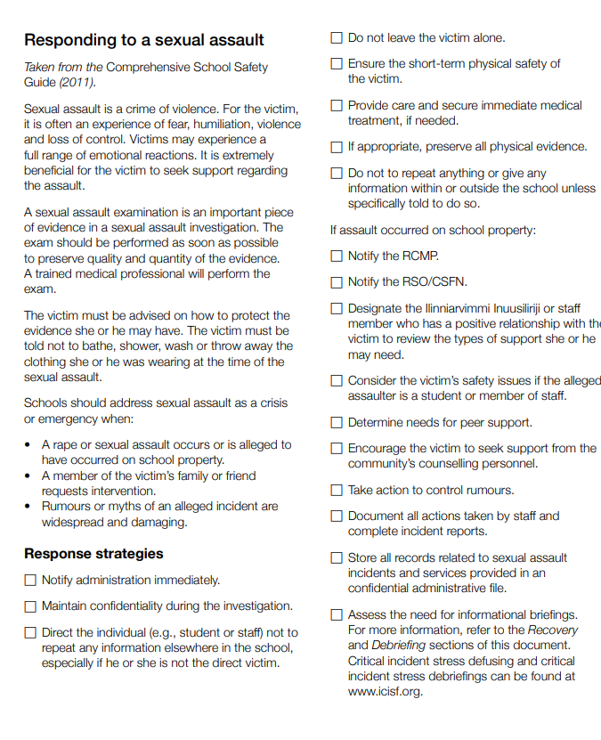

- Are there any curriculum or learning outcomes in your jurisdiction that have elements to address sexual violence/misconduct?

- The Aulajaaqtut curriculum for Grades 10-12 deals with understanding & developing healthy relationships, self-esteem, tolerance and understanding for others
- BeSafe! is a personal safety program for children aged 5-9, with a focus on preventing child sexual abuse. This program is approved grade four curriculum in Nunavut schools
- Respect Education includes training on violence prevention, healthy relationships and bullying prevention. It provides educators with a set of learning resources that they can choose to apply at their discretion within the class but outside the regular school curriculum.
- Annual Youth Conferences/youth facilitator training focusing on: bullying prevention, healthy relationship building, suicide prevention and positive coping skills/self-care

- Does your jurisdiction’s school boards/divisions, schools have school-based peer support groups to address sexual violence/violence?

- Health and Safety Committees responsible for overseeing safety in their school and managing health and safety issues
- School Crisis Response Teams
- Nunavut Teacher Association/GN Safe School Committee which researches and reviews issues and comes up with sets of recommendations regarding the safety of Nunavut teachers
- Student peer support groups (can be established)

- EVALUATION OF IMPACTS

- COMMON MESSAGING (Health, Education)

- CHALLENGES, NEEDS, QUESTIONS, AND SUCCESSES

Northwest Territories

(A) LEGISLATION / POLICIES / GUIDELINES / STANDARDS
(B) RESOURCES, TOOLS, AND SUPPORTS
- Partner Resources
- School District Developed Resources
(C) IMPLEMENTATION EVALUTION OF IMPACTS
(D) COMMON MESSAGING (Health, Education)

(E) CHALLENGES, NEEDS, QUESTIONS, AND SUCCESSES

Yukon

(A) LEGISLATION / POLICIES / GUIDELINES / STANDARDS:
(B) RESOURCES, TOOLS, AND SUPPORTS
- Partner Resources
- School District Developed Resources
(C) IMPLEMENTATION - EVALUTION OF IMPACTS
(D) COMMON MESSAGING? (Health, Education)

(E) CHALLENGES, NEEDS, QUESTIONS, AND SUCCESSES

Public Health Agency of Canada

(A) LEGISLATION / POLICIES / GUIDELINES / STANDARDS
(B) RESOURCES, TOOLS, SUPPORTS
- Partner Resources
- School District Developed Resources
(C) EVALUTION OF IMPACTS
(D) COMMON MESSAGING (Health, Education)
(E) CHALLENGES, NEEDS, QUESTIONS, AND SUCCESSES

National Resources
International Resources
Journal Articles

