School-based Responses to

Cannabis

Environmental Scan

August 2020

The request for this scan began with an email request from Sterling Carruthers in April 2018 for information from PTs where the Ministry of Education is creating “a 'plan' for cannabis? E.g., reviewing curriculum outcomes, reviewing policies, teacher PD etc.”

Guidelines for Scan Completion
- LEGISLATION, POLICIES, GUIDELINES
- Note any overarching or supporting policies connected to school-based approaches or programs to address impact of the 2018 legalization of cannabis; these could be at the provincial / territorial as well as the school board / district levels.

- RESOURCES, TOOLS, WORK PLANS, SUPPORTS
- List school-based cannabis resources/tools used in your jurisdiction.
- List also any upstream approaches which have met with significant positive – or negative – responses
- Any curriculum or learning outcomes in your jurisdiction that have been connected to the legalization of cannabis
- Development of peer-led groups in schools to discuss, provide education around cannabis

- EVALUATION OF IMPACTS
- Use this section to describe any evaluation plans, indicators, measures, and measurement tools your jurisdiction is using regarding to support and enhance use of school-based cannabis education programs and activities, as well as upstream approaches.

- COMMON MESSAGING (Health, Education)

- CHALLENGES, NEEDS, QUESTIONS, AND SUCCESSES
- Use this section to describe any/all challenges, needs, questions, and successes. This section can also house a list of resources that may have not been vetted carefully by referring sources, resources that may be questioned before sharing because the content seems limited or not balanced, or written by companies funded by private sector partners.

British Columbia 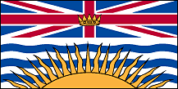 (April 2018)

(A) LEGISLATION, POLICIES / GUIDELINES
Our province is reviewing policies as part of the provincial framework, and I know that the BC Teachers Federation has requested that schools be cannabis free zones (just as they are required to be tobacco free zones)...I imagine that this will be legislated, but it is still in the consideration phase.
Our Ministry is not creating a specific plan for cannabis at this point. We are doing the following however:
- Participating in a cross-govt working group to inform a provincial legalization and regulation framework, which involves the development of a public awareness and education campaign (still in the works)
- Promoting new substance use education resources developed by the Canadian Institute for Substance Use Research (CISUR, formerly CARBC)
- Promoting consultation opportunities to school districts and education partners - e.g. our govt's Cannabis Legalization and Regulation Secretariat is leading some community and stakeholder consultations, CISUR has been leading some Cannabis Dialogues to which school districts were invited to participate (to inform what else is needed around substance use education).

(B) RESOURCES, TOOLS, AND SUPPORTS
Our new provincial curriculum addresses substance use from K-10, in the Physical and Health Education curricular area, though the learning outcomes are quite high level - can be used to address cannabis at a teacher's discretion.
Youth Resources
Kelty Mental Health Resource Centre
Cannabis Info Page
Foundry BC
Cannabis Info Page for youth

Teacher/Parent Resources
CARBC
Cannabis and Youth, a parent's guide
SACY
Cannabis Corner

(C) IMPLEMENTATION --EVALUTION OF IMPACTS
(D) COMMON MESSAGING (Health, Education)
(E) CHALLENGES, NEEDS, QUESTIONS, AND SUCCESSES

Alberta 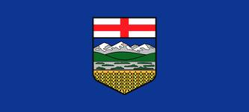 (October 2018)

(A) LEGISLATION, POLICIES / GUIDELINES
The new AB Curriculum won't be specific to cannabis, however there will be Learning Outcomes in Wellness Education curriculum specific to substance use and abuse. "While Alberta Education determines what students need to learn in provincial curriculum (programs of study), teachers use their professional judgement to determine how students achieve the learning outcomes in the provincial curriculum."
(B) RESOURCES, TOOLS, AND SUPPORTS
The English and French versions of Alberta’s cannabis resources for educators are live now on the www.drugsafe.ca website.
If you visit www.drugsafe.ca/cannabis and choose “for Educators” in the “Get Resources” section, they are all there.
Clarity on Cannabis Series
- FAQ for Educators
- Recommended Resources for Schools
- What Alberta Parents and Caregivers Need to Know
Éclaircissements sur le cannabis
- FAQ pour les éducateurs
- Ressources recommandées pour les écoles
- Ce que les parents et tuteurs de l’Alberta doivent savoir
AB Education does not develop resources. However it is developing a Curriculum Development Application that will allow teachers to build lesson plans based on best-practice, evidence based resources.
Alberta Health Services (AHS) Healthy Children and Families and Addiction Prevention Team, in collaboration with AHS’ Cannabis Education and Training Sub-Committee, have pulled together key resources and messages related to cannabis for schools and school authorities in Alberta.
These deliverables include:
· An FAQ Document outlining key questions and answers related to cannabis, its upcoming legalization, and implications for school settings.
· A Recommended Resource List, including suggested links/resources for teachers, parents, and youth. This list includes resources from Canada that are aligned with AHS’ broader messaging related to cannabis as well as adapted versions of high-quality resources from other provinces (adapted with appropriate permissions).
End users for the cannabis messages and resources outlined above include school authority staff/decision makers, school administrators, teachers, school support staff, as well as school community members who have an interest in this topic (e.g. parents).
These products were created between June 2018 and September 2018.
(C) IMPLEMENTATION – EVALUTION OF IMPACTS
(D) COMMON MESSAGING (Health, Education)

(E) CHALLENGES, NEEDS, QUESTIONS, AND SUCCESSES

Saskatchewan 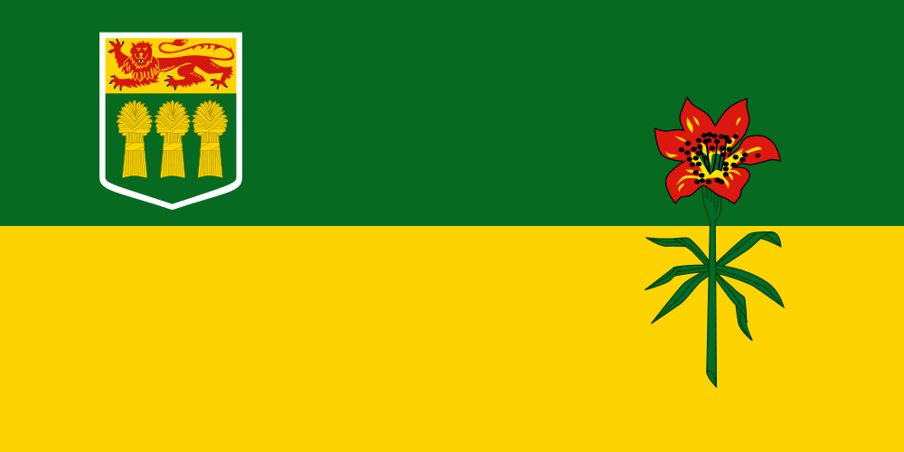 (April 2018)

(A) LEGISLATION, POLICIES / GUIDELINES

In Saskatchewan, we don't focus on a specific drug, rather, we want students to develop the knowledge about substance misuse and how to make healthy decisions.
At this time, we aren't considering policies. It has been mentioned that school divisions will update their alcohol/tobacco policies to include cannabis.
(B) RESOURCES, TOOLS, AND SUPPORTS
Cannabis in Saskatchewan Website
(C) IMPLEMENTATION -- EVALUTION OF IMPACTS
(D) COMMON MESSAGING (Health, Education)
(E) CHALLENGES, NEEDS, QUESTIONS, AND SUCCESSES

Manitoba (April 2018)

(A) LEGISLATION, POLICIES / GUIDELINES
(B) RESOURCES, TOOLS, AND SUPPORTS
There will be little change to the curriculum outcomes - cannabis will likely be grouped with alcohol and tobacco and there will be some emphasis on edibles for younger age groups.
There may be the potential to look at some teaching methods, including inquiry based learning when it comes to drug education.
(C) IMPLEMENTATION - EVALUATION OF IMPACTS
(D) COMMON MESSAGING (Health, Education)

(E) CHALLENGES, NEEDS, QUESTIONS, AND SUCCESSES

Ontario 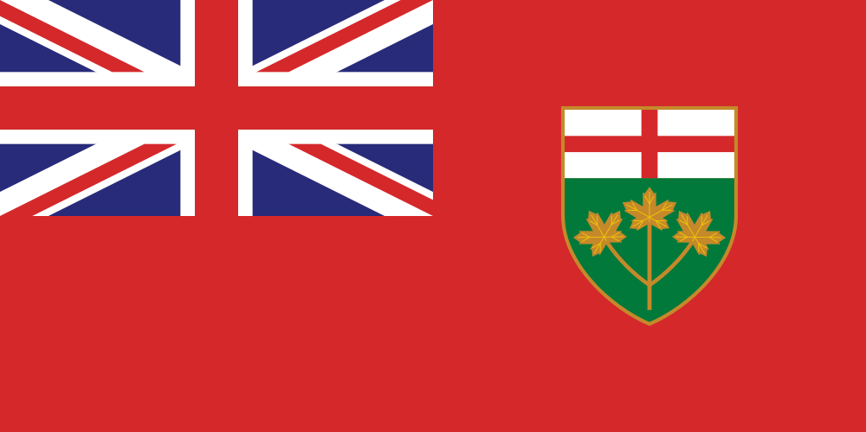 (April 2018)

(A) LEGISLATION, POLICIES / GUIDELINES
March 26 2018 memo - Supporting Schools - Recreational Cannabis Legalization

(B) RESOURCES, TOOLS, AND SUPPORTS
Legalization of Recreational Cannabis

- To prepare the education sector for the legalization of recreational cannabis, the Ministry of Education has developed and released resources for parents/guardians, youth and educators. This includes:
- A cannabis fact-sheet for parents developed in collaboration with the Centre for Addiction and Mental Health (CAMH) and School Mental Health ASSIST.
- A resource for youth that provide factual information developed in collaboration with Kids Help Phone.
- A fact-sheet for educators that highlights changes to the Education Act and to the Ontario Code of Conduct.

The Ontario Student Drug Use and Health Survey (OSDUHS) 2017 (from CPHA Cannabis Weekly Update)
The Ontario Student Drug Use and Health Survey (OSDUHS) is a population survey of Ontario students in grades 7 through 12. This survey provides current and reliable information about the health risk behaviours, attitudes and beliefs of Ontario adolescents, and it tracks changes over time.
https://www.camh.ca/en/science-and-research/institutes-and-centres/institute-for-mental-health-policy-research/ontario-student-drug-use-and-health-survey---osduhs

Cannabis info sheet for parents/guardians and caregivers— Provincial System Support Program (PSSP) at CAMH and the Ministry of Education School Mental Health ASSIST (from CPHA Cannabis Weekly Update)
The info sheet contains facts on cannabis, information on cannabis legalization, the health and social effects of cannabis use on children and youth, as well as where to find support and additional information.
English: https://www.camh.ca/-/media/files/guides-and-publications/cannabis-information-document-smha-camh-en.pdf
French: https://www.camh.ca/-/media/files/guides-and-publications-french/cannabis-information-document-smha-camh-FR.pdf

(C) IMPLEMENTATION - EVALUTION OF IMPACTS
(D) COMMON MESSAGING (Health, Education)

(E) CHALLENGES, NEEDS, QUESTIONS, AND SUCCESSES

New Brunswick 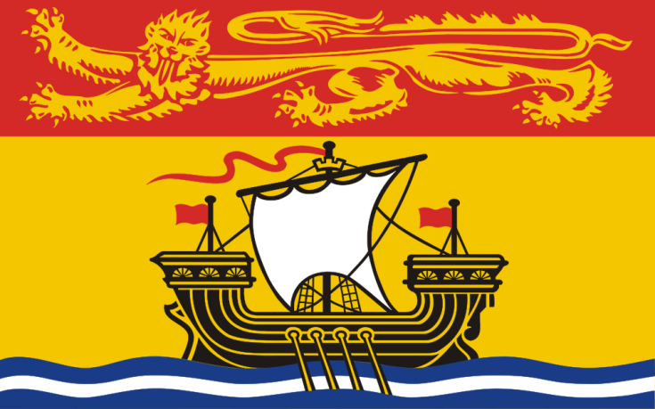 (January 2020)
- LEGISLATION, POLICIES, GUIDELINES

- Legislation:
  - NB Smoke Free Places Act
  - NB Cannabis Control Act
  - Motor Vehicle Act
  - Cannabis Control Act

- NB Department of Education and Early Child Development Policies :
  - Policy 702 Tobacco Free Schools
    - incorporates other products such as tobacco like products such as cigarettes, cigars, pipes, etc.
  - Policy 315 School & Community Partnerships and Sponsorships
    - no alcohol, cannabis or tobacco sponsorships
  - Policy 407 Community Use of Schools
    - Contracts state that school is smoke/tobacco free campus
- Policy 513 Transportation to/from Off Site School Related Activities
- States not permitted to transport alcohol, and no tobacco, or smoking of any kind in vehicle
  - Policy 712 Search and Seizure
    - Students have a reasonable expectation of privacy

- School District:
  - Campaign against Tobacco, Vape and Cannabis Use
  - Scent Free Workplaces/Schools
  - Clearing the Air on Vaping Toolkit

- Public Health/Horizon Health Network’s Healthy Learners in School Program
  - Ottawa Model for Smoking Cessation

- RESOURCES, TOOLS, WORK PLANS, SUPPORTS

Peer-led Groups in Schools
- SWAV or SWAT (Students Working Against Vaping/Tobacco)

Curriculum/Learning Outcomes
- To be provided by Department of Education and Early Child Development

Promising Approaches with Positive Results:
- School and Community Messaging with Cessation Nurse: In one community, smoking cessation nurse from local Health Center met with high school students as a resource consultant for smoke-free health promotion and community development. She advised SWAT team about key actions when applying for community grant to increase communication around tobacco use prevention, and to promote cessation. Youth at that school were able to reach out to her via e-communication to book an appointment. Evaluation results pending, but felt to be positive.

- Policy Awareness: Created district level committee to address vaping. Engaged bus drivers, custodians, subject leads, nurses working in the Healthy Learners in School Program, students, and school administrators to examine the issue of vape use among school aged youth. Created communications strategy and toolkit to educate and inform staff, students, parents and community partners. All high schools delivered an education program in September 2019, reinforced that Tobacco Free Schools Policy included vape products, and explained consequences for non-compliance. Communication sent to parents in writing, voice mail, social media, electronic messaging board, and newspapers. Provided information regarding the dangers of the product, and where to get help for addiction. Signage placed on all buses, all entrances to schools, and at entrances to washrooms. Evidence informed dialogues with youth were intentionally held. Policy compliance significantly improved, still working on increasing cessation resources and support.

- 4th R Healthy Relationships Plus Program: One school district obtained a grant to educate 8th grade teachers in the 4th R Healthy Relationships Plus Program. Pilot study demonstrated it met 8th grade health class curricular outcomes. This is an evidenced informed resource to promote positive youth development, through skill building for setting boundaries in peer relationships. Program focuses on refuse, delay negotiate skill development, with applications to substance use, interpersonal relationships, intimate relationships, etc. Plan to apply for funding to offer program training to 8th grade health teachers across the province.

- Be Smoke Free Conference: Students from several middle and high schools met to explore risks of tobacco and vape use. Through fun and interactive events, youth practiced refusal skills, learned about social media push marketing, busted mistruths and myths, and created action plans to implement in their schools.

- Wellness Passport: School wide or community wide application for 6-8 weeks. Participants earn points for each activity they complete in the passport. Activities involve events related to healthy eating (try a new vegetable, visit a Farmer’s Market, drinking water daily, etc.), physical activities (walking a local trail, trying a new sport, doing an activity with an elder, etc.), mental fitness (inviting someone to sit at your lunch table, writing a list of five things you do well, identifying two things you are thankful for at the end of each day, etc.) and substance free living (limiting screen time to 2hrs per day, writing out three ways to refuse substance offers, putting up a smoke free sign on your front door, etc.). Bonus points can be earned for doing activities with other generations, volunteering, or sleeping 8 hours per night.

School Improvement/District Improvement Plan Resources:
  - GoSmokeFree NB Cessation Resource
  - The LINK Program- where youth can access cessation support
  - Joint Consortium’s Vaping Toolkit
  - Joint Consortium’s Positive Mental Health Toolkit
  - Joint Consortium’s Youth Engagement Resource
  - Joint Consortiums Substance Use Toolkit
  - Healthy School Planner (JCSH)

School Resources:
May be used in classroom lessons, or in the environment to influence the social culture, or shared with parents/guardians/youth-serving organizations:
Elementary School Curriculum

- Heart Healthy Schools K-6 (Heart & Stroke Foundation)
- Clearing the Air on Vaping Toolkit
- Eat Well, Be Active SMART Goals
- At My Best 4-5-6

Middle School Curriculum
- Currently Under Review
- Trivia Games for Middle and High Schools about Tobacco, Vaping, Risky Behaviors, etc.
- 4th R Healthy Relationships Plus Program (for grade 8 health teachers, and guidance)

High School Curriculum

- Personal Development Career Planning

Youth Engagement Groups:
- TATU or SWAT Groups:
  - Tobacco Free Schools Action Guide
  - www.breakitoff.ca
  - Health Canada Don’t Drive High
  - Health Canada Know the Risk
  - Health Canada Consider the Consequences of Vaping
  - Canadian Cancer Society Think Before You Vape Campaign (videos and tools)
  - SOS Safety Magazine for Youth

Parent Engagement Resources:
- Cannabis Talk Kit (Drug Free Kids Canada)
- Together Let’s Start the Conversation About Cannabis (video, brochures) for coaches, athletes, parents
- What Parents Need to Know About Teen Risk Taking (Canadian Association of Mental Health)
- WWW.weedmyths.ca (Mental Health Foundation of Nova Scotia with the Nova Scotia Early Psychosis Program)
- Healthy Canadian Channel: Questions About Cannabis
- What the RCMP want Youth to Know Infographic (Poster for class)

- EVALUATION OF IMPACTS

- Logic Model for Vaping (OTRU) Shared indicators useful for school, family, and community to start dialogue about where changes can be made. OTRU’s Interventions to Prevent Harms from Vaping p. 25
- Building on Our Strengths- Canadian Standards for School-based Youth Substance Use Prevention. A Guide for Educators and Health Personnel
- Healthy Learners in School Program’s Strategic Plan

Evaluation Data Sources:
  - Short term evaluation; School tracking of violations PowerSchool. Measured number of office referrals for vaping on school properties over time, able to target hot-spots and time of day using reporting data. This helped schools to plan for extra supervision for those areas, or ways to make physical/social environment non-conducive to vaping.
  - Medium term evaluation: Tell Them from Me Survey
  - Long term evaluation: New Brunswick Student Wellness Survey, and Canadian Drug, Alcohol, Tobacco Use Survey
  - Presence of tobacco education/prevention, or cessation as strategy on school or district
  - New Brunswick Health Council, community health indicators and protective factors
- Toolkit Evaluation: Horizon/Vitalité Vape Free Toolkit- evaluation component
- Individual school progress on TATU Group Action Plan. (Number of goals, strategies to meet goals, etc.)

- COMMON MESSAGING (Health, Education)
- Working to align messaging among health networks, Government of New Brunswick and Department of Education and Early Child Development
- Consulted with Center for Excellence in Tobacco Cessation, and Population Health Programming to ensure duplication is not occurring, and that evidence-informed best practices are employed in the school environment.
- New Brunswick Anti Tobacco Coalition’s Working Group Against Vaping—by collaborating with other health-serving organizations, we seek to achieve common goals against tobacco and vaping.

- CHALLENGES, NEEDS, QUESTIONS, AND SUCCESSES

- Community Engagement and Mobilization:

Need campaign tools to engage communities in helping youth to live healthy, smoke free lives. All citizens have a role in creating healthy environments that nurture youth.
- Cannabis Education:

Since cannabis has been legalized, need to incorporate into curriculum; and to get more community messaging out. Need for both prevention and harm reduction type messaging.
- Financial Support for Front Line Activities:

Need grant funding to implement novel programming, and to engage youth and community partners in interventions
- Resources for Front Line Work:

Need copyright free resources, especially images--- that can be used/ modified/shared in health and education

Nova Scotia 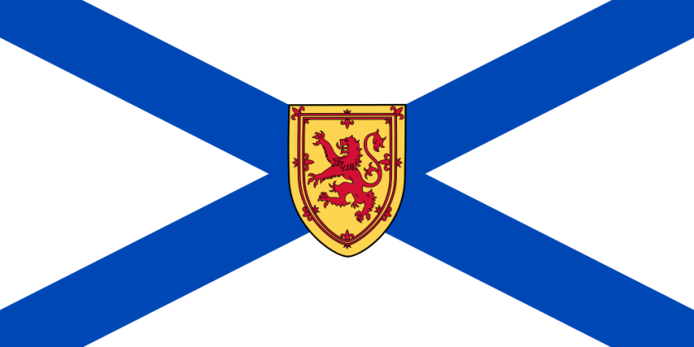

(A) LEGISLATION, POLICIES / GUIDELINES
(B) RESOURCES, TOOLS, AND SUPPORTS
(C) IMPLEMENTATION - EVALUTION OF IMPACTS
(D) COMMON MESSAGING (Health, Education)
(E) CHALLENGES, NEEDS, QUESTIONS, AND SUCCESSES
Quick question – do you currently hold a database or list of current educational resources on cannabis that different P/Ts are using? What would you suggest where to look?

Prince Edward Island 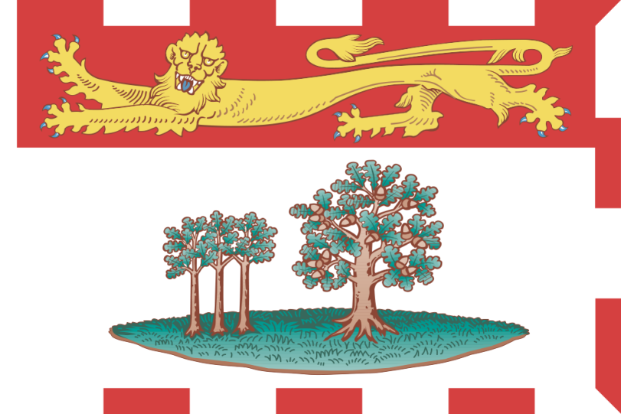 (October 2018)

(A) LEGISLATION, POLICIES / GUIDELINES
(B) RESOURCES, TOOLS, AND SUPPORTS
On October 17th, recreational cannabis is legal across Canada. For months the PEI Government has been working hard to prepare for this change. Within the education system we have developed a cannabis information sharing work plan using a comprehensive school health approach. This includes exploring cannabis information needs in regards to curricula, policies, partnerships, and the whole school environment. This approach will help ensure we are providing those within the education system (school, branch/board, and department staff) with the most up-to-date, accurate, and balanced information about the laws around cannabis, health risks, responsible use, how to talk to youth, and dangers of driving impaired. To support access to this information, we have uploaded a repository of web sites, fact sheets, and resources (English and French) to the PEI Teacher Platform (see attached for log-in instructions) which contains resources for students, teachers, school-based clinicians, and parents. This site will be updated on a regular basis as more resources and products are finalized for use within the school setting.
How to talk to your kids about cannabis— PEI
The PEI government has created policies to reduce the illegal market for cannabis, to help Islanders make an informed choice, and to protect the public health and safety of our citizens.
https://www.princeedwardisland.ca/en/news/how-talk-your-kids-about-cannabis
- JUST THE FACTS
- Public Schools Branch - Alcohol and Drugs - Operational Policy# 606
- Public Schools Branch - Alcohol and Drugs - Operational Procedures 606.1
- Public School Branch - Appendix A – Incident Reference Chart
- La Commission scolaire de langue française - “Possession et/ou consommation de drogues ou d’alcool” Policy#312
(C) IMPLEMENTATION - EVALUTION OF IMPACTS
(D) COMMON MESSAGING (Health, Education)
(E) CHALLENGES, NEEDS, QUESTIONS, AND SUCCESSES
Newfoundland and Labrador (April 2018)

(A) LEGISLATION, POLICIES / GUIDELINES

We have an interdepartmental committee comprised of every department and they each are doing work within their own departments
(B) RESOURCES, TOOLS, AND SUPPORTS
(C) IMPLEMENTATION - EVALUTION OF IMPACTS
(D) COMMON MESSAGING (Health, Education)
(E) CHALLENGES, NEEDS, QUESTIONS, AND SUCCESSES

Nunavut

(A) SCHOOL-BASED MENTAL HEALTH LEGISLATION, POLICIES / GUIDELINES
(B) RESOURCES, TOOLS, AND SUPPORTS

(C)RESOURCES, TOOLS, AND SUPPORTS
(D) IMPLEMENTATION - EVALUTION OF IMPACTS
(E)COMMON MESSAGING (Health, Education)

(E) CHALLENGES, NEEDS, QUESTIONS, AND SUCCESSES

Northwest Territories 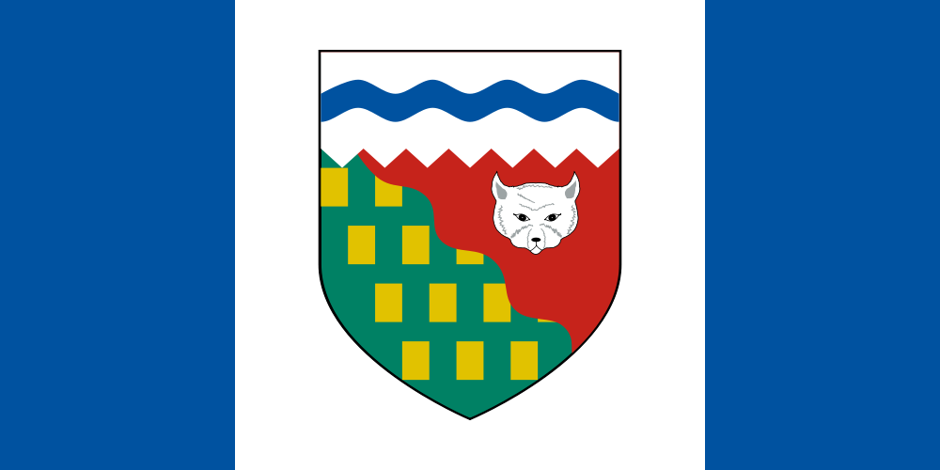 (November 2018)
- LEGISLATION, POLICIES / GUIDELINES

School policies and regulations not specific to cannabis but often referred to as ‘non-medicinal drugs’ or ‘intoxicating substances’.
- Territorial School Code of Conduct
-Prohibits possession, use, sale, purchase or exchanging of intoxicating substances on NWT schools grounds;
- Students, staff and visiting public not to be under the influence of intoxicating substances while at school.
- Education Act
-Provides direction to Education Bodies for possible action related to infractions of the Territorial School Code of Conduct.

- RESOURCES, TOOLS, SUPPORTS
- The GNWT has an interdepartmental working group tasked with developing, distributing and promoting cannabis education resources to all residents of the Northwest Territories with a strong focus on youth education. Resource development and education have centered on 4 themes:
-Cannabis and the brain
-Cannabis and Mental Health
-Cannabis and Pregnancy/ breastfeeding
-Cannabis and Safer Use
- Methods of cannabis education have been wide ranging and in response to the needs identified through community engagement during the ‘What we Heard’ campaign. To date, we have delivered a Facebook live event for parents as well as an interactive, in person and webinar broadcast of ‘cannabis and the brain’ by Dr. Michael Hill from the University of Calgary. We have developed cannabis information sheets for students, parents and school staff and distributed an extensive list of resource links for additional support. We have launched an interactive poster series featuring an AR (augmented reality) phone app as well as a youth cannabis comic resource.
Cannabis in the NWT - Zapper App Campaign
  - https://www.hss.gov.nt.ca/en/services/cannabis
https://www.eia.gov.nt.ca/en/cannabis (general site)

What you need to know about cannabis & school: Resources for Current Teachers / Principals
  - Restricting youth access to cannabis and protecting young people from promotion or enticements to use cannabis is a priority for the GNWT.
https://www.ece.gov.nt.ca/en/services/ressources-pour-les-enseignants-et-les-directeurs-en-poste/what-you-need-know-about

- IMPLEMENTATION - EVALUATION OF IMPACTS
Nothing to report at this time

- COMMON MESSAGING (Health, Education)
- Resource development and education have centered on 4 themes:

-Cannabis and the brain
-Cannabis and Mental Health
-Cannabis and Pregnancy/ breastfeeding
-Cannabis and Safer Use

- With regard to curriculum, cannabis education is addressed in the ‘Alcohol and Other Drugs’ unit in grades 4-9 health as well as in CALM 10 in the ‘Personal Choices’ unit. The draft 4-6 wellness education curriculum follows a collaborative inquiry model and has connections to cannabis education in 4 of the 5 focus areas.

- CHALLENGES, NEEDS, QUESTIONS, AND SUCCESSES
- Responding to the needs of educators and students as we move forward.
- Information from the HBSC also a crucial piece to inform and guide cannabis education.

Yukon 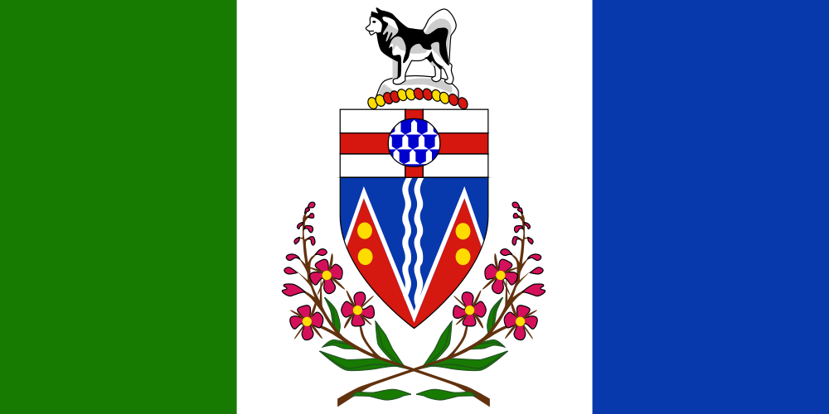 (August 2018)

- LEGISLATION, POLICIES, GUIDELINES
Nothing specific to cannabis at this time.
- RESOURCES, TOOLS, WORK PLANS, SUPPORTS
In development:
1. A Grade 10 unit on Substance Use/Abuse is being developed, targeted for release in 2018/19 school year (this is the one Nikki Crocker is working on)
2. The Dept of Health promotes the “Kickin’ Ash” tobacco prevention program that helps young people “get the facts, express their opinions, and learn the truth about tobacco” https://www.quitpath.ca/kicking-ash/index includes a facilitator manual and small grants available to classrooms/youth groups who want to do their own prevention project
3. Building on the success and recognition of the Kickin’ Ash resource, a new teaching resource will be developed by HSS (“BREATHE” working title) that includes three separate modules: tobacco*, cannabis, and vaping. Recognizing the overlap in desirable skills and assets we would like to nurture in young people to help them make good decisions about substance use, a positive youth development theme will frame all three modules.
* The tobacco module will be based on the original Kickin’ Ash program, but condensed and revised for an older audience
4. HBSC follow-up tour is planned. Facilitators will travel to rural communities where HBSC data was collected to share results, have conversations w. young people re. what this means for their community, and strategize about the future. These discussions will include cannabis use in YT pre-post legalization.
- EVALUATION OF IMPACTS
Nothing formal at this time.
- COMMON MESSAGING (Health, Education)
These are in development, but will most likely closely follow Canada’s Lower-Risk Cannabis Use Guidelines (CAMH) and focus on: delaying use, limiting and reducing how often, choosing lower-risk products and methods of consuming, avoiding altogether if you are at-risk for mental health problems or are pregnant.
- CHALLENGES, NEEDS, QUESTIONS, AND SUCCESSES
Biggest question at the moment is with respect to WHO will do the work that is necessary to build a comprehensive approach to cannabis education and HOW IT WILL BE RESOURCED in Yukon. Traditionally, the Health Promotion Unit and/or Mental Wellness and Substance Use Services (formerly Alcohol and Drug Services) would do the kind-of work involved (developing resources, going classroom presentations, hosting parent info nights, training teacher and other adult allies, etc…) but neither HPU or MWSU is currently resourced or staffed to take on this work w/out compromising other priorities. Tentative plan is to apply to Health Canada’s Substance Use and Addictions Program (SUAP) for required funds.
YT is (mainly) using the following sources to inform development of our educational tools/resources:
1. Canadian Students for Sensible Drug Policy: Toolkit for Educating Youth https://cssdp.org
2. First People’s Principles of Learning https://www2.gov.bc.ca/assets/gov/education/kindergarten-to-grade-12/teach/teaching-tools/aboriginal-education/principles_of_learning.pdf
3. Talking Pot: A Communication Guide for youth allies (CCSA) (currently embargoed)
4. Lower Risk Cannabis Use Guidelines for Canada (CAMH) https://www.camh.ca/-/media/files/pdfs---reports-and-books---research/canadas-lower-risk-guidelines-cannabis-pdf.pdf
5. Cannabis Talk Kit: Know how to talk to your teen (Drug-Free Kids Canada) https://www.drugfreekidscanada.org/wp-content/uploads/2017/06/34-17-1850-Cannabis-Talk-Kit-EN-10.pdf

Public Health Agency of Canada

(A) SCHOOL-BASED MENTAL HEALTH LEGISLATION, POLICIES / GUIDELINES
(B) RESOURCES, TOOLS, SUPPORTS
(C) EVALUTION OF IMPACTS
(D) COMMON MESSAGING (Health, Education)
(E) CHALLENGES, NEEDS, QUESTIONS, AND SUCCESSES

National Resources
(A) VETTED AND APPROVED

COVID-19 and Cannabis Smoking and Vaping: Four Things You Should Know [report]

Summarizes four important facts currently known about COVID-19 and how it can affect people who smoke or vape cannabis products. Topics covered include the potential impact of smoking or vaping cannabis on lung health, the potential impact on the immune system, how it can have an impact on people infected with COVID-19 and guidance for reducing harms.

https://www.ccsa.ca/covid-19-and-cannabis-smoking-and-vaping-four-things-you-should-know-report

Cannabis Use and Youth: A parent's guide (2018)
Resources include:
- You may have heard...
- Common claims about cannabis
- Exploring medical cannabis use
- You and your child
- In summary, try to remember...
- Resources
https://www.heretohelp.bc.ca/workbook/cannabis-use-and-youth-a-parents-guide

CAMH:

Game Changers Resources https://www.camh.ca/en/driving-change/game-changers/game-changers-resources

For youth
Things you should know about cannabis - Click here to download infographic
Quick Tips about safer ways to use cannabis - Click here to download infographic

Council of Chief Medical Officers of Health (CCMOH) Statement on Cannabis Extracts, Edibles and Topical Products

Addressing Stigma: Towards a More Inclusive Health System: The Chief Public Health Officer's Report on the State of Public Health in Canada 2019

7 Things You Need to Know about Edible Cannabis

https://www.ccsa.ca/sites/default/files/2019-06/CCSA-7-Things-About-Edible-Cannabis-2019-en.pdf
- CANNABASICS
This information package is a set of fact sheets on cannabis for health and social service providers. It provides a basic overview of common cannabis plants and products, methods of consumption as well as information to better understand consumption and harm reduction. Each fact sheet is comprised of a high level overview with graphics followed by a detailed overview with links and references.
https://www.cpha.ca/cannabis-resources-providers-beyond-cannabasics?utm_source=Canadian+Public+Health+Assocation&utm_campaign=3ae269b18b-EMAIL_CAMPAIGN_2020_10_22_12_49&utm_medium=email&utm_term=0_1f88f45ba0-3ae269b18b-154371407&ct=t(EMAIL_CAMPAIGN_10_22_2020_9_24)
- The High Way Home?
The High Way Home? is a new interactive website that allows young people to make virtual choices about impaired driving without actually putting their lives at risk. It shows them the life-threatening consequences of poor decisions and the positive outcomes of making the right choices. To address the issue of young drivers impaired by cannabis, the Canadian Centre on Substance Use and Addiction, in partnership with Desjardins Insurance, is pleased to announce the release of The High Way Home?.
https://www.thehighwayhome.ca/?_cldee=c2pob3JuYnlAZWR1LnBlLmNh&recipientid=contact-970dede4f1d1e6118105480fcfeaa931-902d664d35504813a65d1b2f043a10f4&esid=cd1eac47-6905-ea11-a811-000d3af42c56

- Cannabis and your health: 10 ways to reduce risks when using https://www.canada.ca/en/public-health/services/publications/drugs-health-products/cannabis-10-ways-reduce-risks.html
  - Poster
  - Postcard
- Le cannabis et votre santé: 10 façons de réduire les risques lors de la consummation
https://www.canada.ca/fr/sante-publique/services/publications/medicaments-et-produits-sante/cannabis-10-facons-reduire-risques.html
  - Affiche
  - Carte postale
- Clearing the Smoke on Cannabis: Regular use and mental health
https://www.ccsa.ca/sites/default/files/2019-05/CCSA-Cannabis-Use-Mental-Health-Report-2019-en.pdf

- Edible Cannabis, Cannabis Extracts and Cannabis Topicals: A Primer on the New Cannabis Products
https://www.ccsa.ca/sites/default/files/2019-06/CCSA-Cannabis-Edibles-Extracts-Topicals-Topic-Summary-2019-en_0.pdf
- Effects of cannabis use on youth: can we predict the future?
The legalization of cannabis has some health researchers concerned the youth population will have an easier time accessing the product leading to high-risk behavior. Risky patterns of use are associated with poorer health outcomes, substance use disorders, mental health and behavior problems, as well as lower levels of educational and employment outcomes. The two new studies have identified five patterns of cannabis use: youth who abstained (29 per cent), occasional users (27 per cent), decreasers (14 per cent), increasers (20 per cent) and chronic users (11 per cent). https://www.uvic.ca/news/topics/2018+cannabis-youth-bonnie-leadbeater+media-release
- Is Cannabis Safe to Use? Facts for youth aged 13-17 years
- La consommation de cannabis est-elle sécuritaire? Les faits pour les jeunes de 13 à 17 ans
  - Talking Pot with Youth: A Cannabis Communication Guide for Youth Allies
  - Cannabis in Canada: Get the facts
  - Canadian Public Health Association: Resources
  - Is cannabis addictive?
  - Le cannabis crée-t-il une dépendance?
  - Does cannabis use increase the risk of developing psychosis or schizophrenia?
  - La consommation de cannabis augmente-t-elle le risque de développer une psychose ou une schizophrénie?
  - Cannabis Information for Students, Parents/Caregivers, Teachers, and School-based Clinicians
  - Students: 10 Questions About Cannabis Use and Teens
  - Teachers: 10 Questions About Cannabis Use and Your Student
  - School-Based Clinicians: 10 Questions About Cannabis Use and Teens (for Clinicians)
  - Parents / Caregivers: 10 Questions About Cannabis Use and Your Teen
  - University of Waterloo – School of Pharmacy
  - Canadian Centre on Substance Use and Addiction: Marijuana and Youth – Information
  - Information for Health Care Professionals: Cannabis (marihuana, marijuana) and the cannabinoids: https://www.canada.ca/en/health-canada/services/drugs-medication/cannabis/information-medical-practitioners/information-health-care-professionals-cannabis-cannabinoids.html
  - Canadian Centre on Substance Use and Addiction: Know the Health Effects of Cannabis (Infographic)
  - Centre canadien sur les dépendances et l’usage de substances: Connaissez les effets sur la santé
  - Canadian Centre on Substance Use and Addiction: Help your teen understand what’s fact and fiction about marijuana
  - Centre canadien sur les dépendances et l’usage de substances: Aidez vos ados à faire la distinction entre les faits et la fiction au sujet de la marijuana
  - Canadian Centre on Substance Use and Addiction: Talking pot with Youth
  - Centre canadien sur les dépendances et l’usage de substances: Parler pot avec les jeunes
  - Drug Free Kids Canada: Cannabis
  - Drug Free Kids Canada: Cannabis Talk Kit: Know How to Talk with Your Teens
  - Centre for Addictions and Mental Health: Cannabis
  - Centre for Addictions and Mental Health: Cannabis: What Parents/Guardians and Caregivers Need to Know
  - Association canadienne pour la santé mentale: Le cannabis : Ce que les parents et tuteurs doivent savoir
- Cannabis and Youth: A Parents’ Guide (CISUR) https://www.heretohelp.bc.ca/workbook/cannabis-use-and-youth-a-parents-guide?utm_source=Canadian+Public+Health+Assocation&utm_campaign=ee8327892a-EMAIL_CAMPAIGN_2019_11_13_03_44&utm_medium=email&utm_term=0_1f88f45ba0-ee8327892a-154371407
- Lower-Risk Cannabis Use Guidelines (LRCUG) for Youth
This youth education resource provides evidence-based information on safer ways to use cannabis, for those who’ve made the choice to use.
http://www.camh.ca/en/health-info/guides-and-publications/lrcug-for-youth
  - English Brochure: http://www.camh.ca/-/media/files/pdfs---reports-and-books---research/canadas-lower-risk-guidelines-cannabis-pdf.pdf
  - Brochure Français : https://www.camh.ca/-/media/files/pdfs---reports-and-books---research/canadas-lower-risk-guidelines-cannabis-fr.pdf
- Normalizing conversation, not consumption (CPHA)
- Pot + Driving (CPHA)
- Provincial Patterns and Trends in Cannabis Use from the 2016/17 Canadian Student Tobacco, Alcohol and Drugs Survey (CSTADS); and 2) Provincial Health Profiles from the 2016/17 Canadian Student Tobacco, Alcohol and Drugs Survey (CSTADS)
https://uwaterloo.ca/canadian-student-tobacco-alcohol-drugs-survey/reports-and-results/reports-and-tables/2018

- Provincial Patterns in E-Cigarette Use from the 2016/17 Canadian Student Tobacco, Alcohol and Drugs Survey (CSTADS)
https://uwaterloo.ca/canadian-student-tobacco-alcohol-drugs-survey/reports-and-results/reports-and-tables/2019

Q&A Is cannabis a “gateway drug”? Public Health Ontario
In the context of cannabis legalization, public health practitioners may encounter the question of whether cannabis is a “gateway drug” (i.e., its use leads to the use of other substances) in their work in school health and other settings. This Q&A is intended to provide practitioners with current evidence and to enable public health practice. It is beyond the scope of this Q&A to address the health effects of cannabis for youth overall.
https://www.publichealthontario.ca/-/media/documents/qa-cannabis-gateway.pdf?la=en

RCMP - Marijuana: We'd like youth to know (Updated Dec. 2018)
An infographic to help youth bust myths and get the facts about cannabis.
http://www.rcmp-grc.gc.ca/en/marijuana-wed-know

Teen Mental Health - Cannabis
The purpose of this page is to provide you with easy access to information about cannabis that you can use to educate yourself regarding its recreational use. You will find four different sections which contain links to online resources chosen by our team and our expert consultants as sources of best available evidence-based information about cannabis. Links to resources in each of the sections have been selected for the specified audience, but anyone can go to any link for more information. We have also developed four infographics which contain helpful information and answer questions each of the groups outlined below may have.
http://teenmentalhealth.org/cannabis
- Toolkit for hosting parent education sessions (Grey Bruce Public Health Unit)
This toolkit is designed for community groups and organizations to organize timely, relevant and effective cannabis education sessions for parents and caregivers. The toolkit includes event planning checklists and templates; up-to-date information on cannabis legalization; proven strategies for talking to young people about drug use; and links to local services and supports.
Toolkit PDF
Grey Bruce Cannabis page..

Development of the REACH (Real Education About Cannabis and Health) Program for Canadian Youth
The purpose of this project was to create REACH (Real Education About Cannabis and Health), a toolkit and curriculum resource that includes lesson plans for teachers covering the science of cannabis, social science implications, peer pressure, decision making and harm reduction, videos featuring youth testimonials, and supplemental resources. RESULTS: Preliminary feedback suggests the materials are engaging and informative
https://www.healio.com/nursing/journals

USask collaboration creates free cannabis education [Gr 7 & 9]toolkit
REACH (Real Education about Cannabis and Health) is a free classroom resource resulting from a multidisciplinary collaboration between the USask College of Nursing, the College of Pharmacy and Nutrition, and researchers from the Cannabinoid Research Initiative of Saskatchewan (CRIS).
Grade 7 – (scroll ¾ way down page)
Grade 9 – (scroll ¾ way down page)

International Resources
1. Tips for Talking With Youth about Marijuana— Colorado Department of Public Health and Environment If you’re wondering when’s a good time to talk to youth about marijuana, consider this — 40% of youth who have ever used marijuana try it before age 15.
http://responsibilitygrowshere.com/talking-with-youth
2. Australia - Cannabis Information & Support
How dope is your driving? Joint Effort Quit App
https://cannabissupport.com.au/

Journal Articles
1. Association of Cannabis With Cognitive Functioning in Adolescents and Young Adults: A Systematic Review and Meta-analysis (Journal Article— Locked) This systematic review and meta-analysis of 69 cross-sectional studies of 2152 cannabis users and 6575 comparison participants showed a small but significant overall effect size for reduced cognitive functioning in adolescents and young adults who reported frequent cannabis use. However, studies requiring abstinence from cannabis for longer than 72 hours had a very small, nonsignificant effect size. https://jamanetwork.com/journals/jamapsychiatry/article-abstract/2678214?resultClick=24
2. Moffatt, B.M., Jenkins, E.K., & Johnson, J.L. (2013). Weeding out the information: An ethnographic approach to exploring how young people make sense of evidence on cannabis. Harm Reduction Journal, 10, 34. DOI: 10.1186/1477-7517-10-34.
3. The interaction of gender and cannabis in early phase psychosis (Journal Article— Locked) This review examines what is currently known, from gender focused studies, about the interaction of gender, cannabis use and psychotic disorders. https://www.ncbi.nlm.nih.gov/pubmed/28506705
Commentary: https://www.nationalelfservice.net/mental-health/substance-misuse/women-cannabis-psychosis/
4. The interdependence of cigarette, alcohol, and marijuana use in the context of school-based social networks
This article uses mathematical modeling to examine the co-evolution of cigarette smoking, alcohol, and cannabis use within adolescent friendship networks. Finding indicate some evidence of sequential drug use and that an adolescent’s level of marijuana use affects the initiation and continuation of smoking and drinking.
http://journals.plos.org/plosone/article?id=10.1371/journal.pone.0200904
5. Morin, J. F. G., Afzali, M. H., Bourque, J., Stewart, S. H., Séguin, J. R., O’Leary-Barrett, M., & Conrod, P. J. (2018). A Population-Based Analysis of the Relationship Between Substance Use and Adolescent Cognitive Development. American Journal of Psychiatry, appi-ajp.
Alcohol and cannabis misuse are related to impaired cognition. When inferring causality, four nonexclusive theoretical models can account for this association: 1) a common underlying vulnerability model; 2) a neuroplasticity model in which impairment is concurrent with changes in substance use but temporary because of neuroplastic brain processes that restore function; 3) a neurotoxicity model of long-term impairment consequential to substance use; and 4) a developmental sensitivity hypothesis of age-specific effects. Using a developmentally sensitive design, the authors investigated relationships between year-to-year changes in substance use and cognitive development.
https://ajp.psychiatryonline.org/doi/10.1176/appi.ajp.2018.18020202
6. Zuckermann, A. M., Gohari, M. R., de Groh, M., Jiang, Y., & Leatherdale, S. T. (2019). Factors associated with cannabis use change in youth: Evidence from the COMPASS study. Addictive Behaviors, 90, 158-163.
Harmful effects of cannabis use in youth scale with frequency. In the context of approaching legalization in Canada, understanding the distinctions between youth who change and who maintain their cannabis use is essential for designing interventions and policy. A substantial number of characteristics may play a role. This study assessed whether and how youth who change their cannabis use differ from those who do not.
https://www.sciencedirect.com/science/article/abs/pii/S0306460318310207
7. Ames, M. E., Leadbeater, B. J., Merrin, G. J., & Thompson, K. (2018). Patterns of marijuana use and physical health indicators among Canadian youth. International Journal of Psychology. https://doi.org/10.1002/ijop.12549
Chronic users reported more physical symptoms, poorer physical self‐concept, less physical activity, poorer eating practices, less sleep, and higher number of sexual partners during adolescence than other classes. Decreasers also reported poorer physical self‐concept and poorer eating practices than abstainers.

https://onlinelibrary.wiley.com/doi/10.1002/ijop.12549
8. Acute psychotic symptoms linked to adolescent marijuana use (Journal Article – locked)
Many adolescent marijuana users report acute symptoms — paranoia, anxiety or hallucinations — associated with their use of the drug, researchers from Boston Children's Hospital and Harvard Medical School have found. Rates of these symptoms were higher among regular users, those who met criteria for cannabis use disorder (CUD) and those who were also depressed.
https://onlinelibrary.wiley.com/doi/abs/10.1002/adaw.32230
9. Zuckermann, A. M., Gohari, M. R., de Groh, M., Jiang, Y., & Leatherdale, S. T. (2019). Factors associated with cannabis use change in youth: Evidence from the COMPASS study. Addictive behaviors, 90, 158-163.
Harmful effects of cannabis use in youth scale with frequency. In the context of approaching legalization in Canada, understanding the distinctions between youth who change and who maintain their cannabis use is essential for designing interventions and policy. A substantial number of characteristics may play a role. This study assessed whether and how youth who change their cannabis use differ from those who do not. Conclusions: Students who change their cannabis use differ in several demographic and behavioural characteristics. The results raise further concerns about the impact of e-cigarettes and the role of poly-substance use in high-risk trajectories. Distinct classes of cannabis users, essential for policy and intervention development, can be identified in high school populations.
https://www.mendeley.com/catalogue/factors-associated-cannabis-change-youth-evidence-compass-study/
10. The role of energy drink consumption in the intention to initiate marijuana use among adolescents
The current study aims to examine whether energy drink consumption is associated with intentions to try marijuana among adolescents who have never tried marijuana, and whether the effects of energy drink consumption on the intention to try marijuana vary between adolescents who have previously tried alcohol or cigarettes and those who have not. Conclusions
The current study suggests that energy drink consumption (particularly heavy consumption) may be one early precursor in the escalation of substance use. It may be beneficial to include energy drinks in drug education curriculums.
https://www.sciencedirect.com/science/article/abs/pii/S0306460319301285?utm_source=Canadian+Public+Health+Assocation&utm_campaign=deb9bf6dd2-EMAIL_CAMPAIGN_2019_04_15_12_55&utm_medium=email&utm_term=0_1f88f45ba0-deb9bf6dd2-154371407&ct=t(EMAIL_CAMPAIGN_4_16_2019_8_36)
11. Prelegalisation patterns and trends of cannabis use among Canadian youth: results from the COMPASS prospective cohort study
After a steady decrease in patterns of cannabis among youth over several years, it appears that there has been a gradual increase in cannabis use among youth following the start of discourse around cannabis legalisation, with some populations of youth being at greater risk.
https://bmjopen.bmj.com/content/9/3/e026515
12. Emerging Trends in Cannabis Administration Among Adolescent Cannabis Users
The most frequent and consistent route of cannabis use was smoking (99% lifetime), with substantial numbers reporting vaping (44% lifetime) and edible use (61% lifetime). The majority of those who had experimented with multiple routes of cannabis administration continued to prefer smoking, and the most common pattern of initiation was smoking, followed by edibles and then vaping. In addition to cannabis use, adolescents reported high rates of nicotine use and substantial use of other substances. Adolescents who used more cannabis administration routes tended to also report higher frequency of other substances tried.
https://www.jahonline.org/article/S1054-139X(18)30301-X/fulltext
13. Time since first cannabis use and 12‐month prevalence of cannabis use disorder among youth and emerging adults in the United States
Among youth and emerging adults in the United States, the prevalence of cannabis use disorder appears to increase with time since initiation of use and is higher among youth than among emerging adults during each examined time‐frame.
https://onlinelibrary.wiley.com/doi/abs/10.1111/add.14511
14. Perceived harmfulness of various alcohol- and cannabis use modes: Secular trends, differences, and associations with actual substance use behaviors among Norwegian adolescents, 2007-2015
How adolescents from Norway perceived harmfulness of alcohol- and cannabis use depended on the specific substance, its use modes, and secular cohort. Perceived harmfulness was associated with measures of actual substance use predominantly along the culturally- and adolescent-relevant modes of use.
https://www.sciencedirect.com/science/article/pii/S0376871618305374?via%3Dihub
15. Interrelationships among depression, anxiety, flourishing, and cannabis use in youth
Indicators of mental wellbeing, such as flourishing, appear to be associated with a lower likelihood of cannabis use, even after controlling for depression and anxiety. Results suggest prevention strategies for youth cannabis use should aim to foster mental wellbeing among all youth, rather than exclusively targeting those experiencing mental health problems.
https://www.sciencedirect.com/science/article/abs/pii/S0306460318304301
16. Most teens report using marijuana less often after legalization
Only one group of teenagers used marijuana more often after retail sales were legalized in Washington than they did before -- high school seniors who work 11 or more hours per week, according to new research led by a WSU College of Nursing professor.
https://www.jahonline.org/article/S1054-139X(19)30020-5/fulltext
https://www.sciencedaily.com/releases/2019/03/190318102423.htm
17. Cannabis legalization in the provinces and territories: missing opportunities to effectively educate youth?
We continue to see examples of cannabis-related messaging that focus on risk and harm and often adopt a narrow view of the ways in which young people may use cannabis. This traditional risk-based messaging does not resonate with how many youth experience cannabis use.
Watson, T. M., Valleriani, J., Hyshka, E., & Rueda, S. (2019). Cannabis legalization in the provinces and territories: missing opportunities to effectively educate youth? Canadian Journal of Public Health, 1-4.
18. Thompson, K., Merrin, G. J., Ames, M. E., & Leadbeater, B. (2018). Marijuana trajectories in Canadian youth: Associations with substance use and mental health. Canadian Journal of Behavioural Science, 50(1). 17-28, http://doi.org/10.1037/cbs0000090
19. Thompson, K., Leadbeater, B., Ames, M., & Merrin, G. J. (2018). Associations between marijuana use trajectories and educational and occupational success in young adulthood. Prevention Science, 1–13. http://doi.org/10.1007/s11121-018-0904-7
20. Ames, M. E., Leadbeater, B. J., Merrin, G. J., & Thompson, K. (2018). Patterns of marijuana use and physical health indicators among Canadian youth. International Journal of Psychology. https://doi.org/10.1002/ijop.12549
21. Original quantitative research – Tobacco, alcohol and marijuana use among Indigenous youth attending off-reserve schools in Canada: cross-sectional results from the Canadian Student Tobacco, Alcohol and Drugs Survey
While smoking, alcohol, and marijuana rates have decreased compared to 2008/09 in both populations, the gap between the populations has mostly not.
Link
22. Trends of poly-substance use among Canadian youth
Youth poly-substance increased over time with the rate of change accelerating. Male and Indigenous students were significantly more likely to use multiple substances. E-cigarette vaping appears to play a key role in shaping use of multiple substances.
https://www.sciencedirect.com/science/article/pii/S2352853219300355
23. A Descriptive Study of Marijuana Prevention Education in Public Middle and High Schools in Southeastern Colorado
The purpose of this study was to describe the characteristics of marijuana prevention education in public middle and high schools in Southeastern Colorado through survey data collected from school administrators in the spring of 2017. Results of the survey indicate that even within a state that legalized medical marijuana in 2000 and retail marijuana in 2012, public school districts lack consistency in the nature and extent of providing marijuana education and could use more guidance and resources from state- and federal-level research and practice.
https://journals.sagepub.com/doi/abs/10.1177/2373379919855098
24. Vaping cannabis among adolescents: prevalence and associations with tobacco use from a cross-sectional study in the USA
Approximately 1 in 10 high school students reported ever vaping cannabis in the overall sample (9.6%). In multivariable models, adolescents who reported using cigars (adjusted OR (aOR) 3.76, 95% CI 2.33 to 6.07), waterpipe (aOR 2.32, 95% CI 1.37 to 3.93) or e-cigarettes (aOR 3.18, 95% CI 2.38 to 4.25) in the past 30 days had higher odds of reporting ever vaping cannabis compared with their counterparts. There was no significant association between use of smokeless tobacco (aOR 0.89, 95% CI 0.42 to 1.91) or use of cigarettes (aOR 1.27, 95% CI 0.71 to 2.29) in the past 30 days and odds of reporting ever vaping cannabis.
https://bmjopen.bmj.com/content/9/6/e028535
25. Deficient Functioning of Frontostriatal Circuits During the Resolution of Cognitive Conflict in Cannabis-Using Youth
Compared to peers who do not use cannabis, teens and young adults with significant marijuana use history have reduced activation in brain areas that support cognitive control and conflict resolution.
https://jaacap.org/article/S0890-8567(18)31910-5/fulltext
26. Serious and life-threatening events associated with non-medical (recreational) cannabis use in Canadian children and youth (In progress)
https://www.cpsp.cps.ca/surveillance/study-etude/serious-and-life-threatening-events-associated-with-non-medical-recreational-cannabis-use-in-canadian-children-and-youth
27. Association of Marijuana Laws With Teen Marijuana Use - New Estimates From the Youth Risk Behavior Surveys
Consistent with the results of previous researchers,² there was no evidence that the legalization of medical marijuana encourages marijuana use among youth. Moreover, the estimates reported in the Table showed that marijuana use among youth may actually decline after legalization for recreational purposes. This latter result is consistent with findings by Dilley et al⁴ and with the argument that it is more difficult for teenagers to obtain marijuana as drug dealers are replaced by licensed dispensaries that require proof of age.
https://jamanetwork.com/journals/jamapediatrics/fullarticle/2737637
28. Mehra, V. M., Keethakumar, A., Bohr, Y. M., Abdullah, P., & Tamim, H. (2019). The association between alcohol, marijuana, illegal drug use and current use of E-cigarette among youth and young adults in Canada: results from Canadian Tobacco, Alcohol and Drugs Survey 2017. BMC public health, 19(1), 1-10.
6.2% Canadians aged 15-24 reported using e-cigarettes in the past 30-days, while 23.9% reported having ever tried e-cigarettes. Twenty-three percent of the past 30-day users reported using e-cigarettes every day and 72.5% of the past 30-day users reported having nicotine in their last e-cigarette. Additionally, youth aged 15-17 were 4.95 times more likely to be e-cigarette users as compared to those aged 22-24 (OR: 4.95, 95% CI: 3.1-7.9). Moreover, e-cigarette use was significantly associated with marijuana use (OR:4.17, 95% CI: 2.6-6.7) and alcohol use (OR: 5.08, 95% CI: 2.9-9.0), and approached significance with illicit drug use (OR: 1.68, 95% CI: 1.0-2.9). Furthermore, being a current smoker (OR: 2.93, 95% CI: 1.8-4.7) and male (OR: 2.28, 95% CI: 1.5-3.4) was significantly associated with the outcome.
https://bmcpublichealth.biomedcentral.com/articles/10.1186/s12889-019-7546-y
29. An examination of how age of onset for alcohol, cannabis, and tobacco are associated with school outcomes in grade 12
Students who abstained from substance use throughout high school had higher school connectedness, lower truancy, and higher grades in grade 12 than students who did not. Earlier cannabis use was associated with increased truancy in grade 12. English grades were higher among students who did not use tobacco. Finally, post-secondary educational aspirations and expectations were higher among students who initiated substance use later.
https://www.sciencedirect.com/science/article/abs/pii/S0306460319303296
30. Is problematic Internet use associated with alcohol and cannabis use among youth? A systematic review
Current studies do not allow us to determine whether or not PIU and cannabis and alcohol use are linked. Prevention programs for youth addressing risky behavior should include PIU, an important emerging public health problem. Further studies are needed to assess the longitudinal impact of Internet use on substance use among youth.
https://www.sciencedirect.com/science/article/abs/pii/S030646031930680X
31. Pediatricians seeing a growing demand for medical cannabis for kids
Most Canadian pediatricians are shying away from medical cannabis for patients, knowing that it can hurt the developing brain and that there isn’t much research to guide them. But physicians say they are getting increasing requests for cannabis from parents, for a growing list of conditions.
https://theconversation.com/pediatricians-seeing-a-growing-demand-for-medical-cannabis-for-kids-132426
32. It Is Past Time to Consider Cannabis in Vaping Research
Two recent publications in Nicotine and Tobacco Research have focused on measurement issues in electronic nicotine delivery system (ENDS) research among youth or young adults. Conclusions from both of these publications highlight an important blind spot in youth and young adult ENDS research: the increasing prevalence of cannabis vaping.
https://academic.oup.com/ntr/article/22/5/597/5709701
33. Cannabis use during adolescence and the occurrence of depression, suicidality and anxiety disorder across adulthood: Findings from a longitudinal cohort study over 30 years
In the adjusted multivariable model, cannabis use during adolescence was associated with adult depression (aOR = 1.70, 95%-CI = 1.24–2.32) and suicidality (aOR = 1.65, 95%-CI = 1.11–2.47), but not anxiety disorders (aOR = 1.10, 95%-CI = 0.82–1.48). First use at age 15/16 and younger (as against first use between age 16/17 and 19/20 and no use) and frequent use in adolescence (as against less frequent use and no use) were associated with a higher risk of depression in adult life.
https://www.sciencedirect.com/science/article/abs/pii/S0165032719320919
34. The role of school characteristics in pre-legalization cannabis use change among Canadian youth: implications for policy and harm reduction
Fewer than half the schools reported offering school drug use prevention programs; these were not significantly associated with student cannabis use behaviors. In conclusion, current school-based cannabis prevention efforts do not appear sufficiently effective.
https://academic.oup.com/her/article/35/4/297/5867550

35. Cannabis cessation among youth: rates, patterns and academic outcomes in a large prospective cohort of Canadian high school students
Only 14.8% of cannabis users decreased their use between grades. Of these, two-thirds made only incremental downward changes, a pattern which held true for all three transitions. Cessation rates from daily and weekly use decreased every year. After cessation, students had better odds than continuing users (OR = 1.23, 95% CI: 1.03–1.48) and worse odds than never-users (OR = 0.55, 95% CI: 0.31–0.97) for some subcategories of math performance. Students who quit cannabis universally improved class attendance (OR = 2.48, 95% CI: 1.93–3.19) and homework completion (OR = 2.32, 95% CI: 1.85–2.92) compared to continuing users.
Cannabis-cessation-youth-study
36. Impact of 2 Weeks of Monitored Abstinence on Cognition in Adolescent and Young Adult Cannabis Users
Cannabis users showed increased performance compared to controls on sustained attention tasks after 2 weeks of cannabis use.
Article
37. Associations between Recent and Cumulative Cannabis Use and Internalizing Problems in Boys from Adolescence to Young Adulthood
Results showed that increases in recent cannabis use and cumulative prior years of weekly cannabis use were each associated with increases in depression symptoms and anxiety/depression problems. After controlling for time-varying covariates, increases in cumulative prior years of weekly cannabis use, but not recent cannabis use, remained associated with increases in depression symptoms and anxiety/depression problems.
https://link.springer.com/article/10.1007/s10802-020-00641-8
38. “Something that actually works”: Cannabis use among young people in the context of street entrenchment
While most participants derived significant pleasure from the use of cannabis, no participants in our study described using cannabis for purely recreational purposes. A number of participants explicitly framed cannabis as a form of mental health and substance use treatment that was more effective and “healthier” than the long-term use of psychopharmaceuticals and medication-assisted substance use treatment (e.g., opioid agonist therapies). Cannabis use was also understood to ameliorate some of the harms of, or even facilitate transitions out of, periods of street-based homelessness.
https://journals.plos.org/plosone/article?id=10.1371/journal.pone.0236243
39. Cannabis health knowledge and risk perceptions among Canadian youth and young adults
Most respondents were aware of a cannabis-related physical health effect (78.0%). Approximately one-third reported having been exposed to public health messaging about cannabis; digital media was reported most frequently. Compared to never users, ever users were less likely to report general likelihood of addiction (p < 0.001) and harm to mental health (p < 0.001). Approximately one-quarter of past 3-month cannabis users reported they were at least “a little” addicted. Respondents who reported using a particular form of cannabis self-administration (e.g., edibles, smokables) were less likely to perceive harm than those who did not use each form (p < 0.001).
https://harmreductionjournal.biomedcentral.com/articles/10.1186/s12954-020-00397-w
40. Cannabis-related Hospitalizations Among Youth in Canada Before and After Cannabis Legalization
In boys aged 10 to 14 years, cannabis-related hospitalization rates increased from 5.2 per 100,000 one year before legalization [95% confidence interval (CI) 2.9-9.3] to 9.5 per 100,000 after legalization (95% CI 6.2-14.6), although the increase was not statistically significant. Cannabis was reported in 39.3% of substance-related hospitalizations in boys aged 10 to 14 years before legalization, compared with 70.0% after legalization, representing a difference of 30.7% (95% CI 2.8-58.6). There was no increase in cannabis-related hospitalizations among girls or boys aged 15 to 19 years.
https://journals.lww.com/journaladdictionmedicine/Abstract/9000/Cannabis_related_Hospitalizations_Among_Youth_in.99144.aspx

