Scan of School-Based Mental Health Plans in Canadian Provinces and Territories | Abstract  A summary of the school-based mental health plans used in Canadian Provinces and Territories  Joint Consortium for School Health (JCSH)  May 9 2022

Summary

This Environmental Scan is an update from one requested in December 2020:

To collect information on school-based mental health plans in each province/territory in Canada.

Identify any of the mental health plans, policies, guidelines

Identify any initiatives or resources being funded to support mental health in schools.

The Joint Consortium for School Health (JCSH) is hoping to update a 2020-2021 environmental scan on school-based mental health plans in Canadian provinces and territories.
Information will be compiled and shared with members of JCSH Management Committee and School Health Coordinators’ Committee.
To inform this work, we are requesting information in the following areas:
- Any work completed for the benefit of schools’ management of the mental health and well-being of students, educators, and staff
- Plans and reports focusing on concerns for student and staff mental well-being, including but not isolated to the result of the COVID-19 pandemic
- Parameters defined by the guidelines and reports used and/or developed by school districts, ministries, provinces/territories
- Plans include:
  - Programs, initiatives, or activities that are designed to support the health, well-being, and safety of students and staff
  - Programs, initiatives or activities that are designed to promote positive school climates as an approach to well-being. These include, but are not limited to, programs that focus on equity promotion (e.g., anti-racism, anti-homophobia) and/or activities focused on social-emotional skills (e.g., promoting compassion, belonging, empathy, mindfulness) and/or programs/approaches designed to support trauma-informed practice
- Plans / Approaches can be designed for a range of audiences including, but not limited to:
  - Whole school
  - Targeted (e.g., by gender/grade)
  - Students
  - Staff
  - Educators (e.g., pedagogy)
  - Parents/Guardians
- Plan Basis: the Plan can include:
  - promising practice
    - Effectiveness demonstrated through evaluation or qualitative data/user experience
    - Holds promise for other organizations to adapt the approaches based on the soundness of the evidence
  - emerging practice
  - evidence-based and/or evaluated

Scan Results
Province/ Territory | Plan Description | Plan Audiences | Plan Basis | Funding Elements
BC | Mental Health in Schools Strategy (MHiS) | Education leaders, educators, | Promising practice | Grant-funded by BC Ministry of Education
BC | A Pathway to Hope: A roadmap for making mental health and addictions care better for people in British Columbia | Multi-disciplinary teams | Emerging practice
BC | erase (Expect Respect and a Safe Education) | Students, Families, Educators | Promising practice
BC | erase student safety strategy | Educators, education partners | Evidence based, Trauma-informed practice
BC | SOGI-Inclusive Education Resource Guide | Educators | Promising practice
BC | EASE - Everyday Anxiety Strategies for Educators. | Educators | Complements First Peoples Principles of Learning
BC | BC’s Back to School Plan | Educators, Parents | Emerging Practice (COVID-19 focus)
BC | Compassionate Systems Leadership (CSL) training | Education leaders | Emerging Practice | School Districts
BC | SOGI-Inclusive Education |  | Evidence basis
AB | Inclusive Education Policy | Education leaders, educators | Promising practice | Funding formula allocated to school authorities
AB | Working Together to Support Mental Health in Schools | Schools, community partners, government | Evidence based
AB | Mental Health Helpline: 1-877-303-2642 | General; staffed by multidisciplinary team | Promising practice
AB | AHS Addiction and Mental Health | Students, educators | Substances, gambling prevention
AB | Substances, gambling curriculum resources: Lesson Plans  Prevention Strategies  Peer Leadership | Students | Curriculum development
AB | Elementary Mental Health Kit  Junior High Mental Health Kit | Students | Curriculum-based resource
AB | AHS Addiction and Mental Health Mobile Services | Schools, communities | Evidence-based
AB | AHS Addiction and Mental Health expert advice | Schools, communities | Consultation, education
AB | MORE: AHS online resources | Educators, school staff, administrators | Promising practice in child, adolescent addictions, mental health
AB | The Heart of Recovery: Creating Supportive Environments Following a Natural Disaster | Students, staff | Promising practice
AB | Pathways to Hope: Best Practices in Suicide Prevention for Alberta Schools | School authorities | Promising practice
AB | Children’s Mental Health: Resources that help support children and youth with mental health concerns | General: 211 Alberta  Kids Help Phone  Mental Health Help Line  Alberta COVID-19 Youth Mental Health Resource Hub  Togetherall  Bullying  Get help for child abuse, neglect and sexual exploitation | Evidence-based; Promising practice
AB | Addictions and Mental Health – Alberta Health | General: Addiction and mental health supports, naloxone program, and supervised consumption services | Medical services, supports
AB | The Role Community Can Play to Support Mental Health in Schools - Video | Educators, Support teams | Promising practice
AB | Valuing Mental Health: Report of the Alberta Mental Health Review Committee | All of government | Government report
AB | Valuing Mental Health Next Steps | All of government | Government report
AB | 2020-21 School Re-Entry Guide​ | Educators, parents | Emerging practice (COVID-19 focus)
SK | Child Abuse Education and Response (CAPER) Policy Statement and Administrative Procedure | School divisions | Promising practice; protocols
SK | Working Together for Change - Mental Health and Addictions Action Plan 2013 | All of government | Inter-ministerial improvement plan
SK | Framework for a Provincial Education Plan | Education plan | Government report
SK | Mental Health First Aid Training for K-12 Staff | School staff | Mental Health Commission of Canada | Gov of SK
SK | Nourishing Minds | Boards of education, school divisions, schools | Ministry of Education, Health, First Nations
SK | Inspiring Movement | Schools, families, communities, government | Ministry of Education with Ministries of Health and Tourism, Parks, Culture and Sport
SK | Sasktel Be Kind Online | General | Grant funding | Sasktel
SK | Digital Citizenship Education in Saskatchewan Schools | School divisions, schools | Policy planning
SK | Digital Citizenship Continuum from Kindergarten to Grade 12 | Educators | Promising practice, law
SK | Mental Health Capacity Building | Educators, administrators, students | Emerging practice | SHA, Ministries of Health and Education
SK | Deepening the Discussion: Gender and Sexual Diversity | School division staff | Promising practice
SK | Deepening the Discussion: Gender and Sexual Diversity Toolkit | Students, school staff | Evidenced-based
SK | Ministry of Education Policy Statement: Student Alliances for Gender and Sexual Diversity in Saskatchewan Schools | School staff, school divisions | Policy
SK | Saskatchewan’s Action Plan to Address Bullying and Cyberbullying-2013 | Educators, administrators | Promising practice, public consultation, evidenced-based
SK | Caring and Respectful Schools 2004 (currently under renewal) | School staff, students, families, communities | Evidenced-based, promising practice
SK | Pillars for Life: The Saskatchewan Suicide Prevention Plan |  | Evidenced-based, promising practice
MB | A Pathway to Mental Health and Community Wellness: A Roadmap for Manitoba. | Decision-makers, school administrators | Government report
MB | Healthy Schools Initiative | Students, school administrators, families | Promising practice; wellness students, families, staff | Manitoba Health, Manitoba Education and Early Childhood Learning, and Child and Youth Programs
MB | Healthy Schools Grant | Students, school communities | Promising practice: healthy eating, mental health, physical activity, safety, sexual health, substance abuse
MB | Project 11 | Students K-12 | Curriculum focus: MH promotion
MB | Thrival Kits | Students G4-6 | Promising practice: MH promotion
MB | Comprehensive School Health framework | School communities | Evidence-based
MB | Healthy School Planner | School communities | Evidenced-based
MB | Growing Up Ok! | Students | Evidence-based: plain language guide on puberty
MB | School-based clinical teams | School community | Evidence-based: include psychiatric nurses, addictions support workers
MB | Connecting Mental Health Literacy and Well-Being to the Physical Education/Health Education Curriculum | Students, educators | Curriculum focus: Physical Ed / Health Ed
MB | Respect for Human Diversity Policies | School communities | Government policies
MB | Safe and Caring Schools a Resource for Equity and Inclusion in Manitoba Schools | Students, educators | Evidence-based: sexual, gender identity, expression
MB | Supporting Transgender and Gender Diverse Students in Manitoba Schools | Students, educators | Evidence-based guidelines
MB | Responding to Religious Diversity in Manitoba Schools | Educators | Promising practice
MB | Creating Racism-Free Schools through Critical/Courageous Conversations on Race | Educators | Promising practice
MB | Critical/Courageous Conversations on Race: What your child is learning at school and how you can help | Parents’ resource
ON | Education Act | Education system, school districts | No requirement for mental health plans by school districts
ON | Education Act | Education system, district school boards | Requires promotion of student well-being and positive school climate
ON | Education Act | Education system, district school boards | Requires approach of inclusivity and acceptance of all
ON | Mental Health and Addictions Strategy | Multiple ministries, district school boards, students | Includes school setting
ON | School-based mental health model | District school boards, students, educators, administrators | Evidence-based
ON | Education curriculum amendments | District school boards, educators, administrators | Curriculum resource
ON | K-12 Resource Guide | Educators | Promising practice
ON | School Mental Health Ontario | School leaders, educators, students, families | Evidenced-based | Ministry of Education
ON | Mental health leader | District school boards | Promising practice | Ministry of Education funds leader position in each
ON | Guide to Re-Opening Ontario’s Schools | District school boards, partners | Emerging practice (COVID-19 focus) | Ministry of Education mental health funding packages
ON | Mental health workers in secondary schools | Students | Promising practice | Ministry of Education
ON | Mentally Healthy Return to School Toolkit | Directors, superintendents, school mental health professionals, educators, students and parents. | Emerging practice (COVID-19 focus) | Ministry of Education
ON | Student Mental Health Action Kit | Educators, students | Emerging practice (COVID-19 focus)
PE | Covid-19 for Kids - How Can I Help?  Activities and suggestions for children to help them during the Covid-19 pandemic. | Students, parents | Emerging practice
PE | Supporting Your Child or Youth Through Covid-19  Tips for parents and educators for helping children through Covid-19. | Parents, educators | Emerging practice
PE | Strongest Families Government of Prince Edward Island  Variety of programs available for parents and children to support their mental health. | School communities | Government report
NL | Violence Prevention Initiative | Schools, students | Promising practice
NL | Safe and Caring Schools Policy | School administrators | Evidenced-based
NL | Public-Health-Guidance-for-K-12-Schools.pdf (gov.nl.ca) | School administrators, educators | Emerging Practice (COVID-19 focus)
NL | Safe Return to School Reopening Plan | School administrators, educators | Emerging Practice (COVID-19 focus)
NL | Department of Education Responsive Teaching and Learning Policy | Ministry of Education, school administrators, educators | Promising practice
NL | The Autism Action Plan | Ministry, school administrators | Promising practice
NL | The Education Action Plan | Ministry, school administrators | Promising practice
NL | Towards Recovery, Mental Health and Addictions Action Plan |  | Promising practice | 6-month evaluation
NL | Bridge the gApp Youth | Adults, families, youth | Emerging practice
NL | The Community Addictions Prevention and Mental Health Promotion Fund | Individuals, not-for profit organizations | Promising practice | Provincial project fund
NU | Education Act – Part 6: Inclusive Education in Nunavut schools | Ministry, school districts, school administrators | Requires approach of inclusivity and acceptance of all
NU | Inclusive Education Policy | School administrators, educators | Promising practice
NU | Education Support Services Directive & Flowchart | School administrators, educators | Promising practice
NU | Information Sharing Directive | School administrators, educators, service providers (in-school, external); covers risk of suicide incidents | Evidence-based
NU | Cultural-based school counsellors | School administrators, educators, students, families, communities | Promising practice; cultural teachings
NU | Counselling Development Coordinator & Behaviour and Social Emotional Learning Coordinator | School administrators, educators, staff | Promising practice
NU | Inuutsiarniq Literacy Program | Students | Mental health messaging
NU | Aulajaaqtut (10-12) | Students | Healthy coping strategies, self esteem
NU | Ilinniarvimmi Inuusilirijiit Handbook | Teachers | IL responsibilities
NU | Nunavummi Emotional Literacy Series | Students | Culturally appropriate social emotional learning resources from K-12.
NU | Group Process Guide | Students | IL basis for SEL programming
NU | Northern Zones | Students | Self regulation programming G6-8, specific to Nunavut students
NU | Restore Toolkit | School staff, educators | Restoration model and Inuit Qaujimajatuqangit principles (COVID-19 focus)
NU | Be Safe! | Primary students | Evidenced- based: children’s rights; adults’ responsibilities
NU | Respect Education | Educators- PL | Evidence-based; relationships, anti-bullying
NU | School Based Mental Health Support Service Pilot | Students | Evidence-based; in-school services
NU | Nipivut Conference | Youth leadership | Annual event by DoED
NU | Safe Schools and Anti-Violence Committee | Educators; DoEducation staff | Promising practices; (COVID-19 focus 2020)
NU | Inuusivut Anninaqtuq (United for Life) | Youth suicide prevention; resilience; healthy child development | Promising practice

APPENDICES

APPENDIX A: BRITISH COLUMBIA
British Columbia

SCHOOL-BASED MENTAL HEALTH RESOURCES, TOOLS, AND SUPPORTS

- Any work completed for the benefit of schools’ management of the mental health and well-being of students, educators, and staff
  - Ministry of Education Mental Health in Schools Strategy (MHiS).
    - The MHiS strategy provides a vision and pathway for mental health promotion in the B.C. K-12 education system, taking a system-wide approach to mental health promotion.
    - The strategy was built with three elements to support Mental Health promotion in K-12 education system: Compassionate Systems Leadership, Capacity Building and Mental Health in the Classroom. Compassionate Systems Leadership will support education leaders and educators to have the tools and practices they need to support their own well-being and that of their students; Capacity Building is about increasing district, school and educator capacity to understand and address the needs of their students, and Mental Health in the Classroom speaks directly to supporting educators in implementing the PHE curriculum and use the Core Competencies to support mental wellness. Multiple action items support each element.
  - The provincial vision for mental health and addictions: A Pathway to Hope: A roadmap for making mental health and addictions care better for people in British Columbia charts a course to an improved future for health and well-being in B.C. This 10-year vision identifies three-year priority actions including Mental Health in Schools (see EDUC MHiS) and the establishment of Integrated Child and Youth Teams in five school districts. These multi-disciplinary teams will provide support to children, youth and young people and their families whose needs are higher than can be met within a school or through primary care.
  - The expanded erase (Expect Respect and a Safe Education) website provides students, their families and educators with mental health and well-being information including links to resources, including trauma-informed practice tools for educators. Erase also has an online student safety reporting tool, so if a student is worried about something, they can anonymously let an adult know who can lend support.
  - The erase student safety strategy includes a comprehensive training component for educators and education partners in BC. Training has been developed to increase awareness and build capacity regarding Trauma Informed Practice as it relates to the affect the pandemic is having on students. This training is available by registration and offered virtually to BC educators and education partners. Ongoing training is also available on helping students navigate and stay safe in the digital world and classroom.
  - The SOGI-Inclusive Education Resource Guide was launched in January 2021. The guide shares promising practises and strategies to support and champion SOGI-Inclusive Education in B.C. schools and classrooms.
  - The Ministry of Children and Family Development has launched the online version of its school-based anxiety management resource EASE - Everyday Anxiety Strategies for Educators. EASE is a collection of curriculum-aligned, evidence-informed, adaptable classroom resources and lesson plans for educators with students in grades K-7. The online version includes six sections with a series of interactive activities including the creation of an action plan to use EASE strategies with students. The activities are intended to help educators create supportive learning environments for all students.
- Plans and reports focusing on concerns for student and staff mental well-being, including but not isolated to the result of the COVID-19 pandemic
  - BC’s Back to School Plan website is regularly updated to provide parents and educators information regarding B.C.’s return to in-class learning plan. B.C.’s plan includes new health and safety measures, increased funding for protective equipment like masks and new learning groups to help keep everyone safe.
  - MHiS Strategy Implementation:
    - Under the Capacity Building element of the MHiS Strategy, all school districts and Federation of Independent School Associations in British Columbia (FISA BC) received grants to help them better support mental health for all children and for those with substance-use challenges. The Ministry provided these funds promoting a focus on compassionate systems leadership and adult well-being, considering the approaches of social and emotional learning, trauma informed practice, and mental health literacy. Grants can be used for different programs and supports, such as staff training, student workshops, family information nights or to develop new resource materials for educators and families. School districts and FISA BC return action plans to the Ministry and a final report is produced.
    - Compassionate Systems Leadership (CSL) training is being offered to education leaders from every school district. Compassionate Systems Leadership (CSL) is an approach that inspires transformation and instructional best practices for adults which will lead to student success.
  - SOGI-Inclusive Education is in its 2nd year of a three-year strategy. Deliverables for the 2020/21 school year include a SOGI educator summit, launch of the SOGI-Inclusive Education Resource Guide, growth of the SOGI educator network and SOGI First Nations schools network, and pilot of regional SOGI educator summits.

APPENDIX B: ALBERTA
Alberta
SCHOOL-BASED MENTAL HEALTH LEGISLATION, POLICIES / GUIDELINES
The Inclusive Education Policy, introduced in the 2015-2016 Guide to Education, reinforces that the Ministerial Order on Student Learning applies to all learns and that all learners should be treated equitably and with respect.
At its heart, inclusive education addresses three of the most significant determinants of mental health: social inclusion; freedom form discrimination and violence; and access to resources. It also addresses factors that contribute to the gaps in achievement experienced by individual or groups of learners, including poverty, social inclusion, marginalization and mental health issues.
RESOURCES, TOOLS, AND SUPPORTS
- Working Together to Support Mental Health in Schools
Current research clearly identifies the importance of mental health to learning, as well as to students' social and emotional development. Given the important relationship between positive mental health and academic success, schools have an important role in nurturing students' positive mental health and well-being. The goal of this resource is to help build a shared understanding of how schools, community partners and government can better work together to support mental health, to ensure that every student in Alberta has the learning opportunities and supports they need to develop positive mental health, be an engaged and successful learner and reach their full potential. Includes an information tool at the end to guide work around developing a mental health strategy.
- Mental Health Helpline: Phone: 1-877-303-2642

This toll-free helpline provides confidential and anonymous services, crisis intervention, information about mental health services and referrals to other agencies.

- Teachers and Schools – Addictions and Mental Health – Alberta Health Services (AHS)

AHS Addiction and Mental Health has a long association with Alberta schools. AHS works with work with students and teachers in a number of ways to prevent use and abuse of alcohol, other drugs and gambling.

Curriculum-aligned Resources
AHS has developed a series of classroom resources for teachers to use when talking about drugs, alcohol, and gambling. The resources are aligned with Alberta Education's curriculum requirements at the same time as providing prevention programs that are based on research and best practice.
Curriculum-aligned lesson plans and other educational resources to provide students with knowledge and life skills that will empower them to make healthy choices about substance use and gambling.
- Lesson Plans
- Prevention Strategies
- Peer Leadership
Mental Health
- Elementary Mental Health Kit
- Junior High Mental Health Kit

Mobile Service Teams
AHS Addiction and Mental Health Mobile Services teams provide treatment and prevention services on-site, in many Alberta schools and community settings.

Community Collaboration
AHS Addiction and Mental Health expert advice in the area of addiction is often sought by schools and other community groups. AHS Addiction and Mental Health provides consultation to the community in a number of areas important in preventing substance use and abuse by youth. These include resiliency, drug information, policy, resource development and programming expertise.

MORE – Mental Health On-line Resources for Educators

About the Modules
- Free, online professional development modules and related content
- Designed for K-12 educators, school staff, and administrators
- Current issues in child and adolescent addiction mental health
- Content experts and presenters from education, family medicine, nursing, pediatrics, pharmacy, psychiatry, psychology, social work, and more
- Modules available anytime and anywhere you have access to a computer with Internet and sound capability

Objective
- To increase the skills and confidence of school staff to more effectively address the mental health needs of their students; and
- To promote linkages among school staff and mental health professionals treating children’s mental health issues.

- The Heart of Recovery: Creating Supportive Environments Following a Natural Disaster

The goal of the resource is to provide information and strategies that schools can use to create welcoming, caring, respectful and safe learning environments to support the resilience and well-being of students and staff after a natural disaster. The information and strategies described in the resource focus on psychological recovery, "the process of facilitating resilience within individuals, families and communities exposed to disasters".

- Pathways to Hope: Best Practices in Suicide Prevention for Alberta Schools

This resource provides information, a synthesis of relevant and current research, and evidence-informed strategies for developing a comprehensive school-based suicide prevention and intervention strategy. The information can be used by school authorities as they consider their local context and needs with respect to developing policies, strategies and/or protocols.

- Children’s Mental Health: Resources that help support children and youth with mental health concerns
RESOURCES
211 Alberta
Kids Help Phone
Mental Health Help Line
Alberta COVID-19 Youth Mental Health Resource Hub
Togetherall
Bullying
Get help for child abuse, neglect and sexual exploitation

  - Addictions and Mental Health – Alberta Health
Addiction and mental health supports, naloxone program, and supervised consumption services. .

8. The Role Community Can Play to Support Mental Health in Schools - Video

IMPLEMENTATION - EVALUTION OF IMPACTS
Alberta Mental Health Review
The Valuing Mental Health: Report of the Alberta Mental Health Review Committee was released on February 22, 2016. The Committee’s report included 32 recommendations that were synthesized into 18 key actions reflected in Valuing Mental Health Next Steps (June 2017). Valuing Mental Health: Next Steps focuses on improving system continuity and integration, with particular consideration given to four priority populations: children, youth and families; people with multiple and complex needs; people with addictions; and Indigenous people and communities.

COMMON MESSAGING (Health, Education)
From a Comprehensive School Health (CSH) perspective
- The departments of Education and Health encourage schools to use a CSH framework from Canada’s Joint Consortium for School Health to support improved student health and learning outcomes. The internationally recognized CSH framework helps school authorities and schools to apply knowledge through a broad spectrum of programs, policies, activities and services in schools and surrounding communities.
- CSH initiatives supported (and previously funded) by the Government of Alberta demonstrate collaborative partnerships between education, health and community organizations. These initiatives are designed to build capacity in staff, students and parents to improve the well-being of the whole school community.
- The government supported CSH initiatives focus on strategies that address emerging health and well-being issues that impact students’ overall learning and long-term development such as: physical activity and reducing sedentary behaviour; school food environments; injury prevention; social emotional learning and mental well-being; and substance use and prevention.

CHALLENGES, NEEDS, QUESTIONS, AND SUCCESSES

2020 and the challenge of COVID, addressing the needs and questions of school communities in order to successfully support good mental health.
The Government of Alberta has put in place mental health supports in recognition of the unprecedented efforts already in place to slow the spread of COVID-19. There is an extensive list of supports on pages 18-20 of the 2020-21 School Re-Entry Guide​. Alberta Education has also incorporated wellness outcomes for Kindergarten to Grade 9 curriculum with a focus on physical and mental health. High school students continue to be required to take physical education and CALM (which includes information about mental health) as part of their graduation requirements.​
Talking to Children About COVID-19
The following information has been provided by Alberta Health Services and the U.S. Centre for Disease Control.
Remain calm and reassuring.
- Remember that children will react to both what you say and how you say it. They will pick up cues from the conversations you have with them and with others.
Make yourself available to listen and to talk.
- Make time to talk. Be sure children know they can come to you when they have questions.
Avoid language that might blame others and lead to stigma.
- Remember that viruses can make anyone sick, regardless of a person’s race or ethnicity. Avoid making assumptions about who might have COVID-19.
Pay attention to what children see or hear on television, radio, or online.
- Consider reducing the amount of screen time focused on COVID-19. Too much information on one topic can lead to anxiety.
Provide information that is honest and accurate.
- Give children information that is truthful and appropriate for the age and developmental level of the child.
- Talk to children about how some stories on COVID-19 on the Internet and social media may be based on rumors and inaccurate information.

Appendix C: Saskatchewan
Saskatchewan 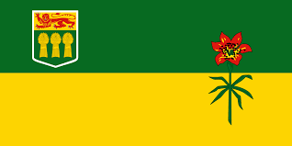
RESOURCES, TOOLS, AND SUPPORTS
    - Child Abuse Education and Response (CAPER) Policy Statement and Administrative Procedure https://www.saskatchewan.ca/government/education-and-child-care-facility-administration/services-for-school-administrators/student-wellness-and-wellbeing/child-abuse-prevention-education-and-response
    - Working Together for Change - Mental Health and Addictions Action Plan 2013 https://www.saskatchewan.ca/government/health-care-administration-and-provider-resources/saskatchewan-health-initiatives/mental-health-and-addictions-action-plan
    - Framework for a Provincial Education Plan https://publications.saskatchewan.ca/#/products/103407
    - Mental Health First Aid Training for K-12 Staff https://www.saskatchewan.ca/government/news-and-media/2020/december/02/400000-provided-for-mental-health-first-aid-training-for-k12-school-staff#:~:text=The%20Government%20of%20Saskatchewan%20announced,member%20in%20each%20Saskatchewan%20school.&text=The%20in%2Dperson%20training%20is,be%20available%20online%20in%202021.
    - Nourishing Minds and Inspiring Movement support school divisions in encouraging 30 minutes of moderate to vigorous physical activity each day and to increase healthy food options at school.
    - Sasktel Be Kind Online: https://bekindonline.com/
    - Report Bullying Saskatchewan Student Online Reporting tool: https://reportbullyingsk.reportcloud.ca/apps/bullying/
    - Digital Citizenship Education in Saskatchewan Schools: A Policy Planning Guide for School Divisions and Schools to Implement Digital Citizenship Education from Kindergarten to Grade 12: https://publications.saskatchewan.ca/#/products/74447
    - Digital Citizenship Continuum from Kindergarten to Grade 12: https://bekindonline.com/wp-content/uploads/2019/02/Digital-Citizenship-Continuum-from-Kindergarten-to-Grade-12.pdf

  - Programs, initiatives or activities that are designed to promote positive school climates as an approach to well-being.
    - Mental Health Capacity Building:
https://www.saskatchewan.ca/government/news-and-media/2019/february/27/mental-health-building-pilots
    - Deepening the Discussion: Gender and Sexual Diversity: https://www.saskatchewan.ca/government/education-and-child-care-facility-administration/services-for-school-administrators/student-wellness-and-wellbeing/gender-and-sexual-diversity
    - Deepening the Discussion: Gender and Sexual Diversity Toolkit: https://www.edonline.sk.ca/webapps/blackboard/content/listContentEditable.jsp?content_id=_248851_1&course_id=_4640_1
    - Ministry of Education Policy Statement: Student Alliances for Gender and Sexual Diversity in Saskatchewan Schools: http://publications.saskatchewan.ca/api/v1/products/89505/formats/106357/download

  - Plans / Approaches can be designed for a range of audiences including, but not limited to:
    - Whole school
    - Targeted (e.g., by gender/grade)
    - Students
    - Staff
    - Educators (e.g., pedagogy)
    - Parents/Guardians
    - Saskatchewan’s Action Plan to Address Bullying and Cyberbullying-2013
https://publications.saskatchewan.ca/api/v1/products/76373/formats/85652/download
    - Caring and Respectful Schools 2004 (currently under renewal)
    - https://publications.saskatchewan.ca/api/v1/products/76795/formats/86084/download
    - Pillars for Life: The Saskatchewan Suicide Prevention Plan https://www.saskatchewan.ca/government/health-care-administration-and-provider-resources/saskatchewan-health-initiatives/suicide-prevention-plan
APPENDIX D: MANITOBA
Manitoba

RESOURCES, TOOLS, AND SUPPORTS
1. https://www.gov.mb.ca/mh/docs/roadmap.pdf - Manitoba’s five-year plan for improving wellness, mental health, substance use and addictions services and programs in the province – A Pathway to Mental Health and Community Wellness: A Roadmap for Manitoba.
Manitoba is committed to providing services for children and youth that consider both mental and physical health care to support their well-being. Supporting children, youth and their parents/caregivers is crucial to their development and not only leads to better health outcomes, but also improved school achievements and an increased feeling of resilience and belonging. To do this, Manitoba will provide more mental health promotion programming in the school system, strengthen the Healthy Food in Schools initiative and expand the availability of school-based services and programming across the province.
2. The Healthy Schools Initiative in Manitoba promotes the health and wellness of students, their families, school staff, and school communities. It is a partnership between Manitoba Health, Manitoba Education and Early Childhood Learning, and Child and Youth Programs (which is a partnership of all departments connected to children). Good health is necessary for learning. Schools can positively influence several of the determinants that affect healthy child, adolescent, and family development. Multiple initiatives are under the Healthy Schools Initiative umbrella:
The Healthy Schools Grant advances comprehensive school health by supporting projects that enhance health and wellness among school-aged children and youth to create sustainable healthy school communities. The Healthy Schools Grant enables school communities to infuse wellness into the culture of their schools by focusing on the priority health topics of Healthy Schools: healthy eating, mental health, physical activity, safety and injury prevention, sexual health, and substance abuse and addictions. The Healthy Schools Grant is available to all schools in Manitoba.
Funding is also provided to community-based organizations to deliver health promotion programming and services in schools such as:
Project 11: a school-based mental health promotion program for students in kindergarten to Grade 12, available in French and English. This initiative includes virtual and in-person lessons and activities designed to improve mental health awareness and positive coping strategies for students. Lessons are aligned directly with curricular outcomes.

Thrival Kits: are distributed to children in grades 4-6 across Manitoba to teach, encourage and support children to adopt positive mental health practices and embed these practices into their daily lives to promote positive well-being into adulthood.
The Healthy Schools Initiative encourages schools to use a CSH framework from Canada’s Joint Consortium for School Health to support improved student health and learning outcomes. Healthy School Planners are also encouraged to direct school decision-making and planning to improve the health of school communities.
Resources are created and available to all schools: Growing Up Ok!
3. Manitoba has enhanced access to school-based mental health and addictions supports, expanding school-based clinical teams with psychiatric nurses and addictions support workers.
4. Manitoba Education and Early Childhood Learning released the document “Connecting Mental Health Literacy and Well-Being to the Physical Education/Health Education Curriculum” in the Fall of 2021. The aim of the document was to enhance understanding of the integration of mental health throughout the current Manitoba K-12 PE/HE Curriculum and to increase awareness of resources that were available to support the implementation of mental health outcomes in the PE/HE Curriculum.
5. Manitoba Education and Early Childhood Learning is currently in the process of redeveloping K-12 Physical Education/ Health Education Curriculum. Content is expected to be released in April of 2023.
6. Manitoba Education and Early Childhood Learning requires school divisions and funded independent schools to develop and implement Respect for Human Diversity Policies that helps Manitoba schools become safer, more equitable, and inclusive. Safe and Caring Schools a Resource for Equity and Inclusion in Manitoba Schools is a tool for equity and inclusions with respect to diversity of sexuality and gender identity and expression. Supporting Transgender and Gender Diverse Students in Manitoba Schools, provides guidelines for ensuring schools are safe and respectful places for transgender and gender diverse students. Responding to Religious Diversity in Manitoba Schools, helps educators respond to the needs of religiously diverse students. Creating Racism-Free Schools through Critical/Courageous Conversations on Race helps inform educators on the effects of racism and how to create equitable, inclusive classrooms. Critical/Courageous Conversations on Race: What your child is learning at school and how you can help is a parent’s version of the Creating Racism Free Schools Document

APPENDIX E: ONTARIO
Ontario 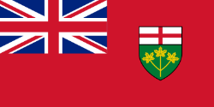

SCHOOL-BASED MENTAL HEALTH LEGISLATION, POLICIES / GUIDELINES
Currently there is no legislative direction in the Education Act that requires district school boards to provide mental health supports for students.

However, the Education Act requires all school boards “promote student achievement and well-being and promote a positive school climate that is inclusive and accepting of all pupils” (Section 169.1, Education Act).

Beginning in 2011, the government launched a cross-government Mental Health and Addictions strategy. The development of the strategy involved multiple ministries with the intention of creating a more integrated and responsive mental health system across the lifespan. The first area of focus was the child and youth mental health system. It was recognized that schools are an ideal place for mental health promotion, prevention and early intervention services.
Prior to 2011, a number of district school boards were providing mental health supports to students; some district school boards had been doing this for quite some time. However, 2011 marked the beginning of the Ministry of Education’s systematic effort to build a consistent approach to student mental health across all 72 district school boards.
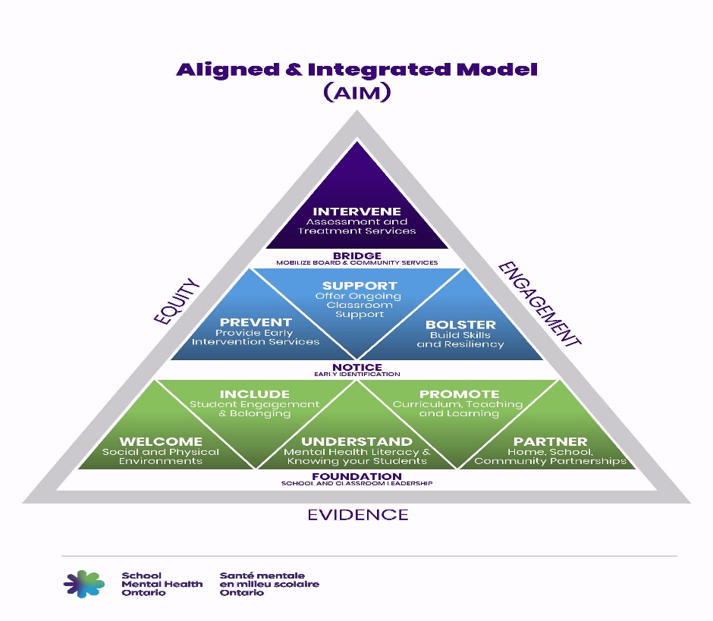
From 2011 to 2017, this included creating the necessary conditions and capacity for implementing an evidence-based approach to student mental health across the province. The ministry focused on creating a comprehensive mental health prevention, promotion, and early intervention structure of supports for all schools.
From the outset, Ontario determined that its school-based mental health model would be assets-based rather than utilize a medical model focused on the diagnoses and treatment of mental illness. Ontario promotes a tiered approach to mental health intervention that supports well-being for all students (Tier 1 – Promotion and Early Identification), more targeted evidence-based help for students requiring additional support and for students that require more intensive treatment (Tier 2 – Prevention and Early Intervention), access to services from community partners when this is required (Tier 3 Intervention and Pathways to Care). Multi-tiered models of support are useful for managing student mental health in schools in regular times but are even more critical when responding to existing and emerging student mental health needs. The following diagram (Aligned and Integrated Model [AIM]) visually explains the tiered approach to mental health intervention in Ontario schools.
As a starting point, the Ministry of Education made the following initial strategic investments in student mental health:
- Amended the education curriculum as part of the regular curriculum review process starting in 2011/12, by enhancing health promotion, emphasizing healthy development and optimal mental health.
- Developed a K-12 Resource Guide to provide educators with information on promotion of healthy development, the early signs of mental health and addiction issues, and strategies that can be used in the classroom to support students.
- Created School Mental Health ASSIST, now renamed School Mental Health Ontario (SMH-ON), an implementation support team with clinical expertise to work with district school boards on student mental health and well-being, with a focus on differentiated capacity-building for a variety of school-based professionals and effective implementation of mental health promotion and prevention programming.
- Funded a Mental Health Leader position in each district school board to lead the development and implementation of a mental health strategy tailored to the local conditions and needs of each district school board. The ministry requires all district school boards to have a three-year board level strategy and one-year action plan that includes support for principals and educators by providing mental health literacy training and facilitating collaboration with both district school board and community mental health providers. These new “Mental Health Leader” positions were rolled out over a three-year timeframe, with all district school boards having a mental health leader and district school board mental health strategy and action plan in place for the 2014-15 school year.
- Provided support for district school boards to provide mental health literacy training for all educators in the province by making available literacy resources to support professional learning opportunities focused on capacity building in mental health and addictions to support students with mental health and addiction issues.
The Ministry of Education was very deliberate and methodical in its approach to supporting student mental health. From 2011 to 2017, working very closely with the ministry’s implementation partner, School Mental Health Ontario (SMH-ON), there was a sustained focus on systematically creating and supporting district school board mental health leadership teams across all 72 provincially funded district school boards to support and provide a consistent, evidence-based approach to student mental health.
From its inception, SMH-ON has been instrumental in helping district school boards to build the foundation, capacity and support for effective and sustainable school mental health practices that are evidence-informed and aligned with Ontario’s school priorities and processes.
During this first phase of implementation support, SMH-ON focused on establishing foundations for effective school mental health practices alongside key stakeholder groups, including teacher federations and principal associations. System and school leaders, particularly Mental Health Leaders and Superintendents with responsibility for mental health, were instrumental in the co-design and co-creation of many of the SMH-ON resources. The collaboration with district school boards and partners remains a cornerstone of Ontario’s approach.
The six key strategic priorities of this initial development phase were:
- Establish organizational conditions;
- Build capacity;
- Introduce evidence-based mental health promotion and prevention programming for all students;
- Support specific populations;
- Contribute to system coordination across sectors; and
- Engage students and school leadership in mental health.
Building upon the initial phase from 2011-2017, in 2018 efforts began, and continue, to scale up mental health promotion, prevention, and early intervention consistently across all schools in the province including:
- Building expertise of school administrators, educators and school-based mental health professionals;
- Providing specific resources for under-served populations;
- Provincial funding for the hiring of school-based mental health professionals in secondary schools (beginning in 2018-19 and continuing);
- Measurement-based care to focus efforts and resources on supports for students that will have the greatest impact; and,
- Encouraging schools to work more closely together with community-based mental health partners to make the best use of resources and develop pathways to care.

Through a collaborative approach, SMH-ON continues to work closely with Mental Health Leaders in district school boards by providing coaching and support for the implementation of their mental health strategies and action plans. The district school board strategies include building educators’ awareness of everyday classroom practices to support student mental health as well as mental health literacy, providing strategies to front-line workers to support students, and working with community partners to promote a proactive, integrated system of care, with clear pathways to/from/through service for students in need of more intensive support.

The ministry provided district school boards with direction concerning the following areas of focus for the 2020-21 school year:
- Continue to implement a tiered approach to mental health that supports well-being for all students, while offering more targeted evidence-based help for those students requiring additional support.

- With the support of SMH-ON, continue efforts to provide ongoing professional learning and related resources to educators and other support professionals. The comprehensive Mentally Healthy Return to School Toolkit should be widely used.

- Be ready to provide enhanced tier two prevention and early intervention services, as the COVID-19 pandemic led to new and increased mental health concerns. SMH-ON will continue to offer training and coaching support in brief services to school-based professionals.

- At tier three, continue collaborating with local child and youth mental health agencies and local healthcare partners to support strong connections and make the best use of mental health resources and supports across the integrated system of mental healthcare.

- Work with local community and healthcare partners to update and enhance district school boards’ suicide prevention, intervention and postvention protocols and ensure that all school administrators and educators have working knowledge of these protocols and know how to reach out for help immediately on behalf of students.

- In order to address existing inequities, pay greater attention to the issues related to the mental health of underserved populations, especially of groups that have been marginalized, such as racialized communities. School boards should tailor mental health resources to address the expressed needs of Black, Indigenous and other underserved students.
As part of the return to school direction for fall 2020, in the Guide to Re-Opening Ontario’s Schools, district school boards were asked to work with partners to develop local protocols for school access by regulated professionals, regulated social service professionals and paraprofessionals for the purpose of delivering school-based supports and services.

RESOURCES, TOOLS, AND SUPPORTS
Supports

Since 2011, the ministry has made strategic investments in school-based mental health. The ministry’s regular investments in student mental health for the 2020-21 school year include:

- School Mental Health Ontario ($6.5 million), the ministry’s implementation partner, to continue to provide all 72 district school boards with implementation support through clinical expertise, evidence-based resources and practical tools for educators, and the delivery of consistent professional learning to a variety of school-based staff, including mental health professionals.

- Mental Health Leaders ($10.4 million) in district school boards, school board staff who are senior clinicians/professionals working closely with School Mental Health Ontario to provide leadership support in their school board for student mental health.

- Mental Health Workers in Secondary Schools ($25 million), school board staff (approximately 180 full-time equivalent positions) who are regulated mental health professionals (e.g., social workers, psychologists and psychotherapists) with specialized training in student mental health, providing mental health promotion, prevention, and intervention to students and referrals to community partners.

- The Well-Being and Mental Health Bundle ($3 million) which is funding district school boards use to meet local needs and priorities that promote well-being and mental health, including safe, healthy, inclusive and accepting learning environments.

Due to the ongoing foundational investments in student mental health which began in 2011 and continue, Ontario had the infrastructure in place across all district school boards in order to make further investments during the COVID-19 pandemic to address the mental health needs of all students, including those more impacted by the effects of the pandemic.
In 2020-21, Ontario students have unprecedented access to school-based mental health supports through new investments, in addition to the investments mentioned above, that include:

- $29 million in new dedicated mental health funding to be used by school boards to proactively support students given the impact of COVID-19 on mental health and well-being.

- $12.5 million in new one-time federal funding to be utilized by school boards in the area of mental health and/or special education to allow boards to hire and train additional staff to provide more supports for students as they return to school.

- $8 million in additional funding provided to school boards to provide for the continuation of school-based mental health supports to students throughout the summer of 2020. During the summer months mental health workers, educators and system leaders received additional training in student mental health.

- School boards were provided with an additional $7.6 million in funding to be used to deliver transition programing for students with high special education needs and/or mental health needs in the two weeks prior to school starting in 2020. This funding was intended to focus on closing gaps in skills development and learning, and on establishing routines for those students for whom a return to school may have proved most challenging.

- To support the provision of mental health services remotely, the ministry entered into an agreement with Ontario Health (Ontario Telemedicine Network) to provide district school boards with access to their virtual care platform (at no cost) since June 1, 2020 and until October 31, 2021.

In addition to the above K-12 education sector specific investments, the government has provided over $147 million to immediately expand access to the provincial mental health and addictions system for people of all ages and address capacity issues in response to COVID-19.

This broad provincial funding includes more than $51.5 million for a cross-sectoral approach to support vulnerable populations, including but not limited to postsecondary students, First Nations communities, Metis, Inuit and urban Indigenous peoples, Black youth, children and youth in care, LGBTQ youth, people with developmental disabilities, and victims of gender-based violence.

The Ministry of Education has also provided $1 million in funding to Kids Help Phone for the provision of counselling support related to topics such as bullying/cyberbullying and mental health.

Resources and Tools
Ontario has been intentional about adopting an asset-based model of student mental health. Ontario has chosen to create sustainable made-in Ontario evidence-based resources that are readily implemented by Ontario schools. These resources are available free of charge to all district school boards and Mental Health Leaders within the district school boards are available to assist schools determine which resources are best for local situations and to provide training and support. Ontario has resisted buying costly proprietary programs that typically require intensive modification and training, opting instead to invest in School Mental Health Ontario for evidence-based programs and resources built for, and often with, Ontario schools.

Ontario’s resources are often differentiated by role and accompanied by robust training and implementation plans and supports provided by SMH-ON. These supports are then contextualized to local context by the Mental Health Leaders for staff within each district school board.

Student learning about mental health and well-being is embedded in both the elementary health and physical education (HPE) and mathematics curricula through learning expectations focused on social-emotional learning skills. Mental health literacy is also part of the elementary HPE curriculum. Information that supports teaching and learning about mental health and well-being is found in the preface of all elementary and secondary curricula.

Resources Developed to Address the Impacts of the COVID-19 Pandemic

For the period March 2020 through to the end of the 2019-20 school year, Ontario students were not in school due to the COVID-19 pandemic. To support the return to classroom learning in fall 2020, the ministry engaged its implementation partner, School Mental Health Ontario, experts in the field of student mental health, to provide a Mentally Healthy Return to School Toolkit for use by all Ontario educators.

The resources found within the Toolkit are intended for various audiences, including directors, superintendents, school mental health professionals, educators, students and parents. Resources from the Toolkit were used to support professional learning for all Ontario educators prior to the return to school in fall 2020 and include a strong focus on building students' social emotional learning skills so that they can build resilience, manage their stress and build positive relationships. The Toolkit materials are intended to be used throughout the 2020-21 school year and into the future. Many of the Toolkit resources are publicly available and can be found on the SMH-ON website: https://smho-smso.ca

The Toolkit materials promote a culturally responsive approach to student mental health. For example, there are resources on how to support conversations with racialized students about mental health. SMH-ON is collaborating with others to develop resources and professional learning to address the impact of oppression on mental health and the connection between student mental health and systemic anti-Black and anti-Indigenous racism.

The Toolkit includes a series of slides, videos, handouts, and classroom resources to support a mentally healthy return to school for all students. A sampling of the resources available include:

- slide deck outlining key concepts of student mental health and well-being that educators need to be aware of and local district school board processes and protocols related to student mental health
- the First 10 Days (and Beyond) resource to help educators plan welcoming school and classroom environments for all students
- 5 Things You Need to Know about student mental health for School Leaders

Students continue to navigate a challenging school year including switching to remote learning during the province wide lockdown (December 2020 – February 2021 and continuing). The ministry wanted to ensure that educators, parent, and students have the tools needed to support student mental health and well-being during this period and beyond.

To address the need, School Mental Health Ontario, developed a Student Mental Health Action Kit released in January 2021. The Action Kit is available on SMH-ON’s website and includes a series of lesson plans and resources designed to help educators with creating mentally healthy classroom environments, noticing students whom they may be concerned about, and teaching students about maintaining good mental health including where and how to seek help.

The resources and lesson plans included in the Action Kit are continually being developed and updated for use by educators for both elementary and secondary students. Educators are not required to conduct formal assessment and evaluation of student work related to these resources and lesson plans unless the materials are directly connected to curriculum expectations.

Additional mental health resources for educators, students and parents are posted on the School Mental Health Ontario website site is: https://smho-smso.ca/
A sampling of available resources includes:
Mental Health Literacy for Educators
- Mental Health in Action on-line course which is designed to provide educators with basic knowledge and information related to mental health, strategies to enhance student mental health, and everyday practices for use in the classroom.
Supporting Minds Strategies at a Glance: Ideas to Support and Bolster Students with Mental Health Problems in the Classroom
- This resource offers classroom educators ideas to SUPPORT students by offering accommodations and modifications to help students to be successful in the classroom and to BOLSTER students by helping to build skills and strategies for supporting mental health
Circle of Support and System Pathways Circle of Support and System Pathways Flowchart
- Designed as a guide for staff when they are concerned about a student and wondering if additional mental health support might be required

Leading Mentally Healthy Schools: A Resource for School Administrators
- This resource provides an overview of key information and resources helpful to administrators in fostering mentally healthy school environments for students and staff.

How to Talk with Your Child When You Feel Concerned, they may be Struggling with a Mental Health Problem
- Tips on how to support a conversation with your child on mental health.

Prepare; Prevent; and Respond: A Suicide Prevention Guide for Parents and Families During COVID-19 and Return to School
- This guide is designed to help by answering some frequently asked questions so that parents and families can prepare, prevent, and respond if they are concerned that their child or teen is experiencing thoughts of suicide.
Additional professional learning materials, including webinars, learning modules, decision-support tools, etc. that highlight a variety of supports for the mental health and well-being of students are also available to school board staff through a provincial virtual learning environment.
IMPLEMENTATION - EVALUTION OF IMPACTS
While there has been no overall formal evaluation of the mental health supports and resources, the Ministry of Education has been methodical and deliberate in its implementation approach. For instance, the rollout of Mental Health Leaders across all 72 district school boards was phased in over three years which enabled the ministry to monitor and adjust supports and resources during the implementation and to make changes as necessary.
Implementation science is a guiding principle in the work of School Mental Health Ontario. D Fixsen, K Blasé and A Metx in a presentation entitled, The Current State of Implementation Science: The Critical Role of Research Education define implementation science as “the scientific study of methods to promote the systematic uptake of clinical research findings and other evidence-based practices into routine practice.”
As a result of taking an implementation science approach, Ontario has been able to bring alignment, consistency, quality, engagement, scalability and sustainability to mental health and wellness practices in Ontario schools and continue to develop made in Ontario resources for Ontario school boards at low or no cost avoiding difficulties with scaling and sustaining proprietary programs.
SMH-ON routinely surveys district school boards through a “mental health scan” to assist with monitoring of the mental health strategies and one-year action plans and to identify emerging priority areas of concern in the area of student mental health for Ontario’s district school boards.
In 2019, SMH-ON, in collaboration with Wisdom2Action launched the #HearNowON initiative to gather student voice from across the province regarding their mental health knowledge needs, ideas for mental health promotion, and to hear about how students would like to be involved in mental health initiatives. Through a provincial survey, regional forums and youth consultations, over 1,000 young people took part in the initiative. The information gathered from this initiative led to a final report that is helping the Ministry of Education, SMH-ON and school boards across the province understand what students want and need with respect to school mental health.
The ministry recently funded a third-party evaluation of the mental health workers; however, the evaluation was postponed due to the pandemic.
COMMON MESSAGING (Health, Education)
- Mental health is something we all want and need, and something that we need to pay attention to and nurture, just as we do with our physical health. That is why this government has prioritized mental health. ​The mental health and well-being for students, staff and families are inextricably linked, as the current COVID-19 pandemic has shown all of us.

- COVID-19 has impacted all students and their families. It has made circumstances especially challenging and it has meant that many more families and students face new vulnerabilities. The Ministry of Education is committed to supporting the mental health of all students.

- The mental health and well-being of students and staff is of critical importance. Schools are an ideal setting for mental health promotion, prevention, identification and early intervention. Students who report feeling mentally well, are more ready to learn, feel a stronger sense of belonging at school, and perform better academically.

CHALLENGES, NEEDS, QUESTIONS, AND SUCCESSES

Challenges were prompted by the COVID-19 pandemic, and the uncertainty generated by possible additional waves of the pandemic, however, the ministry planned accordingly and acted swiftly to mitigate issues.

Ontario has a strong foundation in supporting the mental health of all students. Sustained efforts are needed both within the education sector as well as with community child and youth mental health agencies to ensure alignment of services and clear pathways to care.

APPENDIX E: NEWFOUNDLAND AND LABRADOR
Newfoundland and Labrador
SCHOOL-BASED MENTAL HEALTH LEGISLATION, POLICIES / GUIDELINES

The Department of Education is a partner in the Violence Prevention Initiative of the Government of Newfoundland and Labrador. In support of this initiative, the Student Support Services Division of the Department of Education has established a Safe and Caring Schools Initiative to promote safe and caring learning environments and to be pro-active/preventative in addressing violence issues.

Government of Newfoundland Safe and Caring schools policy (currently being revised): k12_safeandcaring_sacs_policy_procedures.pdf (gov.nl.ca)

Newfoundland and Labrador Public Health guidance for schools (Covid-19): Public-Health-Guidance-for-K-12-Schools.pdf (gov.nl.ca)

Newfoundland and Labrador English School District safe return to school document: Safe Return to School Reopening Plan (google.com)

Department of Education Responsive Teaching and Learning Policy guides the education of students in the province with a safe, inclusive and healthy school community : RTL-Policy.pdf (gov.nl.ca)

The Government of Newfoundland and Labrador has released action plans that will support positive mental health:

The Autism Action Plan: publications-pdf-autism-action-plan-2019-22.pdf (gov.nl.ca)

The Education Action plan: eap-report.pdf (gov.nl.ca)

Towards Recovery, mental health and addictions action plan: mentalhealth-committee-mentalhealth-pdf-mentalhealth-addictions-plan.pdf (gov.nl.ca)

RESOURCES, TOOLS, AND SUPPORTS
Bridge the gapp is a new way to connect with guidance and support for mental health and addictions in Newfoundland and Labrador. The site has supports for adults, families and youth and includes information on resources available as well as online programs such as Strengthening Families and Therapy Assistance Online (TAO): Bridge the gApp Youth
The Community Addictions Prevention and Mental Health Promotion Fund is a provincial project fund for individuals and not-for-profit community groups with an interest in these issues.: https://www.health.gov.nl.ca/health/grantsfunding/CAPMHP_grant.html

APPENDIX F: NUNAVUT
Nunavut 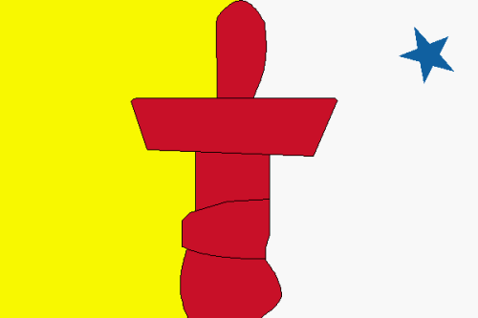

SCHOOL-BASED MENTAL HEALTH LEGISLATION, POLICIES / GUIDELINES

Education Act – Part 6 –covers Inclusive Education in Nunavut schools and outlines access to adjustments and supports for students

Inclusive Education Policy – strategic policy that defines inclusive education in the context of two inter-related pillars: student success and safe and caring schools.

Education Support Services Directive & Flowchart – procedural directive which guides schools on access to specialized support, including pathways to mental health (see attachment)

Information Sharing Directive – procedural directive which guides schools on how to appropriately share information when collaborating with in-school and external service providers. This directive also covers sharing of information in the context of imminent risk of suicide.

Individual Student Support Plans: Guidelines for Development – procedural document which provides guidance on how to embed social-emotional adjustments and supports into personalised learning plans
RESOURCES, TOOLS, AND SUPPORTS
Education Based Human Resources:
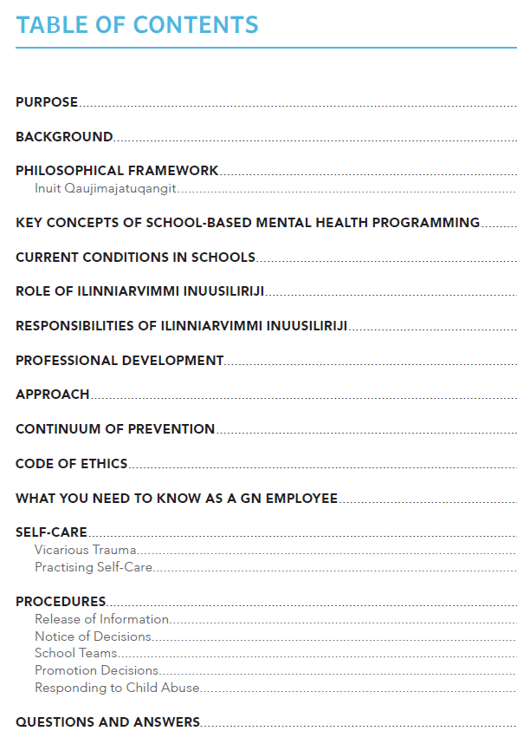
School level
Ilinniarvimmi inuusilirijiit (II) - school based counsellors that support the social-emotional well being of our students. They are members of the school team and are cultural-based vs. clinical counsellors.
Departmental Level
Counselling Development Coordinator & Behaviour and Social Emotional Learning Coordinator – positions within the Dept of Education that directly support school based mental health services and resource development
Resources & Tools
The Inuutsiarniq Literacy Program embeds healthy messaging around mental health. Aulajaaqtut (10-12) focuses on healthy coping strategies and self-esteem.
Ilinniarvimmi Inuusilirijiit Handbook – outlines the role and responsibilities of II and how teachers can access support from them in the school.
Nunavummi Emotional Literacy Series – culturally appropriate social emotional learning resources from K-12. Currently in development and already in use in the primary grades. Picture books, graphic novels, short films, videos, and teacher resources that include foundational skills of self awareness, self-regulation, social awareness in order to acquire skills including, empathy, resiliency and cultural wellness. Sample:
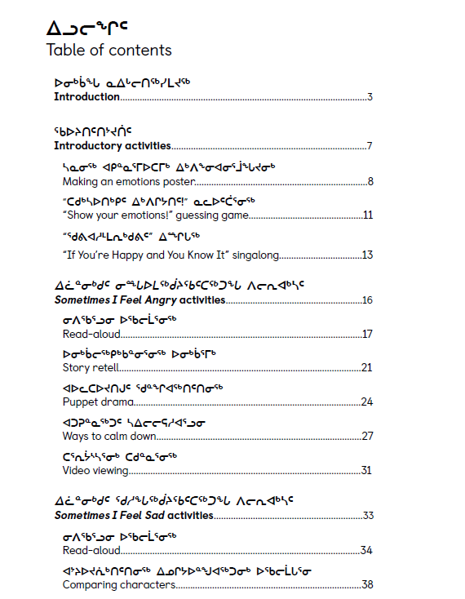
Group Process Guide – handbook geared mostly at II to provide a framework for delivering support to targeted social-emotional programming to groups of students
Northern Zones – self regulation program available for use in Nunavut schools to support self-regulation, adapted from Northern Zones. This program targets Kindergarten-grade 8. Sample:
Mindmasters – mindfulness program available for use in Nunavut schools. This program targets primary students.
RESTORE Toolkit - as part of the resources developed for school staff and educators to support the reopening of schools in 2020, the department developed the RESTORE toolkit. Applying a restoration model and Inuit Qaujimajatuqangit principles, the RESTORE toolkit offers practical strategies to foster safe, caring, and healthy schools within the context of COVID-19. The toolkit includes examples and activities for students focusing on mental health.

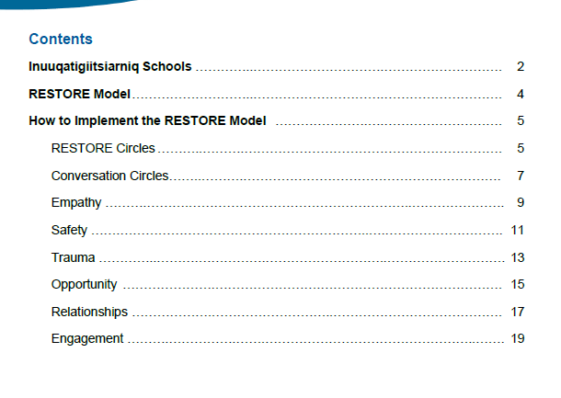

Be Safe! – a personal safety program for primary students which introduces young children to the concepts of children’s rights; safe and supportive friendships; adults’ responsibility to protect children from harm; privacy and safe and unsafe touching; and simple and effective personal safety rules.
Respect Education – training for teachers focusing on approaches to strengthen protective factors in youth. Topics include healthy relationships and bullying prevention.
Services & Other Support
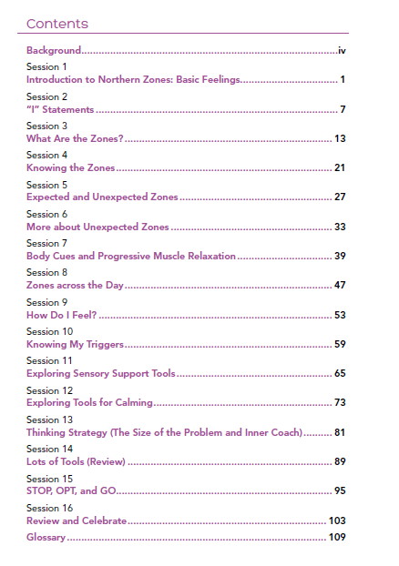
School Based Mental Health Support Service Pilot – beginning in 19-20, this pilot aimed to build on the Education Support Services Directive. The pilot initially planned to provide 2-3 visit per year to targeted schools to support students identified by the school team. The model for this pilot is in flux due to Covid-19, moving to a remote service delivery model.
Psychosocial support – in partnership with the Red Cross, Education can provide psychosocial support upon request to schools following a social emergency or destabilizing crisis. This may include, but is not limited to, psychological first aid training, resources tailored to identified school needs, like safety planning, talking to students about loss, stress management and individual staff and classroom support.
Connected North sessions for students and for staff – interactive sessions for students to nurture wellbeing; interactive webinars related to mental health topics to build school staff capacity (e.g. Student Mental Health and Wellbeing, Working from a Trauma Lens, Supporting Students Facing Adversity, etc.) from a number of service providers.
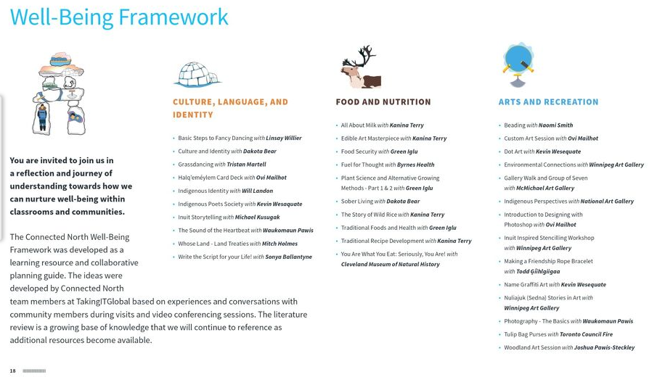
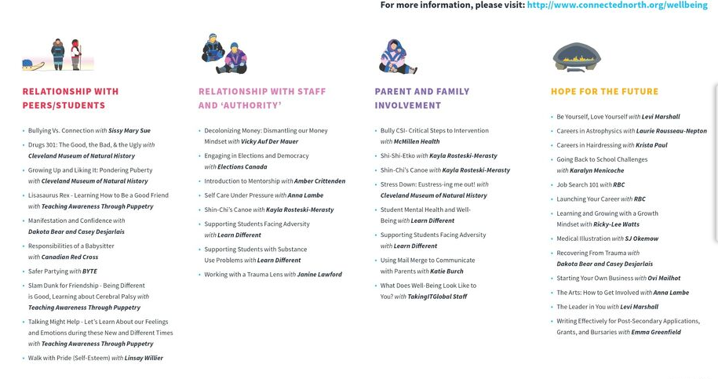

Nipivut Conference – this is a Department of Education driven annual youth leadership conference. Topics include but are not limited to: healthy relationships, supporting peers with grief and loss and developing positive mental health messaging, positive coping/self-care, suicide intervention and prevention.
In some communities, community based Mental Health and Addictions staff (Department of Health) partner with school based II to co-facilitate the Makimautiksat Youth Program within the school setting. Makimautiksat is an evidence-based youth camp which equips Nunavut youth with critical life skills and knowledge that fosters positive mental health and wellness. The Qaujigiartiit Health Research Centre (QHRC) developed the program based on Inuit wellness principles and delivers the facilitator training workshops.

Safe Schools and Anti-Violence Committee - committee, with representatives from the Nunavut Teachers Association and Department of Education meets that meets twice a year and normally updates the Crisis Response Guidelines for Nunavut Schools and the Safety in Schools: Principal’s Planning Manual. This year the committee has reprioritized and is focusing on Covid-19.
Inuusivut Anninaqtuq (United for Life) – Nunavut’s third suicide prevention action plan, which sets out commitments for the department in relation to youth resilience and healthy childhood development (spans 2017-2022).

CHALLENGES, NEEDS, QUESTIONS, AND SUCCESSES

Ongoing Challenges and Questions:

Interdepartmental collaboration

Communication

Vacancy, high turn over in staff, unpredictability with respect to direct service provision and service providers

Training/Capacity Building

Privacy of student information

Logistics (issues relating to distance, travel, internet, etc.)

Approaches: Clinical vs. traditional counselling

See: Our Minds Matter – Office of the Representative of Children and Youth – A youth informed review of mental health services for young Nunavummiut https://rcynu.ca/sites/rcynu.ca/files/RCYO_MHReview_EN_Web.pdf

While JCSH representatives may share this scan with colleagues, please note that this is not public information and is not intended for widespread dissemination.
See Appendices for each P/T for additional notes

