Bullying Prevention and Cyber Safety

Environmental Scan

July 2020

Guidelines for Scan Completion
Bullying Prevention and Cyber Safety
June 2020
Request:
- To collect information on emerging, promising or evidence-based approaches to preventing and addressing bullying and cyberbullying among students in each province/territory in Canada.
- To identify any cyber safety related initiatives/resources that, for example, provide information on staying safe online
- Information will be compiled and shared with members of the Joint Consortium for School Health (JCSH).

What is in scope:
- Building on the work of PREVNET, the scope is focused on effective bullying prevent and intervention approaches.
- The focus of the scan is on bullying and cyberbullying among students in publicly funded schools from Kindergarten to Grade 12.
- Bullying and Cyberbullying as defined by publicly-funded school boards and/or local governments in provinces and territories.
- Cyber Safety such as exploitation and protecting privacy online
- Approach includes:
  - Programs, initiatives or activities that are designed to eliminate or reduce the occurrence of bullying/cyberbullying; and
  - Programs, initiatives or activities that are designed to promote positive school climates as an approach to bullying prevention. These include, but are not limited to, programs that focus on equity promotion (e.g., anti-racism, anti-homophobia) and/or activities focused on social-emotional skills (e.g., promoting compassion, belonging, empathy, mindfulness)
- Approaches can be designed for a range of audiences including, but not limited to:
  - Whole school
  - Targeted (e.g., by gender/grade)
  - Students who Bully
  - Student who is Bullied
  - Bystanders/Witnesses
  - Parents/Guardians
  - Educators (e.g., pedagogy)
- Approaches can be:
  - promising practice
    - Effectiveness demonstrated through evaluation or qualitative data/user experience
    - Holds promise for other organizations to adapt the approaches based on the soundness of the evidence
  - emerging practice
    - New innovative practices that hold promise based on some level of evidence of effectiveness or change
  - evidence-based and/or evaluated
    - Formally evaluated
Out-of-scope:
- Incidents of workplace violence (e.g., student to teacher)
- Incidents involving teachers (e.g., teacher to student)

British Columbia

Alberta

Saskatchewan 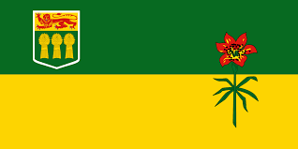 June 2020
- Programs, initiatives or activities that are designed to eliminate or reduce the occurrence of bullying/cyberbullying
  - Sasktel Be Kind Online: https://bekindonline.com/
  - Report Bullying Saskatchewan Student Online Reporting tool: https://reportbullyingsk.reportcloud.ca/apps/bullying/
  - Digital Citizenship Education in Saskatchewan Schools: A Policy Planning Guide for School Divisions and Schools to Implement Digital Citizenship Education from Kindergarten to Grade 12: https://publications.saskatchewan.ca/#/products/74447
  - Digital Citizenship Continuum from Kindergarten to Grade 12: https://bekindonline.com/wp-content/uploads/2019/02/Digital-Citizenship-Continuum-from-Kindergarten-to-Grade-12.pdf
- Programs, initiatives or activities that are designed to promote positive school climates as an approach to bullying prevention. These include, but are not limited to, programs that focus on equity promotion (e.g., anti-racism, anti-homophobia) and/or activities focused on social-emotional skills (e.g., promoting compassion, belonging, empathy, mindfulness)
    - Mental Health Capacity Building: https://www.saskatchewan.ca/government/news-and-media/2019/february/27/mental-health-building-pilots
    - Deepening the Discussion: Gender and Sexual Diversity: https://www.saskatchewan.ca/government/education-and-child-care-facility-administration/services-for-school-administrators/student-wellness-and-wellbeing/gender-and-sexual-diversity
    - Deepening the Discussion: Gender and Sexual Diversity Toolkit: https://www.edonline.sk.ca/webapps/blackboard/content/listContentEditable.jsp?content_id=_248851_1&course_id=_4640_1
    - Ministry of Education Policy Statement: Student Alliances for Gender and Sexual Diversity in Saskatchewan Schools: http://publications.saskatchewan.ca/api/v1/products/89505/formats/106357/download

- Approaches can be designed for a range of audiences including, but not limited to:
  - Whole school
  - Targeted (e.g., by gender/grade)
  - Students who Bully
  - Student who is Bullied
  - Bystanders/Witnesses
  - Parents/Guardians
  - Educators (e.g., pedagogy)
    - Saskatchewan’s Action Plan to Address Bullying and Cyberbullying-2013
https://publications.saskatchewan.ca/api/v1/products/76373/formats/85652/download
    - Caring and Respectful Schools 2004 (currently under renewal)
https://publications.saskatchewan.ca/api/v1/products/76795/formats/86084/download

Manitoba 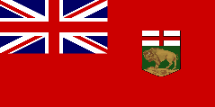

Ontario 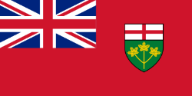

New Brunswick 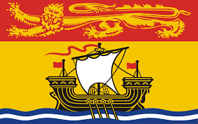

Nova Scotia 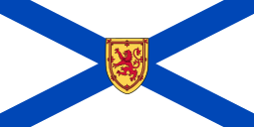

Prince Edward Island 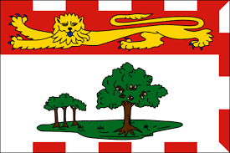
Newfoundland and Labrador July 2020
The Department of Education and Early Childhood Development Safe and Caring Schools Policy (revised 2013) provides guidance to educational stakeholders, particularly to schools and districts, in the development and maintenance of a safe, caring and inclusive learning environment. As well, it outlines a structure for the collection and analysis of data to inform school development plans, to shape practice and to ensure accountability.
The policy includes procedures in positive behaviour supports, code of conduct, bullying intervention protocol, nonviolent crises intervention guidelines, and teaching digital citizenship: https://www.gov.nl.ca/eecd/files/k12_safeandcaring_sacs_policy_procedures.pdf

Nunavut 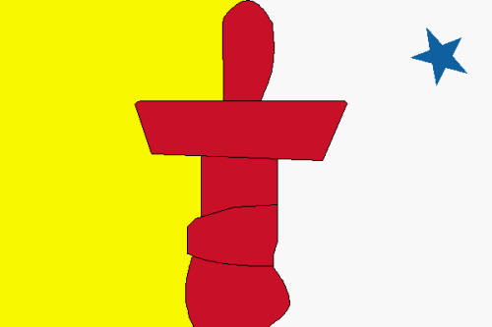 June 2020
Human Resources
- Behaviour and Social Emotional Learning Coordinator position within Student Achievement division to support the development, sharing of resources and to directly support schools.
- Each school has at least one Ilinniarvimmi inuusilirijiit (II) position. This is a position unique to Nunavut, best translated as a cultural counsellor. II providing direct support to students (whole group, small group, 1:1 support), also acting in an advocacy role and as a liason between schools and families. II are members of the school team in Nunavut.
Policy
- District Education Authorities must address the issue of bullying in their Inuuqatigiitsiarniq (Positive School Environment) Policy. All schools must have an Inuuqatigiitsiarniq policy in place.
- Nunavut has a (draft) Inclusive Education Policy which applies to all schools.
- The Crisis Response Guidelines for Nunavut Schools (2016-2019) & Staff and Principal Manuals contain guidelines for schools to prevent and address bullying and resulting incidents.

Training
- RespectEd training for staff (ongoing) - training on violence prevention, healthy relationships and bullying prevention. It provides educators with a set of learning resources that they can choose to apply at their discretion within the class but outside the regular school curriculum.
- Annual Youth Conference for students - the conference rotates, each year in one of four geographical regions. Training topics include bullying prevention, healthy relationship building, suicide prevention and positive coping skills/self-care.
- Bullying Prevention Youth Facilitator Training (ongoing) - provides youth with skills that build upon their knowledge and leverage their potential to be positive role models in their community.

Curriculum
Aulajaaqtut is a strand of the Nunavut curriculum and there is a course of the same name. The Aulajaaqtut course is mandatory in grades 10 & 11 (optional in grade 12) focusing on health, emotional and cultural wellness, safety, physical education, goal setting and career exploration and planning. An important component of this course is healthy relationships, self-esteem, tolerance and understanding for others.

Other Programs
The Department of Education has developed social emotional resources for use in Nunavut schools. These resources are optional. Examples includes:
- Northern Zones is a K-9 social emotional curriculum developed for use in Nunavut focused most heavily on self-regulation
- Mindmasters is a mindfulness resource adapted for use in Nunavut to support the overall wellbeing of students

Northwest Territories 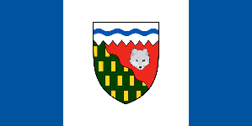
Yukon 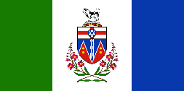

National Resources 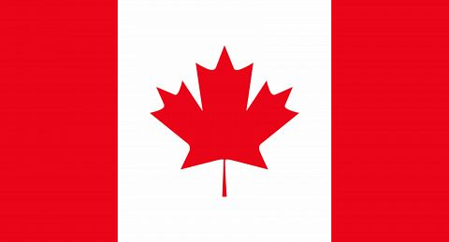
(including) Public Health Agency of Canada

International Resources

Research

