Equity

Environmental Scan

May 2016

Equity: A condition or state of fair, inclusive, and respectful treatment of all members of the school community, regardless of individual differences. All persons have the opportunity to participate fully and to experience success, well-being, and dignity while developing the skills, knowledge, and attitudes necessary to contribute meaningfully to society.
Embedded in this definition are the following points:
- Equity does not mean treating all people the same
- Equity means ‘raising the bar and closing the gap’
- Equity works to avoid and overcome inequalities that infringe on fairness and human rights norms.

Guidelines for Scan Completion
- EQUITY LEGISLATION, POLICIES / GUIDELINES
- Note any overarching or supporting policies connected to equity; these could be at the provincial / territorial as well as the school board / district levels.

- RESOURCES, TOOLS, AND SUPPORTS
- List equity as well as inclusion / diversity resources/tools used in your jurisdiction.
- Are there any curriculum or learning outcomes in your jurisdiction that have equity elements?
- Does your jurisdiction’s school boards/divisions, schools have GSAs (Gay-Straight Alliances) or other school-based peer support equity groups?

- EVALUATION OF IMPACTS
- Use this section to describe any evaluation plans, indicators, measures, and measurement tools your jurisdiction is using regarding to support and enhance equity. Does your jurisdiction have targets? Does your jurisdiction have any results to share?

- COMMON MESSAGING (Health, Education)

- CHALLENGES, NEEDS, QUESTIONS, AND SUCCESSES
- Use this section to describe any/all challenges, needs, questions, and successes.

British Columbia

(A) EQUITY LEGISLATION, POLICIES / GUIDELINES

Diversity in BC Schools: A Framework (Ministry of Education diversity policy) http://www.bced.gov.bc.ca/diversity/diversity_framework.pdf
- Safe Caring and Orderly Schools: A Guide (Ministry of Education safe school policy) http://www.bced.gov.bc.ca/sco/guide/scoguide.pdf
- BC Performance Standards – Social Responsibility (Ministry of Education) http://www.bced.gov.bc.ca/perf_stands/social_resp.htm
(B) RESOURCES, TOOLS, AND SUPPORTS
- Ministry resources:
  - Keeping Kids Safe (from bullying harassment and intimidation) A Guide for Parents (Ministry of Education) http://www.bced.gov.bc.ca/sco/resourcedocs/keeping_kids_safe/keeping_kids_safe.pdf
  - Your Role in Helping Children and Youth Develop Healthy Relationship Skills, developed for teachers (Ministry of Education) http://www.bced.gov.bc.ca/sco/relationship.pdf
  - Making Space: Teaching for Diversity and Social Justice Throughout the K-12 Curriculum (Ministry of Education) (links to provincially prescribed curricula) http://www.bced.gov.bc.ca/irp/program_delivery/ss.htm
- Partner Resources
  - Indian Residential Schools and Reconciliation Resources - http://www.fnesc.ca/learningfirstpeoples/indian-residential-schools-and-reconciliation/
  - Sexual health of youth in BC - http://www.mcs.bc.ca/pdf/AHSV_sexual_health.pdf
  - The BC Teachers Federation has created an LGBTQ Action Group that offers a number of resources for teachers, including lesson plans, workshops, videos, brochures, posters, etc. More information is available at http://www.bctf.ca/SocialJustice.aspx?id=6106.
  - Pride Education Network resources include:
    - Challenging Homophobia – A teacher’s resource book http://pridenet.ca/wp-content/uploads/challenging-homophobia.pdf
    - Dealing with Name-Calling 2010 http://pridenet.ca/wp-content/uploads/dealing-with-name-calling.pdf
    - Myths About Anti-homophobia Education http://pridenet.ca/wp-content/uploads/myths-about-anti-homophobia.pdf
    - Myths About Anti-homophobia Education (Chinese) http://pridenet.ca/wp-content/uploads/myths-about-anti-homophobia-c.pdf
    - Objections to Anti-Homophobia Education http://pridenet.ca/wp-content/uploads/h-h-objections.pdf
    - The Gender Spectrum http://pridenet.ca/wp-content/uploads/the-gender-spectrum.pdf
- School District Developed Resources
  - Questions and Answers For Parents and Family Members of Gay and Lesbian Youth –This booklet was developed by School District 39 (Vancouver) and made available provincially via the BC Ministry of Education website to help parents and family members with their child’s coming out process, or preparing for the process. (available in English, Chinese, Vietnamese, Filipino, French, Korean, Punjabi, and Chinese Traditional).
(C) IMPLEMENTATION --EVALUTION OF IMPACTS
(D) COMMON MESSAGING (Health, Education)

The BC school system is expected to promote values expressed in the Constitution Act, the Charter of Rights and Freedoms, the Official Languages Act, the Multiculturalism Act, the BC Human Rights Code, the Employment Equity Act and the School Act, respecting the rights of all individuals in accordance with the law.

The school system strives to create and maintain conditions that foster success for all students and that promote fair and equitable treatment for all. These conditions include:
- equitable access to and equitable participation in quality education for all students
- school cultures that value diversity and respond to the diverse social and cultural needs of the communities they serve
- school cultures that promote understanding of others and respect for all
- learning and working environments that are safe and welcoming, and free from discrimination, harassment and violence
- decision-making processes that give a voice to all members of the school community
- policies and practices that promote fair and equitable treatment

- CHALLENGES, NEEDS, QUESTIONS, AND SUCCESSES

Alberta

(A) LEGISLATION/POLICIES / GUIDELINES / STANDARDS:
- Amendment to the School Act effective June 1, 2015: https://education.alberta.ca/media/1626590/whats-new-in-the-school-act.pdf
- Guidelines for Best Practices: Creating Learning Environments that Respect Diverse Sexual Orientations, Gender Identities and Gender Expressions: www.education.alberta.ca/caringschools
- Inclusive Education policy in Guide to Education
- Inclusive Education Policy Alberta’s education system is built on a values-based approach to accepting responsibility for all children and students. Inclusion is a way of thinking and acting that demonstrates universal acceptance of, and belonging for, all children and students. To support children and students in attaining the goals as stated in the Ministerial Order on Student Learning, school authorities must ensure that all children and students (Kindergarten to Grade 12), regardless of race, religious belief, colour, gender, gender identity, gender expression, physical disability, mental disability, family status or sexual orientation, or any other factor(s), have access to meaningful and relevant learning experiences that include appropriate instructional supports.
- Human Sexuality Education Policy in Guide to Education
- Human Sexuality Education Policy To ensure that students achieve learning outcomes prescribed by Alberta Education through the programs of study, school jurisdictions and accredited private schools in providing grades 4 to 9 Health and Life Skills, and Career and Life Management, shall ensure that the human sexuality component is offered to all students. Under section 50.1 of the School Act, parents must be provided with notice where courses of study, educational programs or instructional materials, or instruction or exercises, include subject matter that deals primarily and explicitly with religion or human sexuality. Where a parent makes a written request, a student shall be exempt, without academic penalty, from such instruction, course of study, educational program or use of instructional material. For more information, see Notice under Section 50.1 of the School Act.
- Health and Wellness Policies
- Strategic Approach to Wellness
http://www.health.alberta.ca/documents/Strategic-Approach-Wellness-2013.pdf
- The Alberta Health Charter
http://www.albertahealthadvocates.ca/AHA-6971-HealthCharter-FA.pdf
- The Alberta Health Act
http://www.qp.alberta.ca/1266.cfm?page=A19P5.cfm&leg_type=Acts&isbncln=9780779754809
(B) RESOURCES, TOOLS, AND SUPPORTS
- Safe and Caring Schools website
https://education.alberta.ca/safe-and-caring-schools/overview/
(C) IMPLEMENTATION – EVALUTION OF IMPACTS
- The annual report by Alberta Education looks at the ministry's achievements and key activities over the previous year in relation to the goals that were set out in the ministry business plan. The report also features the ministry's audited financial statements.
The annual report is published in June, with an annual report update in the fall. The update provides performance measure results based on provincial achievement tests and diploma examinations which are not available in June.
For more information
(D) COMMON MESSAGING (Health, Education)
- Education is committed to supporting and enhancing the health and learning outcomes of all Kindergarten to Grade 12 students and supports other government ministries, schools, families, non-profit and community organizations in working collaboratively to create and maintain a culture of wellness in school communities across Alberta.
- Our provincial K–12 programs set standards and outcomes that provide students opportunities to develop personal responsibility, wellness and safety to enhance their ability to make positive choices for themselves.
- The Kindergarten to Grade 9 Health and Life Skills program of studies and high school Career and Life Management (CALM) program of studies enable students to make well-informed, healthy choices and to develop behaviours that contribute to the well-being of self and others.
- Promoting welcoming, caring, respectful and safe learning environments that respect diversity and nurture a sense of belonging and a positive sense of self is a priority of our government and is essential for student success and well-being.

(E) CHALLENGES, NEEDS, QUESTIONS, AND SUCCESSES

Saskatchewan

(A) POLICIES / GUIDELINES / STANDARDS:
Ministry of Education Policy Statement- Student Alliances for Gender and Sexual Diversity in Saskatchewan Schools (2015)
https://www.saskatchewan.ca/live/education-learning/anti-bullying
Our Children, Our Communities and Our Future, Equity in Education: A Policy Framework (1997)
http://www.qp.gov.sk.ca/documents/misc-publications/OurChildrenOurCommunitiesandOurFuture.pdf
(B) RESOURCES
- Caring and Respectful Schools: Ensuring Student Well-Being and Educational Success (2004)
http://www.saskatchewan.ca/government/education-and-child-care-facility-administration/services-for-school-administrators/student-wellness-and-wellbeing#caring-and-respectful-schools
- Caring and Respectful Schools: Bullying Prevention a Model Policy (2006)
http://www.saskatchewan.ca/government/education-and-child-care-facility-administration/services-for-school-administrators/student-wellness-and-wellbeing#caring-and-respectful-schools
- Deepening the Discussion Gender and Sexual Diversity (2015)
http://www.saskatchewan.ca/government/education-and-child-care-facility-administration/services-for-school-administrators/student-wellness-and-wellbeing#gender-and-sexual-diversity

- Inspiring Success: Building Towards Student Achievement (2009)
http://publications.gov.sk.ca/documents/11/89498-Inspiring%20Success%20final.pdf
- Saskatchewan Human Rights Commission- Developing an Education Equity Plan in the Pre-K TO 12 Educational System (2008)
http://www.shrc.gov.sk.ca/equity/resources/documents/Developing%20an%20Ed%20Equity%20Plan%20April%2008%20fnl.pdf
(C) IMPLEMENTATION -- EVALUTION OF IMPACTS
- Planning for Action, Equity in Education: An Implementation Handbook for Our Children, Our Communities and Our Future (2001)
http://www.saskschoolboards.ca/old/ResearchAndDevelopment/ResearchReports/EducationEquity/eqtyined.pdf
(D) COMMON MESSAGING (Health, Education)
None
(E) CHALLENGES, NEEDS, QUESTIONS, AND SUCCESSES

Student Engagement Successes:

Student First Anti-Bullying Forums

https://www.youtube.com/watch?v=nneV_jqPY-I&feature=youtu.be

Student First

http://www.saskatchewan.ca/residents/education-and-learning/student-first/student-first-success-stories

Manitoba

(A) POLICIES / GUIDELINES / STANDARDS:
- The Public Schools Amendment Act (Safe and Inclusive Schools) (2013) – included requirement for each school board to establish a respect for human diversity policy https://web2.gov.mb.ca/bills/40-2/pdf/b018.pdf

- The Public Schools Amendment Act (Appropriate Educational Programming) (2005) http://www.edu.gov.mb.ca/k12/specedu/aep/index.html

- Integrating Aboriginal Perspectives into Curricula: A Resource for Curriculum Developers, Teachers, and Administrators (2003) http://www.edu.gov.mb.ca/k12/docs/policy/abpersp/ab_persp.pdf
- Philosophy of Inclusion (page 3 in Supporting Inclusive Schools, A Handbook for Student Services, 2001) http://www.edu.gov.mb.ca/k12/specedu/ss/index.html
(B) RESOURCES
- Belonging, Learning and Growing: Diversity Education (website)
http://www.edu.gov.mb.ca/k12/diversity/
Safe and Caring Schools: Respect for Human Diversity Policies: A Support Document for Manitoba School Divisions and Funded Independent Schools in Developing Human Diversity Policies (Revised 2015) http://www.edu.gov.mb.ca/k12/docs/support/human_diversity/index.html
- Safe and Caring Schools – A Resource for Equity and Inclusion in Manitoba Schools (MB MYGSA) (2014) http://www.edu.gov.mb.ca/k12/safe_schools/
- Diversity and Equity in Education: An Action Plan for Ethnocultural Equity (For Consultation October 2003) http://www.edu.gov.mb.ca/k12/docs/discuss/diversity/div_equity.pdf
(C) IMPLEMENTATION - EVALUATION OF IMPACTS
The Office of the Auditor General of Manitoba’s January 2016 report: Improving Educational Outcomes for Kindergarten to Grade 12 Aboriginal Students assesses how well the Department of Education and Advanced Learning was managing its goal of narrowing the gap in graduation rates between Aboriginal and non-Aboriginal students.
The Manitoba Provincial Report: Tell Them From Me: Bullying and School Safety: 2013/2014 provides educators in the province with statistics on bullying and school safety http://www.edu.gov.mb.ca/k12/safe_schools/ttfm/full_doc.pdf
(D) COMMON MESSAGING (Health, Education)

(E) CHALLENGES, NEEDS, QUESTIONS, AND SUCCESSES

Ontario

(A) POLICIES / GUIDELINES / STANDARDS:
- Ontario’s equity and inclusive education strategy, 2009
https://www.edu.gov.on.ca/eng/policyfunding/equity.pdf
(B) RESOURCES
- Educators’ Equity Workbook, 2012
http://www.harmony.ca/wp-content/uploads/2013/06/Equity-Workbook-sample-web.pdf
- My GSA: http://mygsa.ca/educators/lesson-plans-resources/4781
(C) IMPLEMENTATION - EVALUTION OF IMPACTS
- Implementation of the Strategy is guided by Ministry-developed resources including Equity and Inclusive Education in Ontario Schools: Guidelines for Policy Development and Implementation and a reflective tool entitled How do we know we are Making a Difference?, which were released in 2014, as well as a range of other tools and resources developed through diverse stakeholder partners.
(D) COMMON MESSAGING (Health, Education)

(E) CHALLENGES, NEEDS, QUESTIONS, AND SUCCESSES

New Brunswick 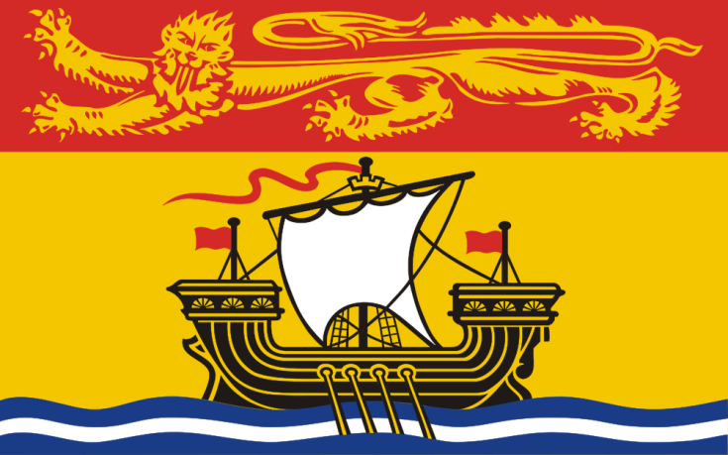

(A) EQUITY LEGISLATION, POLICIES / GUIDELINES:
(B) RESOURCES, TOOLS, AND SUPPORTS
(C) IMPLEMENTATION - EVALUTION OF IMPACTS
(D) COMMON MESSAGING (Health, Education)
(E) CHALLENGES, NEEDS, QUESTIONS, AND SUCCESSES

Nova Scotia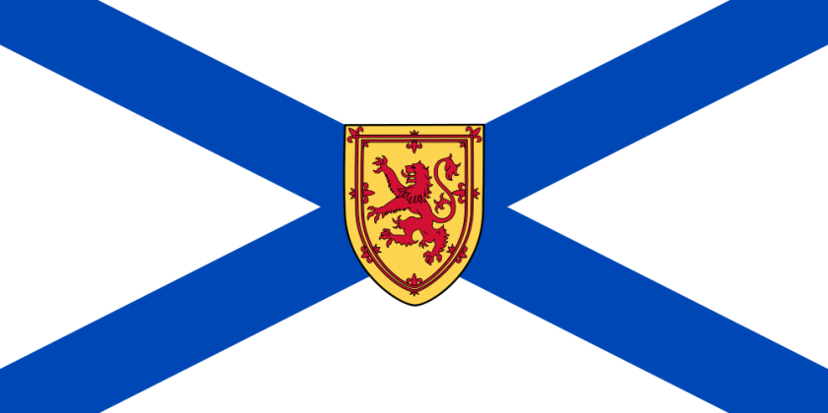

(A) POLICIES / GUIDELINES / STANDARDS:
- Guidelines for supporting trans-gender and gender nonconforming students
https://studentservices.ednet.ns.ca/sites/default/files/Guidelines%20for%20Supporting%20Transgender%20Students_0.pdf
- Racial Equity Policy:
http://studentservices.ednet.ns.ca/sites/default/files/RacialEquityPolicy_Webversion.pdf
Public Health Protocol of Health Equity:
http://www.novascotia.ca/dhw/publichealth/documents/05-Health-Equity-Protocol.pdf
(B) RESOURCES
Respect for Diversity: A Planning Resource
http://studentservices.ednet.ns.ca/sites/default/files/respect_for_diversity_web.pdf
(C) IMPLEMENTATION - EVALUTION OF IMPACTS
(D) COMMON MESSAGING (Health, Education)
(E) CHALLENGES, NEEDS, QUESTIONS, AND SUCCESSES

Prince Edward Island 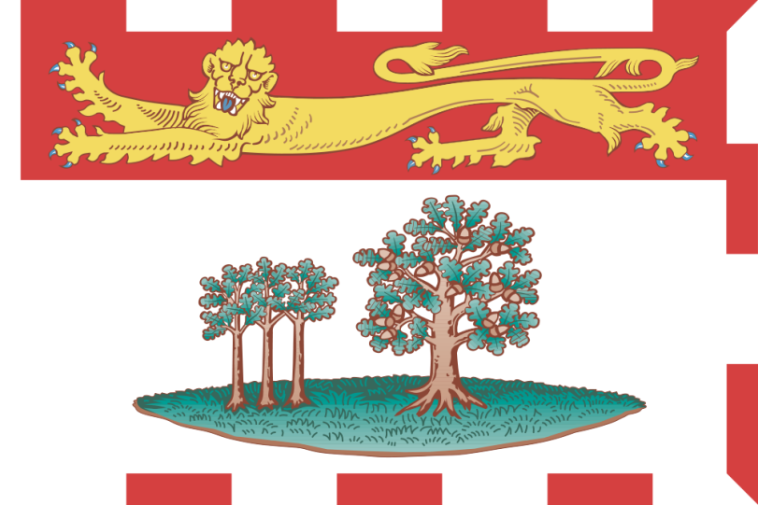

(A) EQUITY LEGISLATION, POLICIES / GUIDELINES
PEI Wellness Strategy
http://www.gov.pe.ca/health/wellness

The PEI Public Health Act http://www.gov.pe.ca/law/regulations/bydept.php3?dept=haw&website=health

Health PEI Chronic Disease Prevention and Management Framework
http://www.healthpei.ca/index.php3?number=publications&dept=&id=2124

School Board Policies:

Race Relations, Cross Cultural Understanding and Human Rights in Learning
Policy -http://www.gov.pe.ca/edu/elsb/files/2014/07/403_Race_Relations_Cross_Cultural_Understanding_and_Human_Rights_in_Learning.pdf
Procedure - http://www.gov.pe.ca/edu/elsb/files/2014/10/403.1_Race_Relations_Cross_Cultural_Understanding_and_Human_Rights_in_Learning.pdf

Diversity Management
Policy - http://www.gov.pe.ca/edu/elsb/files/2014/07/502_Diversity_Management.pdf
Procedure - http://www.gov.pe.ca/edu/elsb/files/2014/07/502.1_Diversity_Management.pdf

Foundation
Policy - http://www.gov.pe.ca/edu/elsb/files/2013/03/wsb-Foundation.pdf

Bullying, Harassment & Discrimination
Policy - http://www.gov.pe.ca/edu/elsb/files/2013/03/wsb-Bullying.pdf

Caring Places to Learn/Safe School Environment
Policy - http://www.gov.pe.ca/edu/elsb/files/2013/03/ADDA.pdf
Regulation - http://www.gov.pe.ca/edu/elsb/files/2013/03/ADDA_R.pdf

Poverty Intervention
Policy - http://www.gov.pe.ca/edu/elsb/files/2013/03/ADF.pdf
Regulation - http://www.gov.pe.ca/edu/elsb/files/2013/03/ADF_R.pdf

Inclusive Education
Policy - http://www.gov.pe.ca/edu/elsb/files/2013/03/ihba.pdf
Regulation - http://www.gov.pe.ca/edu/elsb/files/2013/03/ihba_r.pdf

Workplace Harassment Policy (GBBA)
http://www.gov.pe.ca/edu/elsb/files/2013/03/gbba.pdf

Recruitment and Hiring Policy (501)
http://www.gov.pe.ca/edu/elsb/files/2013/06/501_Recruitment_and_Hiring.pdf

Service Dogs In Schools (404.1)
http://www.gov.pe.ca/edu/elsb/files/2015/04/404.1_Service_Dogs_in_Schools.pdf

(B) RESOURCES, TOOLS, AND SUPPORTS
- 2014 Progress Report on the PEI Social Action Plan (Dept. of Family and Human Services http://www.gov.pe.ca/sss/index.php3?number=1043012&lang=E%20)
- Education and Learning is specifically identified but so is housing, income support, employment supports and services, health, family supports, and social inclusion and participation. Work underway in all government departments is noted.
PEI Working Group for a Livable Income
http://www.cooperinstitute.ca/content/page/programs_income/

PEI Advisory Council on the Status of Women – Equality Report Card 2015 (and previous years)
http://www.gov.pe.ca/acsw/2015-equality-report-card

Mi’kmaq Confederacy of PEI (e.g. Aboriginal Justice Program – Healing Justice with Circles)
http://www.mcpei.ca/programs_services

Pride PEI
http://www.pride-pei.com/
(C) IMPLEMENTATION - EVALUTION OF IMPACTS
Chief Public Health Officer’s Report and Health Trends 2014 http://www.gov.pe.ca/photos/original/CPHO_Trends_14.pdf
Chief Public Health Officer’s Report and Health Trends 2016 – to be released in May 2016 - focus on Equity and the Social Determinants of Health.
(D) COMMON MESSAGING (Health, Education)
(E) CHALLENGES, NEEDS, QUESTIONS, AND SUCCESSES

Newfoundland and Labrador

(A) EQUITY LEGISLATION, POLICIES / GUIDELINES
(B) RESOURCES, TOOLS, AND SUPPORTS
- Equity and Inclusive Education Resource Kit
http://mygsa.ca/educators/mygsaca-equity-inclusive-education-resource-kit-newfoundland-labrador-grades-7-12
(C) IMPLEMENTATION - EVALUTION OF IMPACTS
(D) COMMON MESSAGING (Health, Education)
(E) CHALLENGES, NEEDS, QUESTIONS, AND SUCCESSES

Nunavut 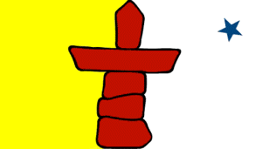

(A) POLICIES / GUIDELINES / STANDARDS:
Education Act (2008) http://www.gov.nu.ca/education-act
Nunavut Human Rights Act http://www.gov.nu.ca/human-rights-act-consolidation
Inuit Language Protection Act http://www.gov.nu.ca/inuit-language-protection-act-consolidation
Official Languages Act http://gov.nu.ca/official-languages-act

Foundation Documents:
Ilitaunnikuliriniq – Foundation for Dynamic Assessment
- http://www.gov.nu.ca/sites/default/files/files/Ilitaunnikuliriniq-DynamicAssessment.pdf

Inuglugijaittuq – Foundation for Inclusive Education
- http://www.gov.nu.ca/sites/default/files/files/Inclusive%20Education%20ENG.pdf
This document provides information for educators about the philosophical view of inclusion from an Inuit Qaujimajatuqangit (IQ) perspective and relates that philosophy to inclusion practices in Nunavut schools.

Inuit Qaujimajatuqangit – Education Framework for Nunavut Curriculum
- http://www.gov.nu.ca/sites/default/files/files/Inuit%20Qaujimajatuqangit%20ENG.pdf
Nunavut has a foundational framework that guides all strands of the curriculum and contains components related to equity.

In Inuit Qaujimajatuqangit: Education Framework for Nunavut Curriculum, Inuit Qaujimajatuqangit or Inuit world view and societal values is described as the philosophical basis for all curriculum in Nunavut. Curriculum developed in Nunavut is founded upon the Inuit Qaujimajatuqangit principles which serve as cross-curricular competencies and provide the foundation for our beliefs about teaching and learning for all Nunavut students. Some of the principals relate to equity:

- Aajiiqatigiingniq – decision making through discussion and consensus
- Piliriqatigiingniq – working together for a common cause
- Tunnganarniq – fostering good spirit by being open, welcoming and inclusive
- Inuuqatigiitsiarniq – respecting others, relationships and caring for people

Inuit Language Protection Act
Every parent whose chid is enrolled in the education program in Nunavut, including a child for whom an individual education plan has been proposed or implemented, has the right to have his or her child receive Inuit Language Instruction

(B) RESOURCES, TOOLS, AND SUPPORTS
Nunavut has a foundational framework that guides all strands of the curriculum and contains components related to equity.

In Inuit Qaujimajatuqangit: Education Framework for Nunavut Curriculum, Inuit Qaujimajatuqangit or Inuit world view and societal values is described as the philosophical basis for all curriculum in Nunavut. Curriculum developed in Nunavut is founded upon the Inuit Qaujimajatuqangit principles which serve as cross-curricular competencies and provide the foundation for our beliefs about teaching and learning for all Nunavut students. Some of the principals relate to equity:

- Aajiiqatigiingniq – decision making through discussion and consensus
- Piliriqatigiingniq – working together for a common cause
- Tunnganarniq – fostering good spirit by being open, welcoming and inclusive
- Inuuqatigiitsiarniq – respecting others, relationships and caring for people

Inuit Language Protection Act
Every parent whose chid is enrolled in the education program in Nunavut, including a child for whom an individual education plan has been proposed or implemented, has the right to have his or her child receive Inuit Language Instruction

- RESOURCES, TOOLS, AND SUPPORTS

Student Support Services Division, which helps to develop guidelines and support for inclusive education programming, including supports for the full range of learner needs.

Nunavut is in the process of drafting Supporting Student Achievement, an inclusive education Handbook for educators.

Building on our Strengths: Aboriginal youth wellness in Canada’s North http://www.jcsh-cces.ca/upload/14-193_BuildingOurStrengths_CFN_RPT.pdf
Safety in Schools: Principal’s Planning Manual 15/16 - Section 9 Emergency preparedness planning for students with disabilities
- Inclusive School Emergency Planning Checklist
- Personal Emergency Response Template
Crisis Response Guidelines for Nunavut Schools 15/16
- Emotional Safety checklist
- Physical safety checklist
- School and classroom climates checklist
- Social Emotional Learning Development checklist
- Use of physical space checklist
  - All adapted from http://www.jcshpositivementalhealthtoolkit.com/
(C) IMPLEMENTATION - EVALUTION OF IMPACTS
Reaching and Teaching All Students – A Model to Guide the Practice of Inclusive Education in Nunavut
Education completed an external review of inclusive education in Nunavut in 2014. Guided by an advisory committee of educators, the objective of the review was to provide a guide for a practical model of inclusive education in Nunavut after identifying the gaps in services and the challenges of delivering appropriate programming to all students in K-12. The review offered the Department of Education evidence-based recommendations that address the challenges meeting the needs of all students.
- COMMON MESSAGING (Health, Education)
Inuglugijaittuq – Foundation for Inclusive Education
http://www.gov.nu.ca/sites/default/files/files/Inclusive%20Education%20ENG.pdf

(E) CHALLENGES, NEEDS, QUESTIONS, AND SUCCESSES

Not all students in Nunavut have an equal access to specialized services and educational assessments. Some regions and communities have limited or no access to specialized services (e.g. educational psychology, speech language pathologists, etc). Assessments are services are limited by capacity, and northern realities such as weather preventing scheduled visits, parents not giving consent and students being absent when a specialist visits.
Currently, a lack of data and inability to track data in Nunavut through the Student Information System makes it difficult to assess how effective the services being provided are and how equitable they are.

Northwest Territories 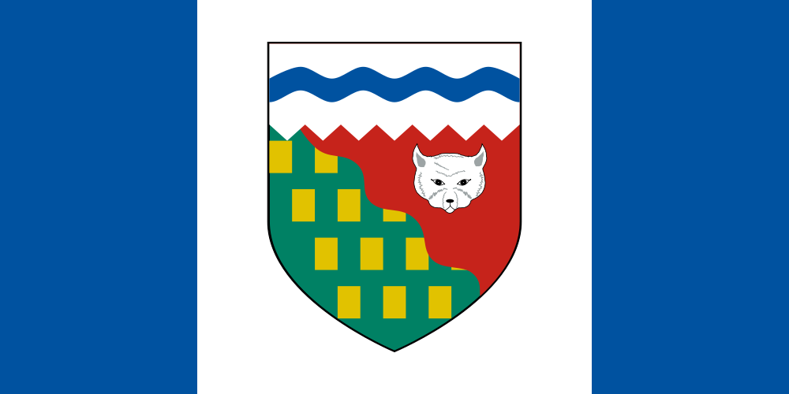

(A) POLICIES / GUIDELINES / STANDARDS
(B) RESOURCES
(C) IMPLEMENTATION EVALUTION OF IMPACTS
(D) COMMON MESSAGING (Health, Education)

(E) CHALLENGES, NEEDS, QUESTIONS, AND SUCCESSES

Yukon 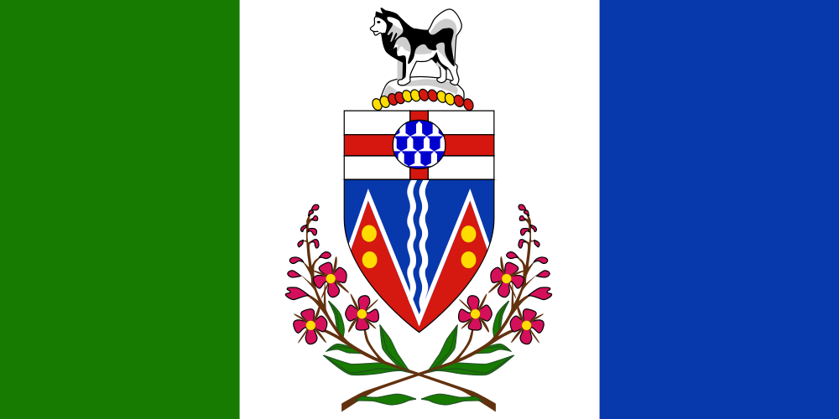

(A) POLICIES / GUIDELINES / STANDARDS:
- Safe and Caring Schools: http://www.education.gov.yk.ca/pdf/policies/safe_caring_schools.pdf
- Sexual Orientation and Gender Identity: http://www.education.gov.yk.ca/pdf/policies/sexual_orientation_and_gender_identity_policy.pdf
- School Nutrition and Inclusion of Yukon First Nations Guide “Food from the Land: Traditional Yukon Food: http://www.education.gov.yk.ca/pdf/policies/school_nutrition_policy.pdf
- BC Performance Standards – Social Responsibility (Ministry of Education) http://www.bced.gov.bc.ca/perf_stands/social_resp.htm
(B) RESOURCES
First Nations curriculum resources: http://www.yesnet.yk.ca/firstnations/curriculum.html
First Nations programs: http://www.yesnet.yk.ca/firstnations/programs.html
First Nations programs and partnerships: Culturally Inclusive Education: http://www.yesnet.yk.ca/firstnations/cul_inclusion.html
Making a Difference: Working with students who have fetal alcohol spectrum disorders: http://www.education.gov.yk.ca/pdf/schools/fasd_manual.pdf

(C) IMPLEMENTATION - EVALUTION OF IMPACTS
(D) COMMON MESSAGING? (Health, Education)

(E) CHALLENGES, NEEDS, QUESTIONS, AND SUCCESSES

Public Health Agency of Canada

(A) EQUITY LEGISLATION, POLICIES / GUIDELINES
(B) RESOURCES, TOOLS, SUPPORTS
(C) EVALUTION OF IMPACTS
(D) COMMON MESSAGING (Health, Education)
(E) CHALLENGES, NEEDS, QUESTIONS, AND SUCCESSES

National Resources
- CAAWS (Canadian Association for the Advancement of Women and Sport and Physical Activity) website
http://www.caaws.ca/ (includes link for Gender Equity)
Leading the Way: Working with LGBT Athletes and Coaches
http://www.caaws.ca/publications/homophobia/
- The National Collaborating Centre for Determinants of Health (Antigonish, NS), does extensive work in this area.
CEA
Newsletter Summer 2015, 55(2) : Implementation and Innovation: The route to equity
http://www.cea-ace.ca/education-canada/article/implementation-and-innovation-route-equity
Conference Papers:
Donnolly, M.L. (2010). The state of equity in Canadian education. A provocation paper prepared for the Canada-United States Colloquium on Achieving Equity Through Innovation Toronto, October 27-28, 2010
https://edpolicy.stanford.edu/sites/default/files/publications/state-equity-canadian-education.pdf

