Addressing Substance Use and Abuse Prevention
in Health Education Curricula,
provincial/territorial programs,
community supports,
youth voice

A Jurisdictional Scan
September 2013

Purpose of Environmental Scan:
To determine the curricula, programs, supports, and youth involvement around substance use/abuse in provinces and territories
Related questions for this Environmental Scan:
1. Outline of Health Education Curricula, other Curricula that features substance use learnings
2. Lists and Links of Provincial / Territorial Programs for youth substance use/abuse
3. Other community supports to assist youth in learning about, treating substance use issues
4. Information in youth voice on the issue of substance use / abuse in a Province/Territory.

Jurisdiction: British Columbia
1. Provincially Recommended Learning Resources
• HealthSmart (grades K-3, 4-7)
• Making Decisions (grade 4)
• Health for Life 2 (grade 8)
• Exploring the Issues: Teens – Alcohol and Other Drugs (grades 8, 9, 10)
• Targeted! How Tobacco and Alcohol Companies Try to Get You Hooked (grade 8)
• Health Issues 9 (grade 9)
• Road Safety Package (grades 9, 10)
2. Provincial Programs:
Programs Provided in School Districts
- Cigarette Smoking Project (Vernon) - The Substance Abuse Prevention Program in SD#22 has developed this program for students who have been suspended for the use of tobacco products while under school jurisdiction. Includes fact-based information on the dangers of cigarette smoking, a smoking habit screening quiz to help to determine if the student has need for further consultation or help, a choice of one student assignment to complete, and a directory of places to get more information or help with quitting smoking. http://www.sd22.bc.ca/smoking/

- Alternative Intervention for Marijuana Suspension (AIMS) (Kelowna) - UBC Okanagan research project aligning the RCMP, Kelowna School District and Addiction Services to provide an alternative program for students. Consists of students completing a self-assessment and attending a one-hour counseling session: http://www.kelowna.ca/CM/page1161.aspx

- Project Resiliency (Langley) http://www.sd35.bc.ca/programs/counselling/default.aspx?ID=33

3. Community Supports
- iMinds – Developed by the Centre for Addiction Research BC to support a whole school approach to prevent substance use related harms and promote mental health. Includes development of classroom lesson plans (grades 6-10), a resource guide for teachers, teacher training and ongoing web support. http://www.carbc.ca/Publications/EducationResources/tabid/329/LiveAccId/10520/Default.aspx

- Provincial Outreach Program for Fetal Alcohol Spectrum Disorder (POPFASD) - Developed by the Ministry of Education to support teachers of students with FASD. Shares current FASD research, resources and successful practices and provides a network for teachers and others. The POPFASD website provides information, e-learning modules and resources for teachers. www.fasdoutreach.ca/
- RoadSense - Insurance Corporation of BC (ICBC) provides curriculum-based materials to BC schools, Grades K-10. The materials support road safety learning outcomes and emphasize the importance of 2 good decision-making skills. In the Grade 8, 9, and 10 materials there are lesson plans dealing with impaired driving (due to alcohol and drugs). Between March and May each year, ICBC speakers tour BC high schools. hhttp://www.icbc.com/road-safety/roadsafety-activities/educators

- Making Decisions - Developed by Alcohol and Drug Education Service (ADES), this learning resource (grades 4-9) is offered to BC schools. ADES plans to conduct a revision process for this resource along with a web friendly component. http://ades.bc.ca/resources/making_decisions.html

- ‘Through a Blue Lens’ - This video for youth on drug abuse is extensively used in BC schools, and was developed by a department of the Vancouver Police called the Odd Squad. http://www.oddsquad.com/

4. Youth Voice
- Drugfacts.ca http://www.drugfacts.ca/

Jurisdiction: Alberta

1. Provincially Recommended Learning Resources

The current Health and Life Skills curriculum has a focus on a broader concept of safety throughout it. The specific topic of substance abuse can be found in:
- W-3.6 - describe the importance of decision-making and refusal skills when offered inappropriate substances; e.g., drugs, tobacco, allergens
- W-5.6 examine and evaluate the impact of caffeine, alcohol and drugs on personal health/wellness; e.g., physical, emotional, social
In the high school Career and Life Management program, the specific topic of substance abuse can be found in:
- P2 - evaluate choices and combinations of choices that can create barriers to achieving and maintaining health, and identify actions to improve health assess the effects of substance use and abuse-tobacco, alcohol, drugs-on health
The optional high school Career and Technology Studies program may address this detailed topic in the Health, Recreation & Human Services cluster. More information on that cluster can be found at:
http://education.alberta.ca/teachers/program/cts/program-of-studies/hrh.aspx

As Alberta moves forward with Curriculum Redesign, one of the initiatives coming from Inspiring Education future programs of study will more focused on competencies then on content and will move towards additional opportunities for local decision making and greater depth of study. More information on Curriculum Redesign can be found at: http://education.alberta.ca/department/ipr/curriculum.aspx

Additional information on wellness-related programs of study can be found on the public Alberta Education website at:
http://education.alberta.ca/teachers/program.aspx

2. Provincial Programs:
- Leaps and Bounds (AB, Canada) - AADAC program for Grades 4-6 (http://www.albertahealthservices.ca/2682.asp). AADAC provides other curriculum-aligned lesson plans and educational resources to provide students with knowledge and life skills that will empower them to make healthy choices about substance use and gambling, such as Own Your Own Zone and Be Your Own Hero. http://www.albertahealthservices.ca/2682.asp
- Creating Opportunities for Resilience and Engagement (CORE) (AB, Canada) - This program consists of a trial in 60 schools with a roll out and test in 8 schools per year. Funded through AADAC and the Alberta Heritage Foundation for Medical Research. http://www.coreconnects.ca/

3. Community Supports:
- Prevent Alcohol and Risk-Related Trauma in Youth (PARTY) Grade 9 students experience a full day session: listening to health-care workers describe the journey of a trauma patient listening to facts about brain and spinal cord injuries http://www.albertahealthservices.ca/services.asp?pid=service&rid=5619
- Stop Smoking Program: This six week stop smoking program for Junior High / High School students' provides support, encouragement, esteem building and mechanisms to help quit smoking. http://www.albertahealthservices.ca/services.asp?pid=service&rid=4976
- Tobacco Prevention: Teaming Up for Tobacco-Free Kids A campaign spreading across Alberta through schools and communities. It is a multi-layered approach to prevention, aimed at kids in Grades 4, 5, and 6—the age attitudes about tobacco use are formed. The campaign combines tobacco education and interactive involvement through a poster contest. http://www.albertahealthservices.ca/services.asp?pid=service&rid=1044404

4. Youth Voice:

Jurisdiction: Saskatchewan

1. Provincially Recommended Learning Resources
Drug education is a topic addressed in Health Education, which is one of the seven Required Areas of Study within Saskatchewan’s Core Curriculum. The renewed provincial health education curricula is designed on an inquiry for a healthy decision-making process that features students developing the understandings, skills, and confidences to negotiate information about drugs, make healthy decisions to improve the health of self, family, and/or community, and then designing and carry out a personal action plan to meet their goals related to avoiding, preventing, and/or reducing the risks and impact of drug use.

Students benefit from drug education that is addressed within a comprehensive provincial health education curriculum. Topics are presented at developmentally appropriate ages. For example, students in grade 3 learn how the misuse of helpful and the use of harmful substances affect the health of self and others, grade 5 students learn to prevent, avoid, and/or respond to negative peer pressure related to drugs, and in grade 9, students learn about the impact of addictions on the well-being of the individual, the family, and the community.

The provincial health education curriculum is designed to be implemented within a comprehensive school health framework that features health professionals, community organizations, and parents/caregivers supporting the school health education program and promoting the healthy development of children and youth through the school setting. This co-ordination reduces the ad hoc, sporadic, sometimes competing initiatives aimed at schools. Co-ordinated, sustained programs have significant, positive health and educational outcomes.

The provincial health education curricula incorporate a specific perspective through which health understandings, skills, and confidences are acquired. Each year, students gain understandings, skills, and confidences from a different perspective and these include:
Grade 6: Affirming Personal Standards
Grade 7: Committing Self
Grade 8: Supporting Others
Grade 9: Promoting Health

2. Provincial Programs:

3. Community Programs
- Fact Sheet: What to do if alcohol or drugs are causing problems in your teen’s life http://www.health.gov.sk.ca/adx/aspx/adxGetMedia.aspx?DocID=59c030e4-8bed-42d9-98b3-c5628af4a552&MediaID=5426&Filename=youth-recovery-fact-sheet-2011.pdf&l=English
- Adolescence Alcohol and Drugs: What Parents Need to Know http://www.health.gov.sk.ca/adx/aspx/adxGetMedia.aspx?DocID=1801,94,88,Documents&MediaID=5755&Filename=adolescence-alcohol-drugs.pdf&l=English

4. Youth Services

Manitoba

The question of prescription drug abuse is addressed in Manitoba through the Substance Use and Abuse Prevention strand of the Physical Education/Health Education curriculum which can be found here: http://www.edu.gov.mb.ca/k12/cur/physhlth/curriculum.html.
Learning outcomes for K-Grade 10 were introduced in 2000 while the Grade 11 outcomes were implemented in 2008.
Learning Outcomes include:
- Kindergarten and Grade 1 - students identify substances, such as medications and prescribed medicinal products that may be helpful or harmful.
- Grade 3 - students learn to identify and describe potential dangers as well as effects and consequences associated with substance abuse (including medicines). Factors that influence decisions regarding substance use are also examined.
- Grade 5 - students distinguish between medicinal and non-medicinal substances and appropriate use (including prescription drugs) as well as their effects and consequences. Peer, cultural, media, and social influences related to substance use and abuse are also identified.
- Grade 7 – students differentiate between the use and abuse of medicinal and non-medicinal substances with further focus on different consequences and the positive and negative social factors that may influence avoidance and/or use of substances.
- Grade 9 - students examine more of the potential consequences of substance use and abuse as well as identify community support agencies and resources.
- Grade10 - students analyze issues, including legal aspects and consequences, concerning the use and abuse of legal and illegal substances (including prescription drugs).
- Grade 11 - the goal is to reinforce the importance of avoiding the use and abuse of substances that may be harmful to self or to others, as taught in previous grades.

Quebec
Presently, the physical education and health section of the Educational program do not include any information about drugs for primary school. However, in secondary school, the physical education and health section of the Educational program include information related to drugs or other substances that is progressive with the age of the students (e.g. type of habits, type of substances discussed): Included in the information is:
- Detrimental lifestyle habits: Comparison of beneficial and detrimental effects of various substances: tobacco, drugs, alcohol, steroids, supplements, foods
- Effects of different substances on performance and training.
The Ethics and Religious cultures section of the Educational program includes content like the following examples:
- The distinction between what is acceptable and unacceptable in society and appropriate and inappropriate behaviour.
In grade 5-6 teachers are invited to talk about peer pressure in general and examples could include:
- A learning and evaluation situation involving thrill-seeking behaviour could be developed in order to help students become aware of the consequences of their personal choices on their health and well-being.
- A learning and evaluation situation that touches on the quest for happiness could help students reflect on each individual's need for affirmation, acceptance and personal development.
Overall, the health sector has not created any programs that focus specifically on prescription drugs to help teachers to discuss these issues. There are different programs on drugs as well as alcohol consumption though. For more information about the syntheses of recommendations for the school context, specifically the section on healthy lifestyle habits: alcohol, drugs, games of chance and gambling visit:
https://www.inspq.qc.ca/pdf/publications/1384_EducationalSuccessHealthWellBeingEffectiveActionInSchools.pdf.

Note: In Quebec grades are divided by cycles as follows:
Primary school cycle 1: Grade 1 and 2
Primary school cycle 2: Grade 3 and 4
Primary school cycle 3: Grade 5 and 6
Secondary school cycle 1: Grade 7 and 8
Secondary school cycle 2: Grade 9, 10 and 11

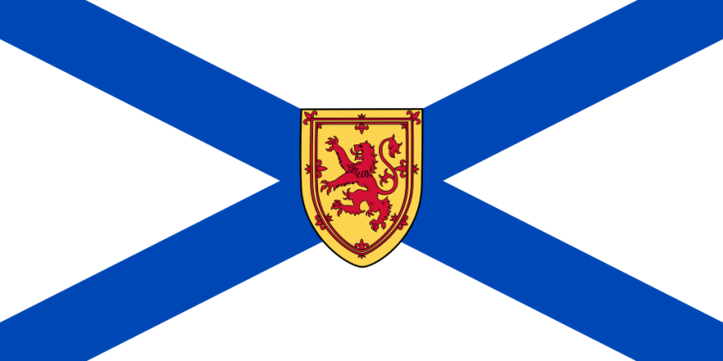
Nova Scotia

In Nova Scotia, Department of Education and Early Childhood Development is working with partners to determine how best to address the prescription drug issue. A point of contention is at what grade level prescription drug abuse should be addressed. Currently, it is included in our grade 9 curriculum. There is significant pressure from parents and community spokespersons to include this as early as grade 6 in our health education curriculum.
It is important to ensure that substance abuse topics are addressed in the right way at the right time and addressing some substance abuse topics too early can result in increasing students' interest in experimentation, not preventing abuse. Decisions need to be based on when to address particular aspects of substance abuse on the best available epidemiological data from the Nova Scotia Department of Health and Wellness. Presently being used are studies such as the Cross-Canada Report on Student Alcohol and Drug Use and surveillance data from the Nova Scotia Student Drug Use Survey (students in grades 7,9, 10, and 12) to prioritize and focus substance use prevention awareness and education. Informed by best practice, drug education in NS begins in grade primary.
Attention is paid to risk behavior just prior to their onset, based students' behavioral development and use patterns. These include:
- Inoculation (prevention efforts aimed at deterring or delaying the onset on use): prior to the average age of first use of a substance but when interest in the substance is occurring (e.g., for alcohol, about ages 11-12 years/grades 5-6)
- Early relevance: when most students are experiencing initial exposure and some are experimenting with the substance (e.g., for alcohol about 13-14 years of age/grades 7-8)
- Later relevance: when students are exposed to higher risk forms of use, different situations, and/or different substances (grade 9)

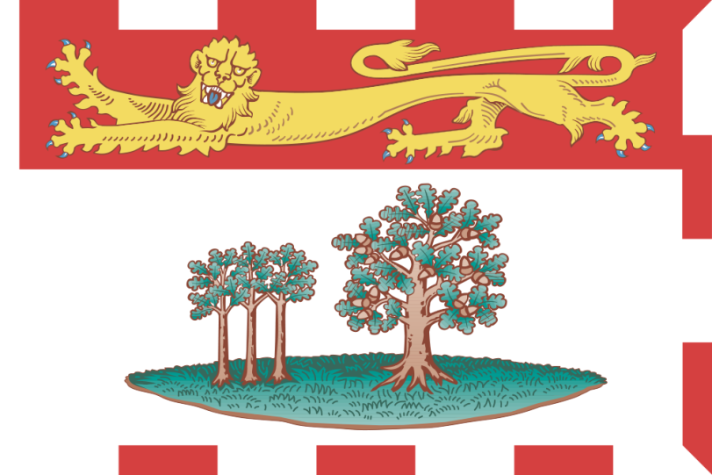
Prince Edward Island

Wellness Choices: General Curriculum Outcome: Students will make responsible and informed choices to maintain health and to promote safety for self and others.
Specific Curriculum Outcomes for Personal Health: Students are expected to:
Grade2: Demonstrate an understanding of responsible use of medicine Grade 3: Describe the importance of decision-making and refusal skills when offered inappropriate substances
Grade 5: Examine and evaluate the impact of caffeine, alcohol, and drugs on personal health/wellness
Grade 6: Analyze how laws, regulations, and rules contribute to health and safety practices
Grade 7: Analyze social factors that may influence avoidance and/or use of particular substances
Grade 8: Identify possible negative consequences of substance use and abuse
Demonstrate an understanding of the effect of harmful involvement with alcohol, cannabis, and other drugs on a family
Develop strategies to effectively access health information and health services in the community
Grade 9: Identify several risks associated with use of alcohol, cannabis, and other drugs
Identify several signs and stages of dependence on a substance
Identify several strategies for helping a friend who is having problems with alcohol or other drugs
Identify ways that laws and community-based services support the treatment of addictions
Draft outcomes for physical education 10 - Students are expected to:
Assess the impact of mental health on overall well-being of self, family, and community
Optional outcome - Design a plan to address community well-being

Youth Substance Use Programs:
Strength Program: http://www.justtalkpei.ca/images/PEI%20Health_Strength_Program.pdf

Youth Voice:
http://www.justtalkpei.ca/uploads/posters/YouthAddiction_11x17_Girl.pdf
http://www.justtalkpei.ca/uploads/posters/cathy.pdf
http://www.justtalkpei.ca/uploads/posters/bob.pdf
http://www.justtalkpei.ca/uploads/posters/sally.pdf
http://www.justtalkpei.ca/uploads/posters/YouthAddiction_11x17_Boy.pdf

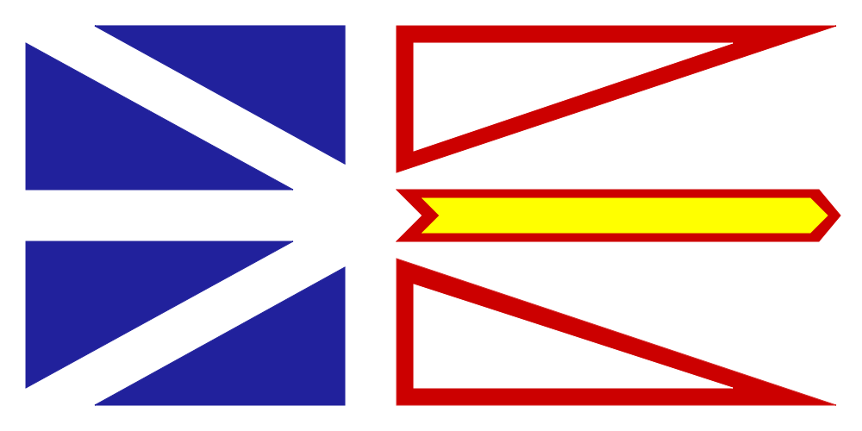
Newfoundland and Labrador

Health/Family Studies K-12 Curricula: Prescription Drug Abuse Related Outcomes
General outcome:
- Partnership with RCMP to carry out the Drug Abuse Resistance Education (D.A.R.E.) program with grade 6 students.

Primary Health: At the primary level, the drug education focus is primarily within the home with an emphasis on medications. As the student nears the end of primary schooling, the focus broadens to raise awareness about situations that could arise outside the home.

Kindergarten and Grade 1: “Unit 4. All Around Me: My Environment” puts a focus on the home with regards to prescription drugs; identifying them as a hazard and the action required to promote personal safety. The outcomes in this unit, by grade, are:
Kindergarten:
- understand that some products commonly found in homes may be harmful if ingested, touched or smelled (medications)
Grade 1:
- identify safety practices employed in the home related to hazards (medicine)
Grade 2: “Unit 4. All Around Me: My Environment”, strives to expand student awareness of drugs beyond the home environment. The outcomes in this unit are:
- understand that medicines contain drugs
- identify dangerous substances around the home
- know how to respond when offered candy or unknown substances by other children or adults
- know when it is safe to accept food or candy from others
- identify certain situations when children need to take medication while in school
Grade 3: The Drug Education component at this grade level promotes the development of knowledge and skills that will enable young people to make responsible decisions regarding drugs. Special attention is given to developing and practicing communication, refusal, decision-making and problem-solving skills. The outcomes in this component are:
- identify common over-the-counter drugs
- understand that some over-the-counter drugs have many questionable value but sometimes are necessary to relieve symptoms of minor ailments
- know how the pharmacist can help when choosing over-the-counter medication
- realize that people sometimes use drugs for non-medicinal purposes
- identify ways that drugs are administered: oral, injections.
- recognize that some drugs may have unpleasant or dangerous side effects
- understand the need for safe handling of medicines
- know that certain combinations of drugs may be life threatening

Elementary: Drug Education focuses on how the body and different drugs interact and how
personal choices about drugs affect the well-being of self and others. The Drug Education component is relevant to the specific needs of children in this province in terms of the impact of drug use, misuse, abuse and chemical dependency. There is an emphasis on identification, prevention, treatment and the legal implications of substance abuse. The outcomes for the Drug Education component, by grade level, are listed below:

Grade 4 Health:
- relate the major functions of medicines and the importance of safe use and handling
- know that the most reliable sources of prescription drugs are doctors, nurses, and pharmacists
- identify some reasons why people use drugs for non-medicinal purposes,
- recognize that nicotine and caffeine are drugs
- identify the reasons why people do or do not smoke
- discuss some of the physiological effects of smoking
- describe the short term and long term effects of smoking
- identify a number of activities to do instead of smoking
- outline the effects of environmental tobacco smoke (ETS)
- suggest ways to protect oneself from environmental tobacco smoke (ETS)
- practice ways to say “no” to drugs

Grade 5 Health:
- outline where and how to obtain accurate information regarding medicines
- understand that food/drink can affect the potency of certain drugs, thus the
- need to follow prescriptions accurately
- realize that alcohol is a drug (depressant)
- identify reasons for drinking and not drinking alcohol
- outline the effects of occasional drinking, regular usage and prolonged usage
- identify commonly used inhalants
- develop awareness of the danger of inhalants
- identify reasons for using and not using mood-altering inhalants
- identify alternate ways to deal with personal problems
- demonstrate a variety of refusal skills
- identify some constructive activities to do instead of using substances, and
- discuss the reasons for laws on drugs and drug abuse

Grade 6 Health:
- evaluate advertising techniques used to convince people to smoke cigarettes and consume alcohol
- discuss the personal and societal cost of smoking, drinking and other drug use
- identify alternative uses for money not spent on tobacco and alcohol
- identify street drugs and their effects on health and well-being
- identify alternatives to drug usage
- recognize the potential for addiction to tobacco and alcoholic beverages
- practice problem-solving and decision-making skills for preventing substance use and abuse
- practice refusal skills
- identify community resources that offer prevention and treatment services for substance abuse,
- recognize that criminal activity is sometimes related to drug abuse

Intermediate Health: In grades 7-8, the drug education component is broken down into Smoking and Alcohol in grade 7 and Alcohol and Other Drugs in grade 8. In grade 9, students apply drug education concepts and skills to relationships. The outcomes for grades 7-9 are as follows:
Grade 7:
- To understand that tobacco contains and addictive drug and other chemicals that effect health
- To identify reasons why people choose to smoke or not to smoke.
- To be aware of the immediate and long-term effects of cigarette smoking, both physical, social and psychological.
- To understand the effects of second-hand and side-stream smoke.
- To understand the influence of advertising on smoking behavior.
- To recognize the rights of smokers and non-smokers.
- To use the decision-making model with regard to tobacco use.
- To identify and practice refusal skills with regard to smoking.
- To promote and encourage appropriate health-related practices.
- To be aware of the laws pertaining to tobacco use.
- To be aware of the immediate and long-term benefits of cessation.
- To identify programs and methods used by smokers in an effort to quit smoking.
Grade 8:
- To distinguish between facts and myths with regards to drugs and alcohol.
- To be aware of the dangers of combining alcohol and other drugs.
- To have an appreciation of the role of drugs in our society.
- To distinguish between drug use, drug misuse, and drug abuse and drug dependence.
- To be aware of the physical and psychological potential for dependence on drugs.
- To be aware of how advertising and the media influence decisions regarding drug use.
- To be aware of Canadian laws relating to the possession, use and sale of drugs.
- To be aware of alternatives to drug abuse/use.
- To consider personal, societal and familial values with respect to the use of drugs.
- To be aware of sources of help for drug-dependent persons
- To be aware of the part that decision making plays in drug use and abuse and to practice assertiveness and refusal in this area.
Grade 9:
- To analyze influences on dating behaviors.
- To develop effective communication skills to assist in maintaining personal values and coping with other issues that may arise in dating relationships.
- To assess the effect of high-risk dating practices on overall wellness.
- To identify healthy ways of coping with stress.
- To apply the decision-making process to common scenarios.

Provincial, National, and International Programs

- National Anti-Drug Strategy: Use Your Voice http://www.nationalantidrugstrategy.gc.ca/prevention/youth-jeunes/speak-exprime/index.html

- Educating Students about Drug Use and Mental Health: Curriculum Support for the Ontario Curriculum (ON, Canada) - http://www.camh.net/education/resources_teachers_schools/drug_Curriculum/index.html

- CAMH offers an integrated set of web based resources for teachers, schools and allied partners to utilize in their prevention/health promotion work with youth: Educating Students About Substance Use & Mental Health - Ready-to-Use Lesson Plans for Your Classroom. Ontario's Health and Physical Education Curriculum now has expectations related to substance use (grade 1-10) and mental health (grade 11-12). http://www.camh.net/curriculum.

- Talking about Mental Illness (TAMI) - An anti-stigma/education program for secondary school students, developed in collaboration with CMHA Ontario Division and Mood Disorders Association. Currently being implemented in 44 school boards across Ontario. http://www.camh.net/education/Resources_teachers_schools/TAMI/index.html

- 3 Virtual Party - An interactive web-based resource, developed by youth, for youth. An educational tool aimed at offering information in an interactive story, promoting healthy choices and reducing risky behaviour related to alcohol use. Targeted to youth 13-19 years of age. www.virtual-party.org

- Take Action Project – Developed by CAMH and Ontario Physical and Health Education Association (OPHEA), Take Action is a comprehensive, classroom-based program designed to support educators and engage school communities in teaching safety awareness regarding medicines and harmful substances and provides information about tobacco, alcohol and substance use through the integration of health and physical education expectations. www.ophea.net.

- Youth Scoop - A free series of tip sheets for child and youth serving professionals that summarize the latest research related to addiction and mental health issues. http://www.camh.net/education/Resources_teachers_schools/Youth%20Scoop/index.html

- School Health and Alcohol Harm Reduction Project (Australia) - Teacher’s Manual, Student Workbooks I and II. http://www.ndri.curtin.edu.au/shahrp/download.html

- MindMatters: Mental Health Promotion Resource for Secondary Schools (Australia) http://www.mindmatters.edu.au/resources_and_downloads/resources_landing.html

- The Gatehouse Project (Australia) - A well-evaluated initiative focused on Grade 8 students in 26 schools in Melbourne, Australia that aimed to improve the emotional well-being of secondary students through individual- and environment-focused approaches.

- NIDA Goes Back to School (USA) - Specialized curricula and other teaching aids http://backtoschool.drugabuse.gov/

- The Seattle Social Development Project (USA) - A universal intervention for students in Grades 1-6 that combines parent training with modified teaching practices. http://depts.washington.edu/ssdp/

- The Child Development Project (USA) - This program is intended to transform schools into “caring communities of learners”. http://www.cdp.auburn.edu/

