

**JCSH Strategic Directions 2020-2025**

**VISION**

**Children and youth in Canada are thriving in school communities that are committed to optimal health, well-being, and learning**

**GOVERNANCE**

Ministries of Education and Ministries responsible for Health/Wellness in 12 of the 13 provinces and territories, and the Public Health Agency of Canada representing the Federal Government at the JCSH tables.

[Sidebars are great for calling out important points from your text or adding additional info for quick reference, such as a schedule.

They are typically placed on the left, right, top or bottom of the page. But you can easily drag them to any position you prefer.

When you’re ready to add your content, just click here and start typing.]

**GOAL 2**

**ENHANCING CAPACITY THROUGH KNOWLEDGE DEVELOPMENT AND EXCHANGE**

To build, share, and leverage knowledge that enables member jurisdictions to support the optimal health, well-being, and learning of children and youth in Canada

**GOAL 4**

**MONITORING, EVALUATION, AND ACCOUNTABILITY**

To implement a comprehensive evaluation framework for the goals, strategies, and operational plans of the JCSH 2020-2025 mandate

**GOAL 3**

**PROMOTING INNOVATION**

To support innovative approaches to policy, programs, and practice in member jurisdictions that address common challenges to the optimal health, well-being, and learning of children and youth in Canada

**GOAL 1**

**PROVIDING LEADERSHIP**

To advance coordinated and aligned policy, programs, and practice that support the optimal health, well-being, and learning of children and youth in Canada

**MISSION**

To work collaboratively across jurisdictions and between the education and health sectors to support optimal health, well-being, and learning of children and youth in school communities

[Cite your source here.]

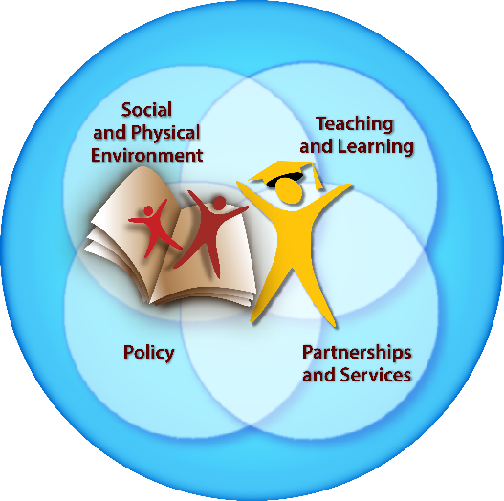

**Enhancing Capacity Through KDE**

**Strategy 1:** Support member jurisdictions to be responsive, resource efficient, and economically responsible by sharing knowledge of what works best and has the greatest positive impact.

**Strategy 2:** Identify and/or develop tools to strengthen existing partnerships across the education and health sectors.

**Strategy 3:** Continue to strengthen knowledge on how CSH-based approaches can meet the needs of diverse population groups and address inequities.

**Strategy 4:** Increase and enhance opportunities for knowledge exchange among member jurisdictions.

**Monitoring, Evaluation, and Accountability**

Strategy 1: Develop annual JCSH operational plans and budgets that specify planned areas of actions to support the five-year JCSH goals and strategies.

Strategy 2: Undertake a comprehensive evaluation of the JCSH during the mandate.

Strategy 3: Support and ensure the ongoing alignment between the JCSH governance structure, the operational policies, and the implementation of the Strategic Directions.

**Promoting Innovation**

**Strategy 1:** Proactively identify and provide potential solutions to existing and emerging challenges to student health, well-being, and learning, and disseminate results among member jurisdictions.

**Strategy 2**: Utilizing a comprehensive school health approach, advance application of evidence to address emerging issues of concern (e.g. vaping).

**Strategy 3:** Continue engaging research partners in order to create an evidence base of strategies to support student health, well-being, and learning and comprehensive school health approaches.

**Strategy 4:** Work with research partners to advance evidence-based reviews of responses to emerging challenges.

**Providing Leadership**

**Strategy 1:** Strengthen connections with the Council of Ministers of Education, Canada and the FPT Ministers of Health to encourage alignment of priorities and needs.

**Strategy 2:** Continue to support member jurisdictions with policy and practice-based tools and resources that leverage a comprehensive school health approach.

**Strategy 3**: Proactively engage with federal initiatives focused on student health and well-being to align with efforts within jurisdictions and encourage principles of CSH to be embedded and visible within these federal initiatives.

**Strategy 4:** Continue to strategically engage representatives of the non-government sector, and key stakeholders in sectors beyond health/wellness/education, in order to advance CSH-based approaches to common needs and issues.