# **Joint Consortium for School Health**

# **Annual Work Plan 2020**

**Executive Summary**

As the Joint Consortium for School Health (JCSH)[1] looks to a renewed mandate, plans for this year’s initiatives have been changed by the global, national, and provincial/territorial responses to the COVID-19 pandemic. For this partnership of Ministries of Health and Education[2], supported by the Public Health Agency of Canada, the consequences of COVID-19 are at the forefront of our work going forward. The health, well-being, and learning successes of all Canadian students are both fundamental goals of the JCSH and key to the post-COVID-19 responses.

JCSH has three overarching priorities for the 2020-2025 mandate. They are as follows:

* **Mental well-being,** COVID-19 crisis response,social-emotional learning, resiliency, anxiety, protective factors and disruptive behaviours;
* **Problematic substance use,** with a strong initial focus on vaping; and
* **School food environment,** including the alignment of healthy eating school food policies and priorities

…all addressed through the comprehensive school health approach.

JCSH will support the Ministries of Education and Health this year as they respond to the needs of Canadian students and school communities in this unprecedented time.

Reflecting the current reality, there are four priority areas for the 2020-2021 year:

1. Communication with Council of Ministers of Education, Canada (CMEC) and the Federal, Provincial and Territorial Ministers of Health to determine their priorities and the ways JCSH can support their work, in light of the pandemic, and given the Consortium’s unique role across both sectors.

2. Provide school authorities and school communities with a resource to have them facilitate use of the 4-component [Comprehensive School Health Framework](http://www.jcsh-cces.ca/images/What_is_Comprehensive_School_Health_-_2-pager_-_July_2016.pdf) to support their work in students’ re-entry into schools.



This resource will also feature the [Core Indicators Model](https://www.jcsh-cces.ca/images/Core_Indicators_Model_2016.pdf) (CIM) of Comprehensive School Health and Student Achievement

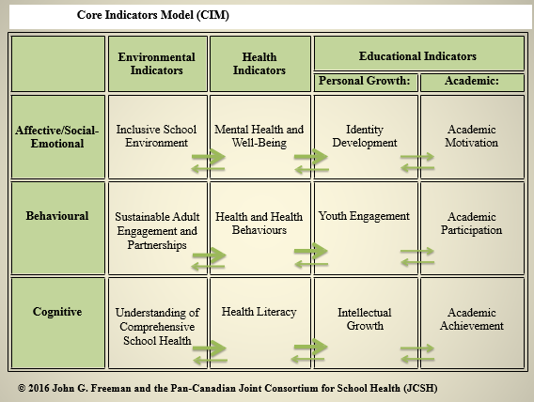

The CIM is intended for use by schools to facilitate them to make the connections between student learning / academic achievement and the comprehensive school health / whole student approach. The CIM provides a roadmap linking the essential features of the school’s physical and social environment that provide students and staff with safety and wellness with learning success. This resource will assist schools in assessing any initiatives, including curriculum around students’ health literacy.

3. The results of the national and international Health Behaviour in School-aged Children (HBSC) survey will be disseminated in the coming months as reports, mini-reports, and webinars. JCSH will work with Public Health Agency of Canada and the HBSC research leads at Queen’s University to identify and circulate topic-specific communications: areas such as mental health, social media use, relationships and connections, or movement behaviours.

4. An ever-green environmental scan to track return-to-school initiatives, impacts, and outcomes throughout Canada and globally to report and transfer learnings.

There are additional action items (See JCSH Work Plan, Appendix 1) planned to support the above areas, and much need for ongoing monitoring and evaluation of our work. JCSH will continue to reach out to its member provinces and territories through the Management Committee and School Health Coordinators’ Committee tables.

1. The Pan-Canadian Joint Consortium for School Health (JCSH) was established by provincial, territorial, and federal governments in 2005 as a means of bringing together two large systems – Education and Health – across the country in order to combine strengths for the wellness and achievement of children and youth in the school setting.

   JCSH is a membership of government departments or ministries. The Department of Education and the Department of Health/Health Promotion in each of the provinces and territories with the exception of Quebec form this membership. Working closely with the members in a funding and supportive role is the Public Health Agency of Canada as the federal collaborator. Since 2005, these 25 ministries/departments and agency have represented a common voice in Canada on the promotion of a comprehensive approach to wellness and success of all students.
2. Although Quebec shares the concerns and objectives of the JCSH and will continue to contribute by sharing information and leveraging best practices, Quebec intends to remain solely responsible for responding to school health needs within its territory.